Members Committee
Two Hundred Twelfth Meeting
Webex Only
June 30, 2021
2:00 p.m. – 5:00 EPT

*Operator assisted phone lines will be opened 30 minutes prior to the start of the meeting. Due to the high volume of remote participation, stakeholders are asked to connect early to allow additional time for operator queue processing.

Administration (2:00-2:10)
- Confirm the presence of a quorum of representatives or designated alternates for this meeting – David Anders
Please ensure you have logged in to the voting application prior to the start of this meeting.
- Anti-trust, Code of Conduct, Meeting Participation, and Safety announcements – David Anders

Consent Agenda (2:10-2:10)
None

Endorsements/ Approvals (2:10-4:50)
- Proposal Introduction (2:10-2:45)
Proposal sponsors will be asked to provide a short synopsis of their proposals for up to 3 minutes each:
  - PJM
  - LS Power (Riverside Generating Company, LLC)
  - Calpine
  - E-Cubed Policy Associates (Sponsored by Elwood Energy)
  - Exelon
  - Public Service Electric & Gas Company (PSEG)
  - Independent Market Monitor (IMM)
  - American Municipal Power (AMP)
  - Delaware Division of the Public Advocate
- Motion to Proceed to Voting on Proposals (2:45-4:15)
Members will entertain a motion to proceed directly to a vote. If the motion fails, stakeholders will be offered the opportunity for questions and answers for up to a total of 1-1/2 hours. The Chair may use discretion as to the length of discussion.

- Voting on Proposals (4:15-5:00)
Votes will be conducted on each proposal. Members may vote yes, no or abstain on each proposal independently; results of each vote will not be displayed until all votes have been taken.
- PJM
- LS Power (Riverside Generating Company, LLC)
- Calpine
- E-Cubed Policy Associates (Sponsored by Elwood Energy)
- Exelon
- Public Service Electric & Gas Company (PSEG)
- Independent Market Monitor (IMM)
- American Municipal Power (AMP)
- Delaware Division of the Public Advocate

Reports (4:50-4:50)
None
 | Future Agenda Items (4:50)
 | Future Meeting Dates
July 28, 2021 |  | 1:15 p.m. | WebEx
September 29, 2021 |  | 1:15 p.m. | WebEx
October 20, 2021 |  | 1:15 p.m. | WebEx
November 17, 2021 |  | 1:15 p.m. | WebEx
December 15, 2021 |  | 1:15 p.m. | WebEx

Author: D. Anders

Antitrust:
You may not discuss any topics that violate, or that might appear to violate, the antitrust laws including but not limited to agreements between or among competitors regarding prices, bid and offer practices, availability of service, product design, terms of sale, division of markets, allocation of customers or any other activity that might unreasonably restrain competition. If any of these items are discussed the chair will re-direct the conversation. If the conversation still persists, parties will be asked to leave the meeting or the meeting will be adjourned.

Code of Conduct:
As a mandatory condition of attendance at today's meeting, attendees agree to adhere to the PJM Code of Conduct as detailed in PJM Manual M-34 section 4.5, including, but not limited to, participants' responsibilities and rules regarding the dissemination of meeting discussion and materials.

Public Meetings/Media Participation:
Unless otherwise noted, PJM stakeholder meetings are open to the public and to members of the media. Members of the media are asked to announce their attendance at all PJM stakeholder meetings at the beginning of the meeting or at the point they join a meeting already in progress. Members of the Media are reminded that speakers at PJM meetings cannot be quoted without explicit permission from the speaker. PJM Members are reminded that "detailed transcriptional meeting notes" and white board notes from "brainstorming sessions" shall not be disseminated. Stakeholders are also not allowed to create audio, video or online recordings of PJM meetings. PJM may create audio, video or online recordings of stakeholder meetings for internal and training purposes, and your participation at such meetings indicates your consent to the same.
Participant Identification in Webex:
When logging into the Webex desktop client, please enter your real first and last name as well as a valid email address. Be sure to select the “call me” option.
PJM support staff continuously monitors Webex connections during stakeholder meetings. Anonymous users or those using false usernames or emails will be dropped from the teleconference.

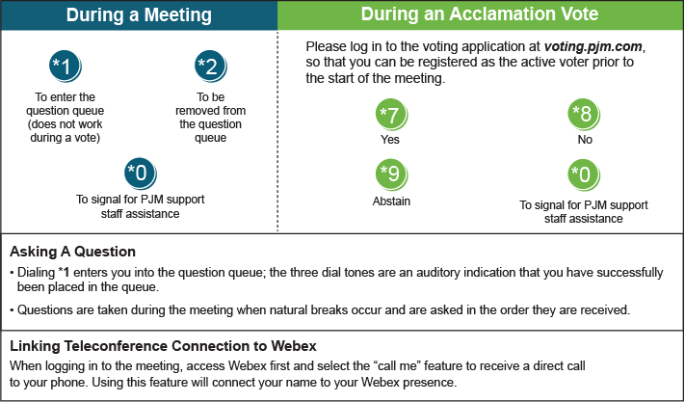

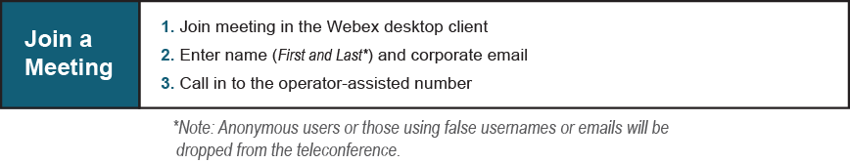
Provide feedback on the progress of this group: Facilitator Feedback Form
Visit learn.pjm.com, an easy-to-understand resource about the power industry and PJM’s role.

