Market Implementation Committee
WebEx Only
March 10, 2021
9:00 a.m. – 4:00 p.m. EPT

Administration (9:00 – 9:05)
Nicholas DiSciullo will review the Antitrust, Code of Conduct, Public Meetings/Media Participation and the WebEx Participant Identification Requirements.

The Committee will be asked to approve the draft minutes from the February 10, 2021 Market Implementation Committee meeting.

Review MIC Work Plan

Endorsements/Approvals (9:05 – 10:40)
- RPM Capacity Transfer Rights (9:05 – 9:35)
Kevin Zemanek, Buckeye Power will review the Problem Statement and Issue Charge addressing RPM Capacity Transfer Rights.
The committee will be asked to approve the Issue Charge at this meeting.

- Long-Term 5-Minute Dispatch & Pricing Work Plan (9:35 – 9:55)
Aaron Baizman will provide a second first read of the PJM/IMM proposal from the Long-Term Five Minute Dispatch & Pricing Matrix that was worked in MIC Special Session meetings. A draft version of associated OA language is posted with meeting materials for informational purposes.
The committee will be asked to endorse the PJM/IMM proposal at this meeting. If the proposal receives greater than 50%, a second non-binding poll will be taken asking whether participants prefer the proposal over the status quo.
Issue Tracking: Five Minute Dispatch and Pricing
- Manual 11 Revisions (9:55 – 10:10)
Nikki Militello will review updates to Manual 11: Energy & Ancillary Service Market Operations as part of the biennial cover-to-cover review.
The committee will be asked to endorse the revisions at this meeting.

- Capital Recovery Factor for Avoidable Project Investment Cost Determinations (10:10 – 10:40)
Jeff Bastian will review the Problem Statement and Issue Charge addressing Capital Recovery Factor for Avoidable Project Investment Cost Determinations.
The committee will be asked to approve the issue charge and endorse the proposal as part of the Quick Fix process outlined in Section 8.6.1 of Manual 34 at this meeting. If the proposal receives greater than 50%, a second non-binding poll will be taken asking whether participants prefer the proposal over the status quo.

First Readings (10:40 – 11:40)
- Reactive Supply and Voltage Control Compensation (10:40 – 11:10)
Jim Davis, Dominion Energy, will provide a first read of the Problem Statement and Issue Charge addressing Compensation for Reactive Supply and Voltage Control service. The committee will be asked to approve the issue charge at its next meeting.

- New Load Locating Behind the Meter of an Existing Generation Resource (11:10 – 11:40)
Jeff Bastian will provide a first read of the Problem Statement and Issue Charge addressing New Load Locating Behind the Meter of an Existing Generation Resource. The committee will be asked to approve the issue charge at its next meeting.

Working Items (11:40 - 12:10)
- Market Suspension (11:40 – 12:10)
- Stefan Starkov will provide an overview of PJM’s proposed solution options.
- Lisa Morelli will facilitate a discussion on the Market Suspension matrix as part of the Consensus Based Issue Resolution process.
Issue Tracking: Rules Related to Market Suspension

Additional Items (12:10 – 12:20)
- IROL-CIP Cost Recovery (12:10 – 12:20)
Darrell Frogg will provide an update on Interconnection Reliability Operating Limits-Critical Infrastructure Protection (IROL-CIP) Cost Recovery.

Informational Section
Interregional Coordination Update
Materials are posted as informational only.

ARR FTR Market Task Force (AFMTF)
Meeting materials are posted to the AFMTF website.

Cost Development Subcommittee (CDS)
Meeting materials are posted to the CDS website.

Demand Response Subcommittee (DRS)
Meeting materials are posted to the DRS website.

DER & Inverter-based Resources Subcommittee (DIRS)
Meeting materials are posted to the DIRS website.

Market Settlements Subcommittee (MSS)
Meeting materials are posted to the MSS website.

Report on Market Operations
The Report on Market Operations will be reviewed during the MC Webinar.

Future Meeting Dates
April 7, 2021 | 9:00 a.m. | WebEx
May 13, 2021 | 9:00 a.m. | WebEx
June 9, 2021 | 9:00 a.m. | WebEx
July 14, 2021 | 9:00 a.m. | WebEx
August 11, 2021 | 9:00 a.m. | WebEx
September 9, 2021 | 9:00 a.m. | WebEx
October 6, 2021 | 9:00 a.m. | WebEx
November 3, 2021 | 9:00 a.m. | WebEx
December 1, 2021 | 9:00 a.m. | WebEx

Author: Nick DiSciullo

Antitrust:
You may not discuss any topics that violate, or that might appear to violate, the antitrust laws including but not limited to agreements between or among competitors regarding prices, bid and offer practices, availability of service, product design, terms of sale, division of markets, allocation of customers or any other activity that might unreasonably restrain competition. If any of these items are discussed the chair will re-direct the conversation. If the conversation still persists, parties will be asked to leave the meeting or the meeting will be adjourned.

Code of Conduct:
As a mandatory condition of attendance at today's meeting, attendees agree to adhere to the PJM Code of Conduct as detailed in PJM Manual M-34 section 4.5, including, but not limited to, participants' responsibilities and rules regarding the dissemination of meeting discussion and materials.

Public Meetings/Media Participation:
Unless otherwise noted, PJM stakeholder meetings are open to the public and to members of the media. Members of the media are asked to announce their attendance at all PJM stakeholder meetings at the beginning of the meeting or at the point they join a meeting already in progress. Members of the Media are reminded that speakers at PJM meetings cannot be quoted without explicit permission from the speaker. PJM Members are reminded that "detailed transcriptional meeting notes" and white board notes from "brainstorming sessions" shall not be disseminated. Stakeholders are also not allowed to create audio, video or online recordings of PJM meetings. PJM may create audio, video or online recordings of stakeholder meetings for internal and training purposes, and your participation at such meetings indicates your consent to the same.
Participant Identification in WebEx:
When logging into the WebEx desktop client, please enter your real first and last name as well as a valid email address. Be sure to select the “call me” option.
PJM support staff continuously monitors WebEx connections during stakeholder meetings. Anonymous users or those using false usernames or emails will be dropped from the teleconference.
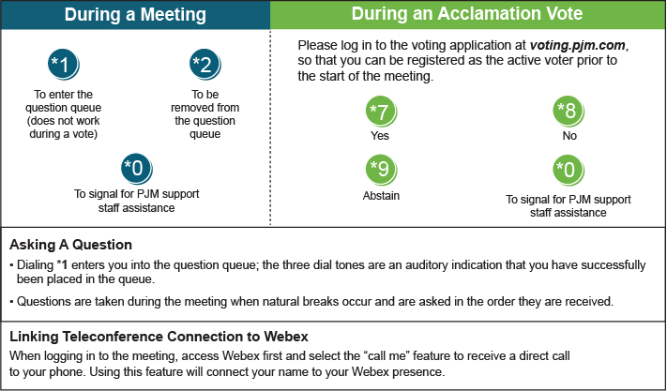

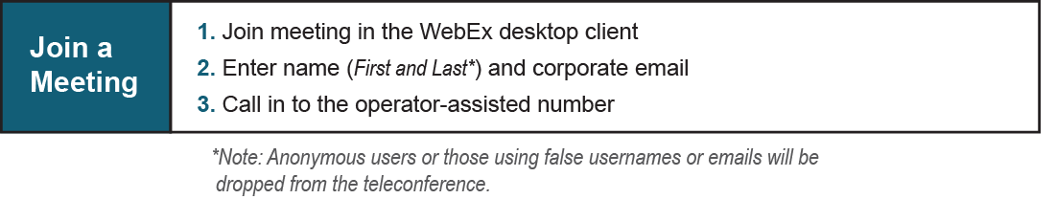
Provide feedback on the progress of this group: Facilitator Feedback Form
Visit learn.pjm.com, an easy-to-understand resource about the power industry and PJM’s role.

