Market Implementation Committee

WebEx Only

July 14, 2021

9:00 a.m. – 3:30 p.m. EPT

Administration (9:00 – 9:05)

Nicholas DiSciullo will review the Antitrust, Code of Conduct, Public Meetings/Media Participation and the WebEx Participant Identification Requirements.

The Committee will be asked to approve the draft minutes from the June 24, 2021 MIC Special Session on Behind the Meter Generation Business Rules on Status Changes and the draft minutes from the June 9, 2021 Market Implementation Committee meeting.

Endorsements/Approvals (9:05 – 10:15)

1. Regulation Mileage Ratio (9:05 – 9:45)
2. Michael Olaleye will review the Problem Statement, Issue Charge, and the PJM solution addressing Regulation Mileage Ratio. This is a quick fix issue as outlined in M34, Section 8.6.1.
3. Joe Bowring, IMM, will review the IMM’s solution addressing Regulation Mileage Ratio.

The committee will be asked to approve the issue charge and endorse the proposed solutions.

1. Manual 6 Revisions (9:45 – 10:00)

Emmy Messina will review revisions to Manual 6: Financial Transmission Rights as part of the periodic review.

The committee will be asked to endorse the revisions at this meeting.

1. Manual 28 Revisions (10:00 – 10:15)

Rebecca Stadelmeyer will review revisions to Manual 28: Operating Agreement Accounting as part of the periodic review.

The committee will be asked to endorse the revisions at this meeting.

First Readings (10:15 – 12:00)

1. Manual 11 Revisions – 5-Minute Dispatch and Pricing (10:15 – 10:35)

Aaron Baizman will provide a first read of revisions to Manual 11: Energy & Ancillary Services Market Operations. The changes address Five Minute Long Term Changes and Transparency.

The committee will be asked to endorse the revisions at its next meeting.

1. Manual 11, Manual 18, and Manual 28 Revisions – Fast Start Pricing (10:35 – 11:05)

Vijay Shah and Rebecca Stadelmeyer will provide a first read of revisions to Manual 11: Energy & Ancillary Services Market Operations, Manual 18: PJM Capacity Market, and Manual 28: Operating Agreement Accounting. The changes address the implementation of Fast Start Pricing.

The committee will be asked to endorse the revisions at its next meeting.

1. Solar-Battery Hybrid Resources (11:05 – 11:35)
2. Scott Baker will provide a summary of the Solar-Battery Hybrid Resources issue that has been worked through the DER and Inverter-based Resources Subcommittee (DIRS).
3. Andrew Levitt will provide a first read of Package A that was developed in the DIRS.
4. Jim Davis, Dominion Energy, will provide a first read of Package C that was developed in the DIRS.

The committee will be asked to endorse the proposals at its next meeting.

1. Energy Efficiency (EE) Addback (11:35 – 12:00)

Joe Bowring, IMM, will provide a first read of a Problem Statement and Issue Charge addressing the calculation of the EE Addback. The committee will be asked to approve the issue charge and endorse the solution as part of the Quick Fix process outlined in Section 8.6.1 of Manual 34 at its next meeting.

Lunch (12:00 – 12:35)

Working Items (12:35 – 2:40)

1. RPM Capacity Transfer Rights (12:35 – 1:00)
2. Lisa Morelli will facilitate a discussion to gather solution options from the committee and develop packages. Additional interests, design components, solution options and packages can be provided in advance of the meeting or during the meeting.
3. Jeff Bastian will provide a hypothetical example of the proposed CTR allocation currently in the matrix vs. the status quo.

[Issue Tracking: Capacity](https://www.pjm.com/committees-and-groups/issue-tracking/issue-tracking-details.aspx?Issue=%7b459A68BA-82B9-4199-8CCF-950FA0C74DDF%7d) Transfer Rights in RPM

1. Regulation for Virtual Combined Cycles (1:00 – 2:00)
2. Tom Hauske will provide education on virtual modeling of combined cycles and how it is handled in energy and ancillary service dispatch and settlements.
3. Ron Cremeans, Vistra, will provide education on operational/technical challenges resulting from unequal regulation assignments.
4. Michael Olaleye will provide education on the causes of virtual combined cycle units not clearing equally in the regulation market, how this issue differs from regulation awards for combined cycles that are modeled differently, and education on prior-used solutions.

[Issue Tracking: Regulation for Virtual Combined Cycles](https://www.pjm.com/committees-and-groups/issue-tracking/issue-tracking-details.aspx?Issue=4156560d-cfb4-45e6-aacd-33ec5c9447ed)

1. Behind the Meter Generation Business Rules on Status Changes (2:00 – 2:40)

Terri Esterly will provide an informational update on the Behind the Meter Generation Business Rules on Status Changes Issue and the proposed Manual 14D, Manual 14G, and OATT revisions coming out of the MIC Special Session meetings.

[Issue Tracking: Behind the Meter Generation Business Rules on Status Changes](https://www.pjm.com/committees-and-groups/issue-tracking/issue-tracking-details.aspx?Issue=f12489e0-3197-4e1a-acdd-1bc5d5a2016c)

Additional Items – (2:40 – 3:10)

1. Parameter Limited Schedules Show Cause Order (2:40 – 3:10)

PJM Staff will provide an overview of FERC’s June 17 order to show cause on Parameter Limited Schedules and discuss next steps in the process.

Informational Section

**Pricing Interface Deletions**  
Materials are posted as informational only.

**Q2 2021 Net Energy Injections Quarterly Report**

Materials are posted as informational only.

**ARR FTR Market Task Force (AFMTF)**   
Meeting materials are posted to the [AFMTF website](https://www.pjm.com/committees-and-groups/task-forces/afmtf).

**Cost Development Subcommittee (CDS)**   
Meeting materials are posted to the [CDS website](https://www.pjm.com/committees-and-groups/subcommittees/cds).

**Demand Response Subcommittee (DRS)**   
Meeting materials are posted to the [DRS website](http://www.pjm.com/committees-and-groups/subcommittees/drs.aspx).

**DER & Inverter-based Resources Subcommittee (DIRS)**

Meeting materials are posted to the [DIRS website.](https://www.pjm.com/committees-and-groups/subcommittees/dirs.aspx)

**Market Settlements Subcommittee (MSS)**

Meeting materials are posted to the [MSS website](http://www.pjm.com/committees-and-groups/subcommittees/mss.aspx).

Report on Market Operations

The Report on Market Operations will be reviewed during the [MC Webinar](http://www.pjm.com/committees-and-groups/committees/mc.aspx).

|  |  |  |  |  |
| --- | --- | --- | --- | --- |
| **Future Meeting Dates and Materials** | | | **Materials Due  to Secretary** | **Materials Published** |
| Date | Time | Location | 5 p.m. | 4 p.m. |
| August 11 | 9 a.m. | WebEx | July 30 | August 4 |
| September 9 | 9 a.m. | WebEx | August 30 | September 2 |
| October 6 | 9 a.m. | WebEx | September 24 | September 29 |
| November 3 | 9 a.m. | WebEx | October 22 | October 27 |
| December 1 | 9 a.m. | WebEx | November 19 | November 24 |

Author: Nicholas DiSciullo

Antitrust:

You may not discuss any topics that violate, or that might appear to violate, the antitrust laws including but not limited to agreements between or among competitors regarding prices, bid and offer practices, availability of service, product design, terms of sale, division of markets, allocation of customers or any other activity that might unreasonably restrain competition. If any of these items are discussed the chair will re-direct the conversation. If the conversation still persists, parties will be asked to leave the meeting or the meeting will be adjourned.

Code of Conduct:

As a mandatory condition of attendance at today's meeting, attendees agree to adhere to the PJM Code of Conduct as detailed in PJM Manual M-34 section 4.5, including, but not limited to, participants' responsibilities and rules regarding the dissemination of meeting discussion and materials.

Public Meetings/Media Participation:

Unless otherwise noted, PJM stakeholder meetings are open to the public and to members of the media. Members of the media are asked to announce their attendance at all PJM stakeholder meetings at the beginning of the meeting or at the point they join a meeting already in progress. Members of the Media are reminded that speakers at PJM meetings cannot be quoted without explicit permission from the speaker. PJM Members are reminded that "detailed transcriptional meeting notes" and white board notes from "brainstorming sessions" shall not be disseminated. Stakeholders are also not allowed to create audio, video or online recordings of PJM meetings. PJM may create audio, video or online recordings of stakeholder meetings for internal and training purposes, and your participation at such meetings indicates your consent to the same.

Participant Identification in WebEx:

When logging into the WebEx desktop client, please enter your real first and last name as well as a valid email address. Be sure to select the “call me” option.

PJM support staff continuously monitors WebEx connections during stakeholder meetings. Anonymous users or those using false usernames or emails will be dropped from the teleconference.

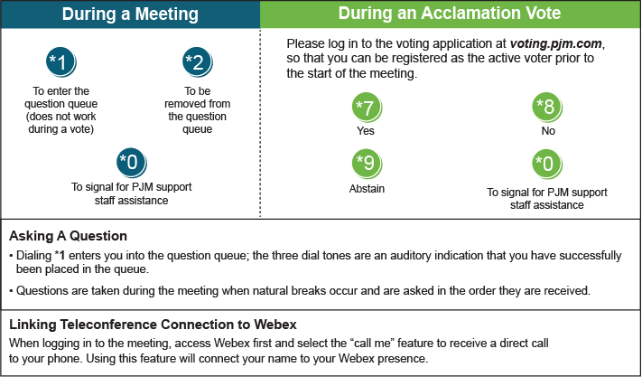

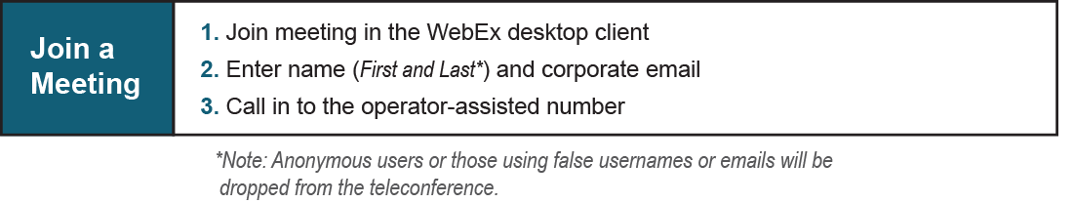

Provide feedback on the progress of this group: [*Facilitator Feedback Form*](https://www.pjm.com/committees-and-groups/committees/form-facilitator-feedback.aspx)   
Visit [*learn.pjm.com*](https://learn.pjm.com/), an easy-to-understand resource about the power industry and PJM’s role.