Markets & Reliability Committee
PJM Conference and Training Center / WebEx
July 27, 2022
9:00 a.m. – 10:35 a.m. EPT
*Operator assisted phone lines will be opened 30 minutes prior to the start of the meeting. Due to the high volume of remote participation, stakeholders are asked to connect early to allow additional time for operator queue processing.

Administration (9:00-9:05)
Welcome, announcements and Anti-trust, Code of Conduct, and Public Meetings/Media Participation – Stu Bresler and Dave Anders

Consent Agenda (9:05-9:10)
- Approve minutes of the June 29, 2022 meeting of the Markets and Reliability Committee (MRC).
- Endorse conforming changes to Manual 01: Control Center and Data Exchange Requirements, Manual 18: PJM Capacity Market, and Manual 28: Operating Agreement Accounting to support the implementation of new testing requirements which were approved in Docket No. ER19-1590 and will become effective with the 2023/20232024 Delivery Year.
Issue Tracking: Load Management Testing Requirements
- Endorse proposed revisions to Manual 14D: Generator Operational Requirements to support the process timing changes for generation deactivations.
Issue Tracking: Deactivation Analysis Period
- Endorse proposed revisions to Manual 28: Operating Agreement Accounting to support the Startup Cost Offer Development proposal the committee endorsed at the April 2022 meeting.
Issue Tracking: Start-Up Cost Offer Development

Informational Notice (9:10-9:30)
- Discussion of Anticipated Section 206 Filing Regarding Operating Agreement (OA) Language on Designated Entity Agreements and Notice of Consultation Related to a Possible Section 205 Filing (9:10-9:30)
Pauline Foley will discuss an anticipated Section 206 filing regarding OA language on Designated Entity Agreements and notice of consultation related to a possible Section 205 filing:
PJM anticipates making a filing pursuant to Section 206 of the Federal Power Act asserting that the Operating Agreement is unjust and unreasonable as it relates to the implementation of Designated Entity Agreements. The specific course of action depends in part on the resolution of the related Problem Statement/Issue Charges at the July 27, 2022 MRC. PJM does not anticipate proposing a replacement rate at the time of filing.
In accordance with Tariff, section 9.2(b) and the Consolidated Transmission Owners Agreement, section 7.5.1(ii), PJM hereby provides notice of consultation preceding a potential filing pursuant to Section 205 of the Federal Power Act to revise the pro forma Designated Entity Agreement set forth in Tariff, Attachment KK.

Endorsements (9:10-9:35)
- Application of Designated Entity Agreement (9:30-10:00)
  - Greg Poulos, CAPS on behalf of the Delaware Division of the Public Advocate and the New Jersey Division of the Rate Counsel, will review a proposed Issue Charge seeking to address the terms & conditions and the application of Designated Entity Agreement.
  - Denise Foster, EKPC on behalf of joint TO sponsors, will review a proposed Issue Charge seeking to address the terms & conditions and the application of Designated Entity Agreement.
The committee will be asked to approve a proposed Issue Charge.
Issue Tracking: Application of Designated Entity Agreement
- Market Seller Offer Cap (9:10-9:35)
Dave Anders and Pat Bruno will review proposed revisions to the Market Seller Offer Cap (MSOC) as endorsed by the Resource Adequacy Senior Task Force (RASTF). The committee will be asked to endorse the proposed Tariff revisions. Same day endorsement may be sought at the MRC and MC for the Tariff revisions.
Issue Tracking: Capacity Market Reform

First Readings (9:35-10:35)
- Variable Environmental Costs and Credits (9:35-10:00)
Melissa Pilong will review a proposed solution including corresponding Operating Agreement Schedule 2 revisions to provide detailed guidance and updates to rules related to variable environmental charges and/or credits and their inclusion in cost-based energy offers. The committee will be asked to endorse the proposal and corresponding OA revisions at its next meeting.
Issue Tracking: Variable Environmental Costs and Credits
- 2022 Quadrennial Review (10:00-10:25)
Rebecca Carroll will review a proposed solution and corresponding revisions addressing the Quadrennial Review. The committee will be asked to endorse the proposal and corresponding revisions at its next meeting. Same day endorsement may be sought at the MRC and the Special MC – Quadrennial Review meetings.
Issue Tracking: 2022 Quadrennial Review
- Manuals (10:25-10:35)
  - Emmy Messina will review proposed revisions to Manual 6: Financial Transmission Rights as part of the periodic review and ARR FTR Market Task Force-based conforming changes (Docket No. ER22-797-000). The committee will be asked to endorse the proposed Manual 6 revisions at its next meeting.

Future Agenda Items (10:35)

Future Meeting Dates and Materials |  |  |  | Materials Due  to Secretary | Materials Published
Date | Time | Location
August 24, 2022 | 9:00 a.m. |  | PJM Conference & Training Center and WebEx | August 12, 2022 | August 17, 2022
September 21, 2022 | 9:00 a.m. |  | PJM Conference & Training Center and WebEx | September 9, 2022 | September 14, 2022
October 24, 2022 | 1:00 p.m. |  | Hyatt Regency Chesapeake Bay Golf Resort, Spa and Marina in Cambridge, MD | October 12, 2022 | October 17, 2022
November 16, 2022 | 9:00 a.m. |  | PJM Conference & Training Center and WebEx | November 4, 2022 | November 9, 2022
December 21, 2022 | 9:00 a.m. |  | PJM Conference & Training Center and WebEx | December 9, 2022 | December 14, 2022

Author: M. Greening

Antitrust:
You may not discuss any topics that violate, or that might appear to violate, the antitrust laws including but not limited to agreements between or among competitors regarding prices, bid and offer practices, availability of service, product design, terms of sale, division of markets, allocation of customers or any other activity that might unreasonably restrain competition. If any of these items are discussed the chair will re-direct the conversation. If the conversation still persists, parties will be asked to leave the meeting or the meeting will be adjourned.

Code of Conduct:
As a mandatory condition of attendance at today's meeting, attendees agree to adhere to the PJM Code of Conduct as detailed in PJM Manual M-34 section 4.5, including, but not limited to, participants' responsibilities and rules regarding the dissemination of meeting discussion and materials.

Public Meetings/Media Participation:
Unless otherwise noted, PJM stakeholder meetings are open to the public and to members of the media. Members of the media are asked to announce their attendance at all PJM stakeholder meetings at the beginning of the meeting or at the point they join a meeting already in progress. Members of the Media are reminded that speakers at PJM meetings cannot be quoted without explicit permission from the speaker. PJM Members are reminded that "detailed transcriptional meeting notes" and white board notes from "brainstorming sessions" shall not be disseminated. Stakeholders are also not allowed to create audio, video or online recordings of PJM meetings. PJM may create audio, video or online recordings of stakeholder meetings for internal and training purposes, and your participation at such meetings indicates your consent to the same.
Participant Identification in Webex:
When logging into the Webex desktop client, please enter your real first and last name as well as a valid email address. Be sure to select the “call me” option.
PJM support staff continuously monitors Webex connections during stakeholder meetings. Anonymous users or those using false usernames or emails will be dropped from the teleconference.

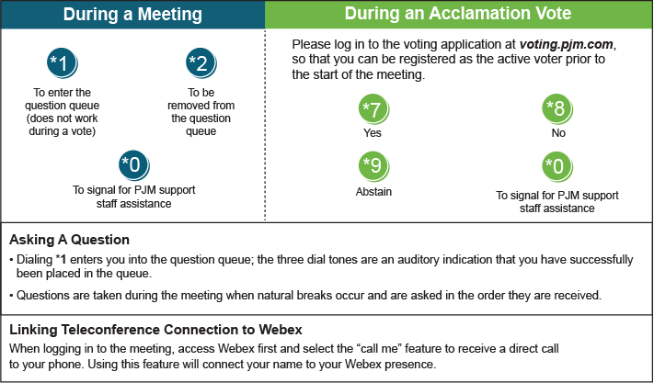

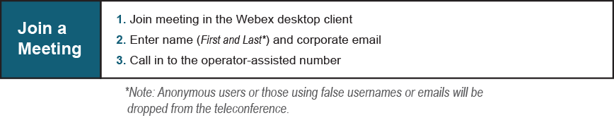
Provide feedback on the progress of this group: Facilitator Feedback Form
Visit learn.pjm.com, an easy-to-understand resource about the power industry and PJM’s role.

