Operating Committee
WebEx Only
July 15, 2021
9:00 a.m. – 2:00 p.m. EDT

Administration (9:00-9:15)
Lauren Strella Wahba, PJM, will provide announcements; review the Antitrust, Code of Conduct, Public Meetings/Media Participation, and the WebEx Participant Identification Requirement.
  - Review and approve draft minutes from the June 10th OC meeting.

  - Review of the OC work plan.

Review of Operations (9:15-9:35)
PJM COVID-19 Update
Paul McGlynn, PJM, will provide an update on PJM’s operations plan in response to COVID-19. https://pjm.com/committees-and-groups/pandemic-coordination.aspx

Review of Operating Metrics
Hong Chen, PJM, will review the June 2021 PJM operating metrics slides. Metrics will include PJM’s load forecast error, BAAL performance, and transmission / generation outage statistics.

Endorsements/Approvals (9:35 – 9:55)
- Manual 13: Emergency Operations
Brian Oakes, PJM, will review Manual 13 changes. The Operating Committee will be asked to endorse these changes at today’s meeting.

- Non-Firm Transmission Service Preemption Problem Statement and Issue Charge
Jeff McLaughlin, PJM, will review a Quick Fix Problem Statement & Issue Charge to modify language in section
14.2 of the OATT related to preemption of non-firm transmission service. The Operating Committee will be
asked to approve the issue charge and endorse the proposed solution upon first read as part of the
Quick Fix process outlined in Section 8.6.1 of Manual 34. The accelerated timeline is necessary to
ensure a timely FERC response to the associated 205 filing, and avoid stakeholder exposure to the non-
firm preemption process. The MRC and MC will also be asked to endorse the solution and OATT
revisions upon first read at the July committee meetings.

First Reading (9:55 – 10:15)
- Sunset of Non-Retail Behind the Meter Generation Business Rules Issue
Terri Esterly, PJM, will review the status of the Non-Retail Behind the Meter Generation Business Rules issue worked in the OC. The Operating Committee will be asked to approve the issue sunset at its next meeting.
https://www.pjm.com/committees-and-groups/issue-tracking/issue-tracking-details.aspx?Issue=11f0cd39-9096-45d1-becb-d01ff0b77086
- Manual 03A: Energy Management System (EMS) Model Updates and Quality Assurance
Eliseo Carrasco, PJM, will review Manual 03A changes. The Operating Committee will be asked to endorse these changes at its next meeting.

Informational Updates (10:15-2:00)
- Fuel Security Update
Patricio Rocha Garrido and Natalie Tacka, PJM, will present further details about the preliminary results of the 2021 Fuel Security analysis.
- PJM Cybersecurity Education
John Conboy, PJM, will provide an overview of how PJM prepares for and responds to cyber-attacks.
- Order to Show Cause on Real Time Values and Parameter Limited Schedules
Chen Lu and Keyur Patel, PJM, will provide an update on the recent 206 Order on Real Time Values and Parameter Limited Schedules.

LUNCH 12:00-12:30

- System Operations Subcommittee (SOS) Report
Paul Dajewski, PJM, will provide a summary of the most recent SOS meeting.

- Solar-Battery Hybrid Resources
Scott Baker, PJM, will provide an overview of a solution package developed in the DER and Inverter-based Resources Subcommittee on solar-battery hybrids resources, including a preview of items that will seek endorsement through the Operating Committee.

- Winter Operations Assessment Follow-Up: Load Shed
Paul McGlynn, PJM, will provide an update on Load Shed efforts that are part of PJM’s Winter Operations Assessment.

- NERC Project 2019-06 Cold Weather Update
Chris Pilong, PJM, will provide and review of the proposed Standards revisions as well as the potential impacts these may have to PJM and generation owners

- 2021 Generator Cold Weather Operating Limitations Survey Update
Dan Bennett, PJM, will provide a status update on the 2021 Generator Cold Weather Operating Limitations Survey in eDART.

- Reliability Compliance Update
Becky Davis, PJM, will provide an update on NERC, SERC and RFC standards, and other pertinent regulatory and compliance information, and solicit feedback from the members on Reliability Compliance efforts.

Working Items

Informational Only Postings

OC Subcommittee/ Task Force Informational Section
System Operations Subcommittee (SOS): SOS Website
Data Management Subcommittee (DMS): DMS Website
DER & Inverter-Based Resources Subcommittee (DIRS): DIRS Website
Fuel Requirements for Black Start Resources: Fuel Reqt. for Black Start Resources Issue Tracker
Synchronous Reserve Deployment Task Force: SRDTF Website
IROL – CIP Cost Recovery: IROL – CIP Cost Recovery Issue Tracker

Future Meeting Dates and Materials |  |  | Materials Due  to Secretary | Materials Published
Date | Time | Location | 5 p.m. | 4 p.m.
August 12, 2021 | 9 a.m. | WebEx | August 2, 2021 | August 5, 2021
September 10, 2021 | 9 a.m. | WebEx | August 31, 2021 | September 3, 2021
October 07, 2021 | 9 a.m. | WebEx | September 27, 2021 | September 30, 2021
November 04, 2021 | 9 a.m. | WebEx | October 25, 2021 | October 28, 2021
December 02, 2021 | 9 a.m. | WebEx | November 22, 2021 | November 24, 2021

Author: L. Strella Wahba

Antitrust:
You may not discuss any topics that violate, or that might appear to violate, the antitrust laws including but not limited to agreements between or among competitors regarding prices, bid and offer practices, availability of service, product design, terms of sale, division of markets, allocation of customers or any other activity that might unreasonably restrain competition. If any of these items are discussed the chair will re-direct the conversation. If the conversation still persists, parties will be asked to leave the meeting or the meeting will be adjourned.

Code of Conduct:
As a mandatory condition of attendance at today's meeting, attendees agree to adhere to the PJM Code of Conduct as detailed in PJM Manual M-34 section 4.5, including, but not limited to, participants' responsibilities and rules regarding the dissemination of meeting discussion and materials.

Public Meetings/Media Participation:
Unless otherwise noted, PJM stakeholder meetings are open to the public and to members of the media. Members of the media are asked to announce their attendance at all PJM stakeholder meetings at the beginning of the meeting or at the point they join a meeting already in progress. Members of the Media are reminded that speakers at PJM meetings cannot be quoted without explicit permission from the speaker. PJM Members are reminded that "detailed transcriptional meeting notes" and white board notes from "brainstorming sessions" shall not be disseminated. Stakeholders are also not allowed to create audio, video or online recordings of PJM meetings. PJM may create audio, video or online recordings of stakeholder meetings for internal and training purposes, and your participation at such meetings indicates your consent to the same.
Participant Identification in WebEx:
When logging into the WebEx desktop client, please enter your real first and last name as well as a valid email address. Be sure to select the “call me” option.
PJM support staff continuously monitors WebEx connections during stakeholder meetings. Anonymous users or those using false usernames or emails will be dropped from the teleconference.

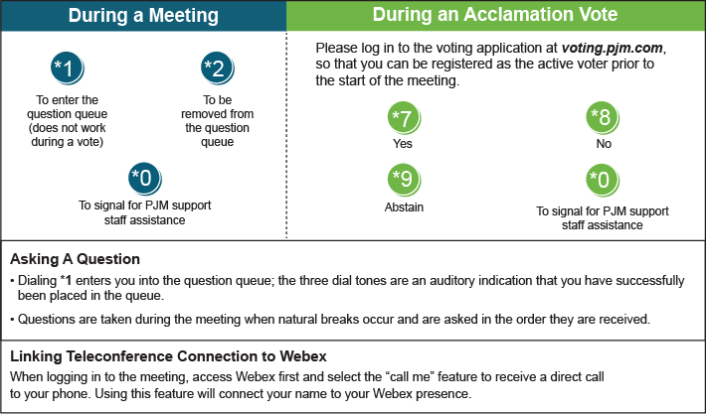

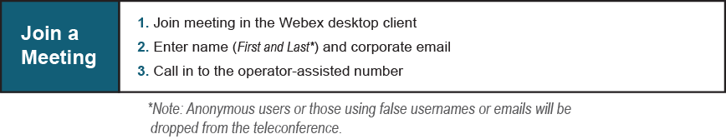
Provide feedback on the progress of this group: Facilitator Feedback Form
Visit learn.pjm.com, an easy-to-understand resource about the power industry and PJM’s role.

