Operating Committee
PJM Conference & Training Center, Audubon, PA
June 9, 2022
9:00 a.m. – 2:00 p.m. EDT

*Operator assisted phone lines will be opened 30 minutes prior to the start of the meeting. Due to the high volume of remote participation, stakeholders are asked to connect early to allow additional time for operator queue processing.

Administration (9:00-9:20)
Jeff McLaughlin, PJM, will provide announcements; review the Antitrust, Code of Conduct, Public Meetings/Media Participation, and the WebEx Participant Identification Requirement.
  - Review and approve draft minutes from the May 12th OC meeting.

  - Review of the OC work plan.

  - Amanda Egan, PJM will review an upcoming change to PJM’s Voting Application which will go-live on June 15th.

Review of Operations (9:20-9:40)
Review of Operating Metrics
Stephanie Schwarz, PJM, will review the May 2022 PJM operating metrics slides. Metrics will include PJM’s load forecast error, BAAL performance, and transmission / generation outage statistics.

- Security Update
Steve McElwee, PJM, will provide a security briefing.

Endorsements/Approvals (9:40-9:45)
- Manual 01: Control Center and Data Exchange Requirements
Jack O’Neill, PJM, will review conforming changes to Manual 01: Control Center and Data Exchange Requirements as a part of the Load Management Testing Requirements Issue Charge and Problem Statement.
The Operating Committee will be asked to endorse these changes at today’s meeting.
Load Management Testing Requirements

First Reading (9:45 -10:45)
- Internal NITS Process
Susan McGill, PJM, will review a proposed Issue Charge and Problem Statement that will clarify and enhance the processes related to internal Network Integration Transmission Service (NITS).
The Operating Committee will be asked to approve the Issue Charge at its next meeting.

- Max Emergency Changes for Resource Limitation Reporting
- Chris Pilong, PJM, will present a first read of Package A addressing the Max Emergency Changes for Resource Limitation Reporting matrix as a part of the Consensus Based Issue Resolution Lite process.
- A representative from Monitoring Analytics will present a first read of Package B addressing the Max Emergency Changes for Resource Limitation Reporting matrix as a part of the Consensus Based Issue Resolution Lite process.
The Operating Committee will be asked to endorse these proposals at its next meeting.
Issue Tracking: Max Emergency Changes for Resource Limitation Reporting

6A. Manual 14D: Generator Operational Requirements
Dave Egan, PJM, will review changes to Manual 14D: Generator Operational Requirements as a part of the Deactivation Analysis Period quick fix process.
The Operating Committee will be asked to endorse these changes at its next meeting.
Deactivation Analysis Period

Additional Items (10:45-12:15)
- Upcoming Filing Related to EPA Proposed Rule
Gary Helm, PJM, will provide stakeholders with an update about PJM’s intent to file comments in response to the Environmental Protection Agency’s proposed rule on the Federal Implementation Plan Addressing Regional Ozone Transport for the 2015 Ozone National Ambient Air Quality Standard regarding emission of nitrogen oxides from generating units. (Docket EPA-HQ-OAR-2021-0668)

- Managing Transmission Line Ratings Order No. 881 Compliance Filing (RM20-16-000) Update
David Hislop, PJM, and Bilge Derin, PJM, will provide an informational update regarding PJM’s FERC Order No. 881 compliance efforts relating to ambient adjusted ratings. Although subject to continued discussion and revision, PJM has also posted a draft of the proposed Tariff language that will be filed as part of PJM’s July 12, 2022 Order No. 881 compliance filing. PJM intends to devote the OC Special Session immediately following today’s Operating Committee meeting to discuss the draft Tariff language. PJM continues to provide updates and solicit stakeholder input at Operating Committee meetings as it prepares its compliance filing.
Order 881

- PPL Dynamic Line Rating Implementation Update
Dave Hislop, PJM, will provide an update on the implementation of the PPL Dynamic Line Rating.

- Synchronous Reserve Event Actions and Expectations Update
Ilyana Dropkin, PJM, will provide an update on the SRDTF activities.
SRDTF Website

- Regulation Performance Update
Ilyana Dropkin, PJM, will provide an update on PJM regulation market performance.

- Primary Frequency Response Update
Ross Kelly, PJM, will provide an update on PJM primary frequency response performance.

- Synchronous Reserve Update
Dave Kimmel, PJM, will provide a review of recent synchronous reserve performance.

- Reliability Compliance Update
Becky Davis, PJM, will provide an update on NERC, SERC, RF, and NAESB standards, and other pertinent regulatory and compliance information, and solicit feedback from the members on Reliability Compliance efforts.

- Outage Coordination
Paul McGlynn, PJM, will provide an update on the approach and timeline for working the outage coordination Issue Charge approved at the May OC meeting.

Working Items (12:15-2:00)
Lunch (12:15 – 12:45)
- Renewable Dispatch
Janell Fabiano, PJM, will facilitate a discussion to identify solution options and review solution packages on the Renewable Dispatch matrix as part of the Consensus Based Issue Resolution process.
Issue Tracking: Renewable Dispatch

Informational Only Postings
- System Operations Subcommittee (SOS)
Donnie Bielak, PJM, will provide a summary of the most recent SOS meeting.

OC Subcommittee/ Task Force Informational Section
System Operations Subcommittee (SOS): SOS Website
Data Management Subcommittee (DMS): DMS Website
DER & Inverter-Based Resources Subcommittee (DIRS): DIRS Website
Fuel Requirements for Black Start Resources: Fuel Reqt. for Black Start Resources Issue Tracker
Synchronous Reserve Deployment Task Force: SRDTF Website
IROL – CIP Cost Recovery: IROL – CIP Cost Recovery Issue Tracker

Future Meeting Dates and Materials |  |  | Materials Due  to Secretary | Materials Published
Date | Time | Location | 5 p.m. | 4 p.m.
July 14, 2022 | 9 a.m. | PJM Conference & Training Center and WebEx | July 1, 2022 | July 7, 2022
August 11, 2022 | 9 a.m. | PJM Conference & Training Center and WebEx | August 1, 2022 | August 4, 2022
September 8, 2022 | 9 a.m. | PJM Conference & Training Center and WebEx | August 29, 2022 | September 1, 2022
October 7, 2022 | 9 a.m. | PJM Conference & Training Center and WebEx | September 27, 2022 | September 30, 2022
November 3, 2022 | 9 a.m. | PJM Conference & Training Center and WebEx | October 24, 2022 | October 27, 2022
December 8, 2022 | 9 a.m. | PJM Conference & Training Center and WebEx | November 28, 2022 | December 1, 2022

Author: Jeffrey McLaughlin

Antitrust:
You may not discuss any topics that violate, or that might appear to violate, the antitrust laws including but not limited to agreements between or among competitors regarding prices, bid and offer practices, availability of service, product design, terms of sale, division of markets, allocation of customers or any other activity that might unreasonably restrain competition. If any of these items are discussed the chair will re-direct the conversation. If the conversation still persists, parties will be asked to leave the meeting or the meeting will be adjourned.

Code of Conduct:
As a mandatory condition of attendance at today's meeting, attendees agree to adhere to the PJM Code of Conduct as detailed in PJM Manual M-34 section 4.5, including, but not limited to, participants' responsibilities and rules regarding the dissemination of meeting discussion and materials.
Public Meetings/Media Participation:
Unless otherwise noted, PJM stakeholder meetings are open to the public and to members of the media. Members of the media are asked to announce their attendance at all PJM stakeholder meetings at the beginning of the meeting or at the point they join a meeting already in progress. Members of the Media are reminded that speakers at PJM meetings cannot be quoted without explicit permission from the speaker. PJM Members are reminded that "detailed transcriptional meeting notes" and white board notes from "brainstorming sessions" shall not be disseminated. Stakeholders are also not allowed to create audio, video or online recordings of PJM meetings. PJM may create audio, video or online recordings of stakeholder meetings for internal and training purposes, and your participation at such meetings indicates your consent to the same.
Participant Identification in WebEx:
When logging into the WebEx desktop client, please enter your real first and last name as well as a valid email address. Be sure to select the “call me” option.
PJM support staff continuously monitors WebEx connections during stakeholder meetings. Anonymous users or those using false usernames or emails will be dropped from the teleconference.

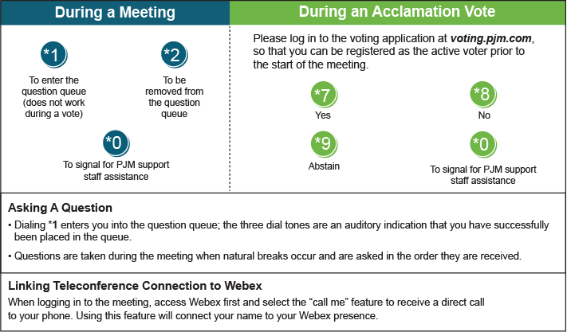

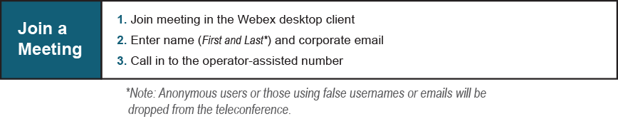

Provide feedback on the progress of this group: Facilitator Feedback Form
Visit learn.pjm.com, an easy-to-understand resource about the power industry and PJM’s role.

