Planning Committee
PJM Conference and Training Center
November 14, 2019
9:00 a.m. – 12:00 p.m. EPT

Administration (9:00-9:15)
- Welcome, announcements and review of the Anti-trust, Code of Conduct, and Media Participation Guidelines.
- Approve Planning Committee (PC) Agenda for this meeting
- Approve draft minutes from the October 17th, 2019 PC meeting
- Review of PC Charter

Endorsements (9:15-10:30)
- Critical Infrastructure Stakeholder Problem Statement and Issue Charge
Mr. Erik Heinle, Office of the Peoples Counsel for the District of Columbia, and Greg Poulus, CAPS, will present a Problem Statement and Issue Charge related to Critcal Infrastructure Stakeholder Oversight. The Committee will be requested to endorse the Issue Charge at today’s meeting.
- Relay Subcommittee Charter Revisions
Mr. Mark Kuras, PJM, will present modifications to the Relay Subcommittee Charter related to the addition of data gathering requirement for compliance with TPL-001-4 category P5. The Committee will be requested to endorse the proposed revisions at today’s meeting.
- Competitive Transmission Proposal Fee Restructuring Update
Mr. Mark Sims, PJM, will present as a second read of the revised competitive transmission proposal fee and associated revisions to the Operating Agreement language. The Committee will be requested to endorse the Operating Agreement language at today’s meeting.
- Manual 14F Revisions
Mr. Mark Sims, PJM, will present revisions to PJM Manual 14F Competitive Planning Process related to the cost committment process. The Committee will be requested to endorse these revisions at today’s meeting.
Issue Tracking: Cost Committment
- Manual 19 Revisions
Mr. John Reynolds, PJM, will present revisions to PJM Manual 19 related to a periodic review and forecast documentation. The Committee will be requested to endorse these revisions at today’s meeting.

First Reads (10:30-11:00)
- Manual 14G Revisions Update
Mr. Bernie O’Hara, PJM, will present a first read to Manual 14G, Section 2.2 updates regarding projects applying for interconnection under Attachment Y.
- Sunset the DER Ride-Through Task Force
Mr. Jonathan Thompson, PJM, will review work completed at the DER Ride-Through Task Force. The committee will be asked to endorse sun-setting the DER Ride-Through Task Force at its next meeting.

Informational Updates (11:00-12:00)
- Member Maintenance and Account Manager Update
Ms. Amanda Egan, PJM, will provide an update on the Membership Management Community, as well as provide information on Account Manager (CAM) roles, responsibilities and requirements.
- Secure File Transfer Tool Update
Mr. Larry Farmer, PJM, will provide an update on the secure file transfer tool which will be employed by PJM in the future.
- Capacity Interconnection Rights Education
Ms. Brinda Malladi, PJM, will provide education on the Capacity Interconnection Rights process.
- Effective Load Carrying Capability (ELCC) Education
Mr. Patricio Rocha Garrido, PJM, will review the ELCC-based method to determine the UCAP value of wind and solar resources and discuss potential steps going forward.
- Market Efficiency Process Enhancement Task Force Update
Mr. Fran Barrett, PJM, will provide an update on the MEPETF.

- PJM Interconnection Queue Status Update
Ms. Onyinye Caven, PJM, will provide an update on the status of PJM Interconnection Queues.

- Reliability Compliance Update
Mr. Preston Walker, PJM, will provide an update on the activities, issues and items of interest at NERC, SERC, and RF.
- Model Build Activity Update
Mr. Peter Lamaina, PJM, will provide an update regarding current model build activities, including the 2020 series RTEP cases.

Informational Posting
2019 Summer Loads
PJM posted a Summer 2019 paper reviewing loads, weather, and other market conditions. The link to the paper is below:
https://pjm.com/-/media/committees-groups/committees/oc/20191015/20191015-item-18-2019-summer-operations-paper.ashx

Future Meeting Dates
Thursday, December 12, 2019 | 9:00 a.m. – 12:00 p.m. |  | Planning Committee | PJM Conference & Training Center/ WebEx
Tuesday, January 07, 2020 | 9:00 a.m. – 12:00 p.m. |  | Planning Committee | PJM Conference & Training Center/ WebEx
Tuesday, February 04, 2020 | 9:00 a.m. – 12:00 p.m. |  | Planning Committee | PJM Conference & Training Center/ WebEx
Tuesday, March 10, 2020 | 9:00 a.m. – 12:00 p.m. |  | Planning Committee | PJM Conference & Training Center/ WebEx
Tuesday, April 14, 2020 | 9:00 a.m. – 12:00 p.m. |  | Planning Committee | PJM Conference & Training Center/ WebEx
Tuesday, May 12, 2020 | 9:00 a.m. – 12:00 p.m. |  | Planning Committee | PJM Conference & Training Center/ WebEx
Tuesday, June 02, 2020 | 9:00 a.m. – 12:00 p.m. |  | Planning Committee | PJM Conference & Training Center/ WebEx
Tuesday, July 07, 2020 | 9:00 a.m. – 12:00 p.m. |  | Planning Committee | PJM Conference & Training Center/ WebEx
Tuesday, August 04, 2020 | 9:00 a.m. – 12:00 p.m. |  | Planning Committee | PJM Conference & Training Center/ WebEx
Tuesday, September 01, 2020 | 9:00 a.m. – 12:00 p.m. |  | Planning Committee | PJM Conference & Training Center/ WebEx
Tuesday, October 06, 2020 | 9:00 a.m. – 12:00 p.m. |  | Planning Committee | PJM Conference & Training Center/ WebEx
Wednesday, November 04, 2020 | 9:00 a.m. – 12:00 p.m. |  | Planning Committee | PJM Conference & Training Center/ WebEx
Tuesday, December 01, 2020 | 9:00 a.m. – 12:00 p.m. |  | Planning Committee | PJM Conference & Training Center/ WebEx
Author: Molly Mooney

Antitrust:
You may not discuss any topics that violate, or that might appear to violate, the antitrust laws including but not limited to agreements between or among competitors regarding prices, bid and offer practices, availability of service, product design, terms of sale, division of markets, allocation of customers or any other activity that might unreasonably restrain competition. If any of these items are discussed the chair will re-direct the conversation. If the conversation still persists, parties will be asked to leave the meeting or the meeting will be adjourned.

Code of Conduct:
As a mandatory condition of attendance at today's meeting, attendees agree to adhere to the PJM Code of Conduct as detailed in PJM Manual M-34 section 4.5, including, but not limited to, participants' responsibilities and rules regarding the dissemination of meeting discussion and materials.

Public Meetings/Media Participation:
Unless otherwise noted, PJM stakeholder meetings are open to the public and to members of the media. Members of the media are asked to announce their attendance at all PJM stakeholder meetings at the beginning of the meeting or at the point they join a meeting already in progress. Members of the Media are reminded that speakers at PJM meetings cannot be quoted without explicit permission from the speaker. PJM Members are reminded that "detailed transcriptional meeting notes" and white board notes from "brainstorming sessions" shall not be disseminated. Stakeholders are also not allowed to create audio, video or online recordings of PJM meetings. PJM may create audio, video or online recordings of stakeholder meetings for internal and training purposes, and your participation at such meetings indicates your consent to the same.
Participant Identification in WebEx:
When logging into the WebEx desktop client, please enter your real first and last name as well as a valid email address. Be sure to select the “call me” option.
PJM support staff continuously monitors WebEx connections during stakeholder meetings. Anonymous users or those using false usernames or emails will be dropped from the teleconference.

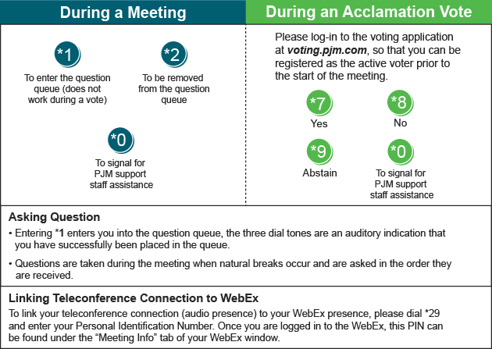

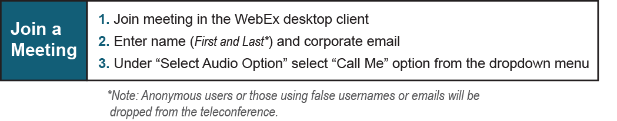

Provide feedback on the progress of this group: Facilitator Feedback Form
Visit learn.pjm.com, an easy-to-understand resource about the power industry and PJM’s role.

