Members Committee Webinar
PJM Conference and Training Center
October 26, 2020
1:00 p.m. – 4:00 p.m. EPT

Administration (1:00-1:05)
Welcome, announcements and Anti-trust and Code of Conduct announcement – Janell Fabiano

Informational Updates (1:05-1:55)
1. Schedule 9 Stated Rates Review (1:05 – 1:25)
Jim Snow will provide a review of Schedule 9 Stated Rates.
2. FERC Order 2222 Overview (1:25 – 1:45)
Thomas DeVita will provide an overview of FERC Order 2222

3. Interregional Coordination (1:45 – 1:55)
Joseph Ciabattoni will provide an update on interregional coordination activities

Upcoming Stakeholder Process Items (1:55 – 2:15)
4. Stakeholder Process Forum (1:55 – 2:05)
Michele Greening will review key topics and outcomes from today’s Stakeholder Process Forum
5. Stakeholder Process Survey Progress Update (2:05 – 2:15)
Michelle Souder will provide an update on activities in response to the 2019 Stakeholder Survey.

Reports (2:15-3:30)
6. State Activities (2:15-2:20)
Receive report on recent activities of the Organization of PJM States, Inc. – Gregory Carmean
7. Market Monitoring Report (2:20-2:30)
Receive report of the Independent Market Monitor – Joe Bowring

8. PJM Updates (2:30 – 3:00)
- Receive report on market operations – Jennifer Freeman
- Receive report on system operations – Hong Chen
- Receive report on recent regulatory activities – Mark Stanisz

9. Standing Committee Reports (3:00 - 3:25)
A. Markets and Reliability Committee (MRC) – Dave Anders
- Market Implementation Committee (MIC) – Nick Disciullo
- Operating Committee (OC) – Danielle Croop
- Planning Committee (PC) – Molly Mooney

10. Open Issue Reports
No verbal updates planned for this month.

11. Open Issue Reports – Informational
Item | Issue | Committee | Contact
A. | Behind the Meter Generation (covered in MIC report) | MIC | Terri Esterly
B. | Five Minute Dispatch and Pricing | MIC | Alex Scheirer
C. | Fuel Cost Policy  (covered in MIC report) | MIC | Bhavana Keshavamurthy/ Diane Antonelli
D. | PRD Credits Disposition  (covered in MIC report) | MIC | Nick Disciullo
E. | Real Time Market Values  (covered in MIC report) | MIC | Brian Chmielewski/ Kevin Hatch
F. | Rules Related to Market Suspension (covered in MIC report) | MIC | Stefan Starkov
G. | Stability Limits in Markets and Operations (no update) | MIC | Nick Disciullo
H. | Transparency in PAI Settlements | MIC | Nick Disciullo
I. | Black Start Unit Involuntary Termination & Substitution Rules | OC | Becky Davis
J. | Critical Infrastructure Stakeholder Oversight | PC | Christina Stotesbury/ Joe Hay
K. | Storage as a Transmission Asset | PC | Michele Greening/ Amanda Long
L. | ARR/FTR Market Review | AFMTF (hiatus) | Dave Anders/ Emmy Messina
M. | Effective Load Carrying Capability (ELCC) for Limited Duration Resources and Intermittent Resources | CCSTF | Melissa Pilong/ Jaclyn Lukach
N. | Carbon Pricing | CPSTF | Suzanne Coyne
O. | Distributed Energy Resources in PJM Markets | DIRS | Scott Baker/ Hamad Ahmed
P. | Solar-Battery Hybrid Resources | DIRS | Scott Baker/ Hamad Ahmed
Q. | Financial Risk Mitigation | FRMSTF | Anita Patel/ Michele Greening
R. | Integration of HVDC Converter as a New Type of Capacity Resource | HVDCSTF | Vijay Shah / Lisa Krizenoskas

Future Agenda Items ( 3:25 – 3:30)

Future Meeting Dates
November 16, 2020/  December 14, 2020 | 1:00 p.m.  1:00 p.m. | WebEx/ Teleconference  WebEx/ Teleconference
Author: Janell L Fabiano

Antitrust:
You may not discuss any topics that violate, or that might appear to violate, the antitrust laws including but not limited to agreements between or among competitors regarding prices, bid and offer practices, availability of service, product design, terms of sale, division of markets, allocation of customers or any other activity that might unreasonably restrain competition. If any of these items are discussed the chair will re-direct the conversation. If the conversation still persists, parties will be asked to leave the meeting or the meeting will be adjourned.

Code of Conduct:
As a mandatory condition of attendance at today's meeting, attendees agree to adhere to the PJM Code of Conduct as detailed in PJM Manual M-34 section 4.5, including, but not limited to, participants' responsibilities and rules regarding the dissemination of meeting discussion and materials.
Public Meetings/Media Participation:
Unless otherwise noted, PJM stakeholder meetings are open to the public and to members of the media. Members of the media are asked to announce their attendance at all PJM stakeholder meetings at the beginning of the meeting or at the point they join a meeting already in progress. Members of the Media are reminded that speakers at PJM meetings cannot be quoted without explicit permission from the speaker. PJM Members are reminded that "detailed transcriptional meeting notes" and white board notes from "brainstorming sessions" shall not be disseminated. Stakeholders are also not allowed to create audio, video or online recordings of PJM meetings. PJM may create audio, video or online recordings of stakeholder meetings for internal and training purposes, and your participation at such meetings indicates your consent to the same.
Participant Identification in WebEx:
When logging into the WebEx desktop client, please enter your real first and last name as well as a valid email address. Be sure to select the “call me” option.
PJM support staff continuously monitors WebEx connections during stakeholder meetings. Anonymous users or those using false usernames or emails will be dropped from the teleconference.



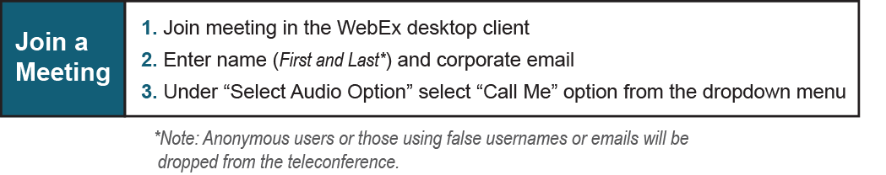
Provide feedback on the progress of this group: Facilitator Feedback Form
Visit learn.pjm.com, an easy-to-understand resource about the power industry and PJM’s role.

