Market Implementation Committee
PJM Conference & Training Center, Audubon, PA
April 10, 2019
9:00 a.m. – 3:00 p.m. EPT

Administration (9:00-10:30)
Ms. Bhavana Keshavamurthy and Ms. Chantal Hendrzak will provide announcements; review the Antitrust, Code of Conduct, Public Meetings/Media Participation, the WebEx Participant Identification Requirement, and Issue Tracking.

The Committee will be asked to approve the draft minutes from the March 6, 2019 MIC meeting.

- Mr. Andy Ott, PJM, will discuss PJM’s path forward for the 2022/2023 Base Residual Auction.
- Next steps to address recommendations from the report of the independent consultants on the GreenHat default
- Mr. Ott will discuss the next steps and timeline for engaging stakeholders to determine necessary market rule, credit requirement, stakeholder process, and membership qualification changes to ensure the concerns that gave rise to the GreenHat default are addressed.
- Mr. Dave Anders, PJM, will review the details of the initiated stakeholder process.
- Mr. Adam Keech, PJM, will provide an overview of the Energy Price Formation simulation results.

Endorsements/Approvals (10:30-11:15)
- FTR Forfeiture Hourly Component (10:30-10:45)
Mr. Brian Chmielewski, PJM, will present on an issue identified in the FTR Forfeiture hourly cost component calculations. The proposed solution includes revisions to the Operating Agreement language update and Manual 6.
The committee will be asked to endorse these revisions.
Issue Tracking: FTR Forfeiture Rule Changes

- Incremental Auction Revenue Rights Coordination (IARR) with MISO - Problem Statement & Issue Charge (10:45-11:00)
Mr. Brian Chmielewski, PJM, will present a problem statement and issue charge to address an issue identified in IARR coordination with MISO.
The committee will be asked to approve the problem statement and issue charge.

- PJM Transmission Service Business Practices Update (11:00-11:15)
Mr. Jeff McLaughlin, PJM, will present revisions to the PJM Regional Business Practices document associated with the new OASIS application.
The committee will be asked to endorse the changes.

First Readings (11:15-1:20)
- Manual 11, 13 and 28 revisions for Gas Contingencies in Reserves (11:15-11:45)
Ms.Natalie Tacka, PJM, will provide a first read of revisions to Manual 11, 13 and 28 to clarify the impact of operationalizing gas contingencies on reserve requirements and reserve market eligibility. The committee will be asked to endorse the manual revisions at the May MIC meeting.
- Cover to Cover Review of Manual 6 (11:45-12:00)
Ms.Emmy Messina, PJM, will provide a first read on updates to Manual 6 as part of the cover to cover review.

Lunch (12:00-1:00)

- RT SCED Dispatch and Pricing ( 1:00-1:20)
A representative from Monitoring Analytics will present a first read on a problem statement related to RT SCED dispatch and pricing.

Working Issues (1:20-1:40)
- Electric Storage Participation - FERC Order 841 (1:20-1:40)
Ms. Gabby Genuario, PJM, will present education to clarify the different components in cost-based offer for energy storage resources.
Issue Tracking: Electric Storage Participation FERC Order 841

Additional Items (1:40-3:00)
- NYISO/PJM JOA Language Updates (1:40-2:00)
Ms. Nikki Militello, PJM, will provide an update on the NYISO/PJM JOA.

- Fuel Cost Policy Annual Review (2:00-2:15)
Ms.Melissa Pilong, PJM, will provide an overview of the Fuel Cost Policy deadlines for the upcoming annual reveiw.

- Fixed Resource Requirement (“FRR”) Alternative (2:15-2:40)
Mr. Jeff Bastian, PJM, will provide an overview of the requirements and provisions of the FRR Alternative.

- Combined Cycle Start Up Cost Calculation (2:40-3:00)
Mr. Tom Hauske, PJM, will provide an overview of the Combined Cycle start up cost calculation.

Informational Section
Credit Subcommittee (CS)
Meeting materials will be posted to the CS website.

Demand Response Subcommittee (DRS)
Meeting materials will be posted to the DRS web site.

Intermittent Resources Subcommittee (IRS)
Meeting materials will be posted to the IRS web site.

Interregional Coordination Update
Materials are posted as informational only.

Market Settlements Subcommittee (MSS)
Meeting materials are posted to the MSS web site.

Report on Market Operations
The Report on Market Operations will be reviewed during the MC Webinar.

M03 Updates
Materials are posted as informational only.

Future Meeting Dates
May 15, 2019 | 9:00 a.m. | PJM Conference & Training Center/ WebEx
June 12, 2019 | 9:00 a.m. | PJM Conference & Training Center/ WebEx
July 10, 2019 | 9:00 a.m. | PJM Conference & Training Center/ WebEx
August 7, 2019 | 9:00 a.m. | PJM Conference & Training Center/ WebEx
September 11, 2019 | 9:00 a.m. | PJM Conference & Training Center/ WebEx
October 16, 2019 | 9:00 a.m. | PJM Conference & Training Center/ WebEx
November 13, 2019 | 9:00 a.m. | PJM Conference & Training Center/ WebEx
December 11, 2019 | 9:00 a.m. | PJM Conference & Training Center/ WebEx

Author: Bhavana Keshavamurthy

Antitrust:
You may not discuss any topics that violate, or that might appear to violate, the antitrust laws including but not limited to agreements between or among competitors regarding prices, bid and offer practices, availability of service, product design, terms of sale, division of markets, allocation of customers or any other activity that might unreasonably restrain competition. If any of these items are discussed the chair will re-direct the conversation. If the conversation still persists, parties will be asked to leave the meeting or the meeting will be adjourned.

Code of Conduct:
As a mandatory condition of attendance at today's meeting, attendees agree to adhere to the PJM Code of Conduct as detailed in PJM Manual M-34 section 4.5, including, but not limited to, participants' responsibilities and rules regarding the dissemination of meeting discussion and materials.

Public Meetings/Media Participation:
Unless otherwise noted, PJM stakeholder meetings are open to the public and to members of the media. Members of the media are asked to announce their attendance at all PJM stakeholder meetings at the beginning of the meeting or at the point they join a meeting already in progress. Members of the Media are reminded that speakers at PJM meetings cannot be quoted without explicit permission from the speaker. PJM Members are reminded that "detailed transcriptional meeting notes" and white board notes from "brainstorming sessions" shall not be disseminated. Stakeholders are also not allowed to create audio, video or online recordings of PJM meetings. PJM may create audio, video or online recordings of stakeholder meetings for internal and training purposes, and your participation at such meetings indicates your consent to the same.

Participant Identification in WebEx:
When logging into the WebEx desktop client, please enter your real first and last name as well as a valid email address. Be sure to select the “call me” option.
PJM support staff continuously monitors WebEx connections during stakeholder meetings. Anonymous users or those using false usernames or emails will be dropped from the teleconference.

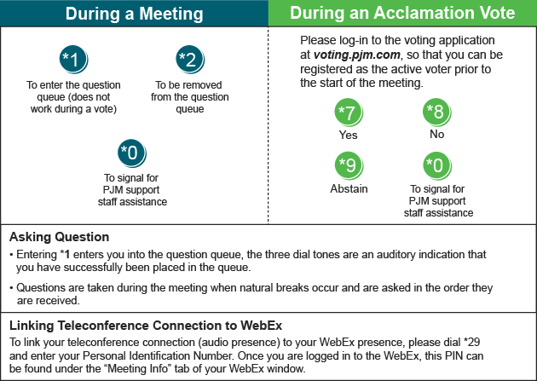

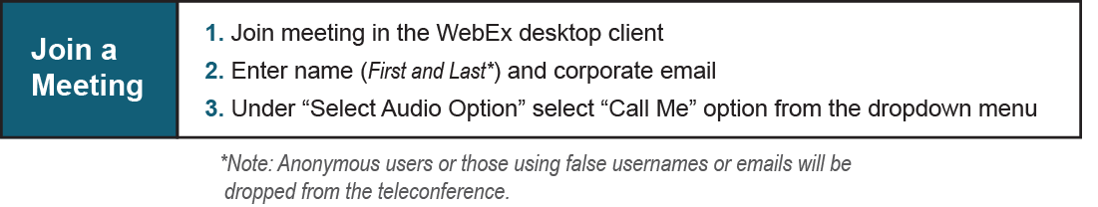

Provide feedback on the progress of this group: Facilitator Feedback Form
Visit learn.pjm.com, an easy-to-understand resource about the power industry and PJM’s role.

