Markets and Reliability Committee
Webex Only
July 23, 2020
9:00 a.m. – 11:35 a.m.
*Operator assisted phone lines will be opened 30 minutes prior to the start of the meeting. Due to the high volume of remote participation, stakeholders are asked to connect early to allow additional time for operator queue processing.

Administration (9:00-9:05)
Welcome, announcements and Anti-trust, Code of Conduct, and Public Meetings/Media Participation – Stu Bresler and Dave Anders

Consent Agenda (9:05-9:10)
- Approve minutes of the June 18, 2020 meeting of the Markets and Reliability Committee (MRC).
- Endorse administrative updates to Manual 6: Financial Transmission Rights resulting from the Manual’s periodic review.
- Endorse Tariff clean-up revisions related to PJM’s recent market participation risk evaluation enhancements filing.

Endorsements/Approvals (9:10-9:40)
- Five Minute Dispatch and Pricing (9:10-9:40)
Tim Horger and Vijay Shah will provide an update regarding Five Minute Dispatch and Pricing and will review a proposed solution addressing the short-term. The committee will be asked to endorse the proposed solution and corresponding language revisions. Members Committee endorsement/approval will be sought on the same day.
Issue Tracking: Five Minute Dispatch and Pricing

First Readings (9:40-11:35)
- DIMA Operating Agreement Revisions (9:40-10:00)
Ed Kovler will review proposed OA language revisions to support improving situational awareness with the Dispatch Interactive Map Application (DIMA). The committee will be asked to endorse the proposed revisions at its next meeting.
Issue Tracking: Improving Situational Awareness with the Dispatch Interactive Map Application (DIMA)
- Market Efficiency Process Enhancement Task Force (10:00-10:40)
Jack Thomas will provide an update of the Phase 3 work completed at the Market Efficiency Process Enhancement Task Force (MEPETF) and present proposed solution packages. Nick Dumitriu will present the proposed OA language changes. The committee will be asked to endorse a proposed solution and corresponding OA language revisions as its next meeting.
Issue Tracking: RTEP Market Efficiency Analysis
- Risk Management Committee Charter (10:40-10:55)
Dan Sarti will provide an update regarding potential revisions to the Credit Subcommittee Charter including an expansion to incorporate risk and a proposed change in parent reporting structure. The resulting charter is being renamed Risk Management Committee Charter. The committee will be asked to endorse the revised charter at its next meeting.

- Critical Infrastructure Stakeholder Oversight Senior Task Force (10:55-11:25)
Greg Poulos and Erik Heinle will present a first read to revoke the related Issue Charge being worked at the Special PC Sessions. They will also seek first read of a Problem Statement and replacement Issue Charge at this meeting. The committee will be asked to endorse the revocation and the replacement Issue Charge at its next meeting.
Issue Tracking: Critical Infrastructure Stakeholder Oversight

- PJM Manuals (11:25-11:35)
  - Onyinye Caven will review proposed revisions to Manuals 14A, 14B and 14G related to FERC’s Order on PJM’s Order 845 Second Compliance Filing. The committee will be asked to endorse the revisions at its next meeting.

Informational Reports
None

Informational Only
- Manual 39 Changes
A revision to Manual 39: “Nuclear Plant Interface Coordination” was posted effective 06/22/2020. This revision includes only changes to the Attachment C: “Plant Specific NPIRs Revision History” reflecting recent plant specific nuclear plant interface requirement (NPIR) changes.

Future Agenda Items (11:35)

Future Meeting Dates
August 20, 2020 | 9:00 a.m. | PJM Conference & Training Center/ WebEx
September 17, 2020 | 9:00 a.m. | PJM Conference & Training Center/ WebEx
October 29, 2020 | 9:00 a.m. | PJM Conference & Training Center/ WebEx
November 19, 2020 | 9:00 a.m. | PJM Conference & Training Center/ WebEx
December 17, 2020 | 9:00 a.m. | PJM Conference & Training Center/ WebEx

Author: M. Greening

Antitrust:
You may not discuss any topics that violate, or that might appear to violate, the antitrust laws including but not limited to agreements between or among competitors regarding prices, bid and offer practices, availability of service, product design, terms of sale, division of markets, allocation of customers or any other activity that might unreasonably restrain competition. If any of these items are discussed the chair will re-direct the conversation. If the conversation still persists, parties will be asked to leave the meeting or the meeting will be adjourned.

Code of Conduct:
As a mandatory condition of attendance at today's meeting, attendees agree to adhere to the PJM Code of Conduct as detailed in PJM Manual M-34 section 4.5, including, but not limited to, participants' responsibilities and rules regarding the dissemination of meeting discussion and materials.

Public Meetings/Media Participation:
Unless otherwise noted, PJM stakeholder meetings are open to the public and to members of the media. Members of the media are asked to announce their attendance at all PJM stakeholder meetings at the beginning of the meeting or at the point they join a meeting already in progress. Members of the Media are reminded that speakers at PJM meetings cannot be quoted without explicit permission from the speaker. PJM Members are reminded that "detailed transcriptional meeting notes" and white board notes from "brainstorming sessions" shall not be disseminated. Stakeholders are also not allowed to create audio, video or online recordings of PJM meetings. PJM may create audio, video or online recordings of stakeholder meetings for internal and training purposes, and your participation at such meetings indicates your consent to the same.
Participant Identification in WebEx:
When logging into the WebEx desktop client, please enter your real first and last name as well as a valid email address. Be sure to select the “call me” option.
PJM support staff continuously monitors WebEx connections during stakeholder meetings. Anonymous users or those using false usernames or emails will be dropped from the teleconference.

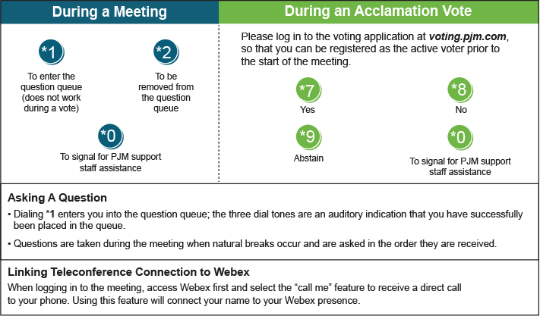

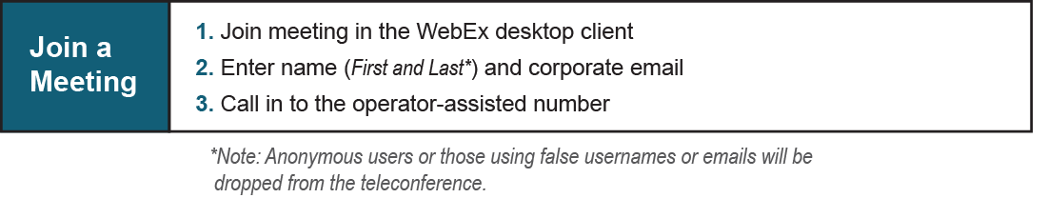
Provide feedback on the progress of this group: Facilitator Feedback Form
Visit learn.pjm.com, an easy-to-understand resource about the power industry and PJM’s role.

