Markets & Reliability Committees
PJM Conference and Training Center, Audubon, PA / WebEx
November 16, 2022
9:00 a.m. – 1:05 p.m. EPT
*Operator assisted phone lines will be opened 30 minutes prior to the start of the meeting. Due to the high volume of remote participation, stakeholders are asked to connect early to allow additional time for operator queue processing.

Administration (9:00-9:05)
Welcome, announcements and Anti-trust, Code of Conduct, and Public Meetings/Media Participation – Stu Bresler and Dave Anders

Consent Agenda (9:05-9:10)
- Approve minutes of the October 24, 2022 meeting of the Markets and Reliability Committee
- Endorse proposed revisions to Manual 3: Transmission Operations resulting from its periodic review.
- Endorse proposed revisions to Manual 3A: Energy Management System (EMS) Model Updates and Quality Assurance (QA) resulting from its periodic review.

Endorsements (9:10-11:45)
- Transmission Constraint Penalty Factor (9:10-9:30)
Susan Kenney will provide an update regarding the Transmission Constraint Penalty Factor (TCPF) activities at the Energy Price Formation Senior Task Force (EPFSTF) and Vijay Shah will review a proposed TCPF solution package as endorsed by the EPFSTF. The committee will be asked to endorse the proposed solution package and corresponding Tariff and Operating Agreement (OA) revisions.
Issue Tracking: Operating Reserve Demand Curve (ORDC) & Transmission Constraint Penalty Factors
- Energy and Reserve Market Circuit Breaker (9:30-10:00)
- Susan Kenney will provide an update regarding the Energy and Reserve Market Circuit Breaker activities at EPFSTF.
- Adrien Ford, ODEC, will move and John Rohrbach, SMECO, will second a Main Motion for a proposed circuit breaker solution package.
- David Scarpignato, Calpine, will move and Tom Hoaston, LS Power, will second an Alternative Motion for a proposed circuit breaker solution package.
The committee will be asked to endorse a proposed solution.
Issue Tracking: Operating Reserve Demand Curve (ORDC) & Transmission Constraint Penalty Factors
- Variable Operations & Maintenance Cost Development (10:00-10:25)
- Roger Cao will review the proposed Main Motion solution and corresponding OA Schedule 2 and Manual 15: Cost Development Guidelines revisions addressing the development of variable operations and maintenance costs.
- Jason Barker, Constellation, will review the proposed Alternative Motion solution.
The committee will be asked to endorse a proposed solution and corresponding OA and Manual revisions.
Issue Tracking: Variable Operating and Maintenance Cost
- Maximum Emergency Changes for Resource Limitation Reporting (10:25-10:45)
Chris Pilong will review a proposed solution package and Manual 13: Emergency Operations revisions addressing the Max Emergency Changes for Resource Limitation Reporting. The committee will be asked to endorse the proposed solution and corresponding Manual revisions.
Issue Tracking: Max Emergency Changes for Resource Limitation Reporting
- Critical Natural Gas Infrastructure – Demand Response Participation (10:45-11:05)
Pete Langbein will review a proposed solution and corresponding revisions to Manual 11: Energy & Ancillary Services Market Operations, Manual 18: PJM Capacity Market, the Tariff, OA, and Reliability Assurance Agreement (RAA). The solution and corresponding revisions address the prohibition of Critical Natural Gas Infrastructure load as a demand response resource pursuant to recommendations included in the FERC/NERC report on the severe cold weather event in Texas and South Central US in February 2021. The committee will be asked to endorse the proposed solution and corresponding Manual, Tariff, OA, and RAA revisions.
Issue Tracking: Critical Gas Infrastructure – Demand Response Participation
- FTR Bilateral Review and Reporting Requirements (11:05-11:25)
James Waweru will review a proposed solution addressing the FTR Bilateral Review and Reporting issue. The committee will be asked to endorse the proposed solution and corresponding Tariff revisions.
Issue Tracking: FTR Bilateral Review and Reporting Requirements
- Replacement Resource Transactions (11:25-11:45)
Michael Borgatti, Gabel Associates on behalf of Eagle Point Power Generation LLC, will review proposed Issue Charge and revisions to Manual 18: PJM Capacity Market seeking to address replacement resource transactions. The committee will be asked to approve the Issue Charge and endorse the proposed Manual 18 revisions as part of the Quick Fix process outlined in Section 8.6.1 of Manual 34. The committee will be asked to approve the Issue Charge and endorse the Manual revisions upon first read.

First Readings (11:45-1:05)
- Rules Related to Market Suspension (11:45-12:10)
Stefan Starkov will review a proposed solution addressing the treatment of market suspensions. The committee will be asked to endorse the proposed solution and corresponding OA revisions at its next meeting.
Issue Tracking: Rules Related to Market Suspension
- Market Participant Default Flexibility (12:10-12:30)
Colleen Hicks will review the proposed solution package addressing the alignment of PJM’s authority in event of a default. The committee will be asked to endorse the solution package and corresponding Tariff and OA revisions at its next meeting.
Issue Tracking: Market Participant Default Flexibility
- Clarifying Tariff and OA Revisions (12:30-12:45)
Janell Fabiano will review proposed clarifying Tariff and OA revisions as endorsed by the Governing Documents Enhancements and Clarifications Subcommittee (GDECS). The committee will be asked to endorse the proposed Tariff and OA revisions at its next meeting.
- Manuals (12:45-1:05)
  - Darrell Frogg will review proposed revisions to Manual 10: Pre-Scheduling Operations resulting from its periodic review. The committee will be asked to endorse the proposed revisions at its next meeting.
  - Darrell Frogg will review proposed revisions to Manual 14D: Generator Operational Requirements resulting from its periodic review. The committee will be asked to endorse the proposed revisions at its next meeting.
  - Rebecca Stadelmeyer will review proposed revisions to Manual 27: Open Access Transmission Tariff Accounting resulting from its periodic review. The committee will be asked to endorse the proposed revisions at its next meeting.

Informational Posting Only
- The PJM Manual 03 Attachment E: Automatic Sectionalizing Schemes Pending Approval and Recent Changes document has been posted on the PJM website at: https://www.pjm.com/markets-and-operations/etools/oasis/system-information.aspx.

Future Agenda Items (1:05)

Future Meeting Dates and Materials |  |  |  | Materials Due  to Secretary | Materials Published
Date | Time | Location
December 21, 2022 | 9:00 a.m. |  | PJM Conference & Training Center and WebEx | December 9, 2022 | December 14, 2022

Author: M. Greening

Antitrust:
You may not discuss any topics that violate, or that might appear to violate, the antitrust laws including but not limited to agreements between or among competitors regarding prices, bid and offer practices, availability of service, product design, terms of sale, division of markets, allocation of customers or any other activity that might unreasonably restrain competition. If any of these items are discussed the chair will re-direct the conversation. If the conversation still persists, parties will be asked to leave the meeting or the meeting will be adjourned.

Code of Conduct:
As a mandatory condition of attendance at today's meeting, attendees agree to adhere to the PJM Code of Conduct as detailed in PJM Manual M-34 section 4.5, including, but not limited to, participants' responsibilities and rules regarding the dissemination of meeting discussion and materials.

Public Meetings/Media Participation:
Unless otherwise noted, PJM stakeholder meetings are open to the public and to members of the media. Members of the media are asked to announce their attendance at all PJM stakeholder meetings at the beginning of the meeting or at the point they join a meeting already in progress. Members of the Media are reminded that speakers at PJM meetings cannot be quoted without explicit permission from the speaker. PJM Members are reminded that "detailed transcriptional meeting notes" and white board notes from "brainstorming sessions" shall not be disseminated. Stakeholders are also not allowed to create audio, video or online recordings of PJM meetings. PJM may create audio, video or online recordings of stakeholder meetings for internal and training purposes, and your participation at such meetings indicates your consent to the same.
Participant Identification in Webex:
When logging into the Webex desktop client, please enter your real first and last name as well as a valid email address. Be sure to select the “call me” option.
PJM support staff continuously monitors Webex connections during stakeholder meetings. Anonymous users or those using false usernames or emails will be dropped from the teleconference.

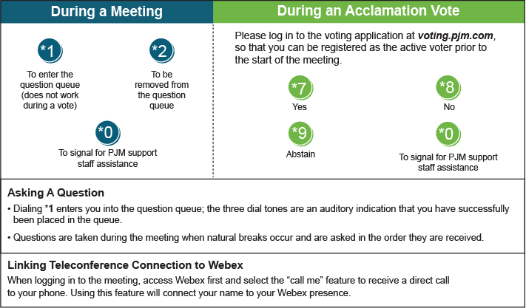

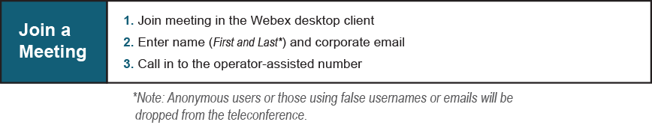
Provide feedback on the progress of this group: Facilitator Feedback Form
Visit learn.pjm.com, an easy-to-understand resource about the power industry and PJM’s role.

