Operating Committee
PJM Conference & Training Center, Audubon, PA
October 7, 2022
9:00 a.m. – 2:00 p.m. EDT

*Operator assisted phone lines will be opened 30 minutes prior to the start of the meeting. Due to the high volume of remote participation, stakeholders are asked to connect early to allow additional time for operator queue processing.

Administration (9:00-9:10)
Jeff McLaughlin, PJM, will provide announcements; review the Antitrust, Code of Conduct, Public Meetings/Media Participation, and the WebEx Participant Identification Requirement.
  - Review and approve draft minutes from the September 8 OC meeting.
  - Review of the OC work plan.

Review of Operations (9:10 - 9:30)
- PJM COVID-19 Update (9:10 – 9:15)
Paul McGlynn, PJM, will review an update on PJM’s operations plan in response to COVID-19.
https://pjm.com/committees-and-groups/pandemic-coordination.aspx

Review of Operating Metrics (9:15 – 9:25)
Hong Chen, PJM, will review the September 2022 PJM operating metrics slides. Metrics will include PJM’s load forecast error, BAAL performance, and transmission / generation outage statistics.

- Security Update (9:25 – 9:30)
Zeenath Fernandes, PJM, will provide a security briefing.

Endorsements/Approvals (9:30 – 10:00)
- Manual 3A: Energy Management System Model Updates & Quality Assurance (9:30 – 9:40)
Jeff Schmitt, PJM, will review Manual 3A changes as a part of the periodic review.
The Operating Committee will be asked to endorse these changes at today’s meeting.

- Renewable Dispatch (9:40 – 10:00)
A review of the joint PJM/IMM solution package will be performed for the Renewable Dispatch issue as part of the CBIR process.
Issue Tracking: Renewable Dispatch
The Operating Committee will be asked to endorse the proposed solution at today’s meeting.

First Reading (10:00 – 11:15)
- Winter Weekly Reserve Target Update (10:00 – 10:20)
Andrew Gledhill, PJM, will review the results of the 2022/23 Winter Weekly Reserve Target (WWRT) analysis.
The Operating Committee will be asked to endorse the results at its next meeting.

- Manual 03: Transmission Operations (10:20 – 10:35)
Lagy Mathew, PJM, will review Manual 03 changes as a part of the periodic review.
The Operating Committee will be asked to endorse these changes at its next meeting.

- Manual 10: Pre-Scheduling Operations (10:35 – 10:45)
Ray Lee, PJM, will review Manual 10 changes as a part of the periodic review.
The Operating Committee will be asked to endorse these changes at its next meeting.

- Manual 14D: Generator Operational Requirements (10:45 – 10:55)
Ray Lee, PJM, will review Manual 14D changes as a part of the periodic review.
The Operating Committee will be asked to endorse these changes at its next meeting.

- Manual 13: Emergency Operations (10:55 – 11:15)
Chris Pilong, PJM, will review conforming changes to Manual 13 associated with the Max Emergency Changes for Resource Limitation Reporting issue endorsed by the OC on September 8, 2022.
The Operating Committee will be asked to endorse these changes at its next meeting.
Issue Tracking: Max Emergency Changes for Resource Limitation Reporting

Additional Items (11:15 – 2:00)
- PPL Dynamic Line Rating Implementation Update (11:15 – 11:30)
Dave Hislop, PJM, will provide an update on the implementation of the PPL Dynamic Line Rating.

- Order 881 Update (11:30 – 11:45)
Dave Hislop, PJM, will provide an update on Order 881 efforts.

- Status Update on Circuit Court Remand (11:45 – 12:00)
Pauline Foley, PJM, will provide a status update on the circuit court remand related to challenges to solution-based DFAX cost allocation.

Lunch (12:00 – 12:30)

- Intelligent Reserve Deployment Update (12:30 – 12:50)
Mike Zhang, PJM, will provide an update on Intelligent Reserve Deployment (IRD).

- Cold Weather Preparation Update (12:50 – 1:00)
Lauren Strella Wahba, PJM, will review Generation Resource Cold Weather Preparation activities.

- Fuel Supply Overview (1:00 – 1:15)
Brian Fitzpatrick, PJM, will provide an overview of current fuel supply issues.

- Fuel Requirements for Black Start Resources (1:15 – 2:00)
Tom Hauske and Dave Kimmel will review revisions to Manual 27: Open Access Transmission Tariff Accounting, Manual 12: Balancing Operations, Manual 14D: Generator Operational Requirements and Schedule 6A of the OATT for the Fuel Requirements for Black Start Resources. These revisions conform with the PJM/Brookfield/DCOPC proposal, which was endorsed with 76% support in the offline MIC/OC vote. The proposal and these revisions are scheduled for a vote at the October 24 MRC meeting.
Issue Tracking: Fuel Requirements for Black Start Resources

Informational Only Postings
- Reliability Compliance Update
Becky Davis, PJM, will provide an update on NERC, SERC, RF, and NAESB standards, and other pertinent regulatory and compliance information, and solicit feedback from the members on Reliability Compliance efforts.

- System Operations Subcommittee (SOS)
Donnie Bielak, PJM, will provide a summary of the most recent SOS meeting.

- NERC Lessons Learned
Kevin Hatch, PJM, will review the latest posted NERC Lessons Learned reports.

- Fuel and Energy Security Update
Natalie Tacka, PJM, will provide an update on the Fuel and Energy Security initiative.

- PJM Summer Operations
An informational presentation is available with today’s meeting materials on PJM Summer Operations performance. Donnie Bielak will be available to answer any questions.

OC Subcommittee/ Task Force Informational Section
System Operations Subcommittee (SOS): SOS Website
Data Management Subcommittee (DMS): DMS Website
DER & Inverter-Based Resources Subcommittee (DIRS): DIRS Website
Fuel Requirements for Black Start Resources: Fuel Reqt. for Black Start Resources Issue Tracker
Synchronous Reserve Deployment Task Force: SRDTF Website
Dynamic Line Rating Task Force: DLRTF Website
IROL – CIP Cost Recovery: IROL – CIP Cost Recovery Issue Tracker

Future Meeting Dates and Materials |  |  | Materials Due  to Secretary | Materials Published
Date | Time | Location | 5 p.m. | 4 p.m.
November 3, 2022 | 9 a.m. | PJM Conference & Training Center and WebEx | October 24, 2022 | October 27, 2022
December 8, 2022 | 9 a.m. | PJM Conference & Training Center and WebEx | November 28, 2022 | December 1, 2022

Author: Jeffrey McLaughlin

Antitrust:
You may not discuss any topics that violate, or that might appear to violate, the antitrust laws including but not limited to agreements between or among competitors regarding prices, bid and offer practices, availability of service, product design, terms of sale, division of markets, allocation of customers or any other activity that might unreasonably restrain competition. If any of these items are discussed the chair will re-direct the conversation. If the conversation still persists, parties will be asked to leave the meeting or the meeting will be adjourned.

Code of Conduct:
As a mandatory condition of attendance at today's meeting, attendees agree to adhere to the PJM Code of Conduct as detailed in PJM Manual M-34 section 4.5, including, but not limited to, participants' responsibilities and rules regarding the dissemination of meeting discussion and materials.
Public Meetings/Media Participation:
Unless otherwise noted, PJM stakeholder meetings are open to the public and to members of the media. Members of the media are asked to announce their attendance at all PJM stakeholder meetings at the beginning of the meeting or at the point they join a meeting already in progress. Members of the Media are reminded that speakers at PJM meetings cannot be quoted without explicit permission from the speaker. PJM Members are reminded that "detailed transcriptional meeting notes" and white board notes from "brainstorming sessions" shall not be disseminated. Stakeholders are also not allowed to create audio, video or online recordings of PJM meetings. PJM may create audio, video or online recordings of stakeholder meetings for internal and training purposes, and your participation at such meetings indicates your consent to the same.
Participant Identification in WebEx:
When logging into the WebEx desktop client, please enter your real first and last name as well as a valid email address. Be sure to select the “call me” option.
PJM support staff continuously monitors WebEx connections during stakeholder meetings. Anonymous users or those using false usernames or emails will be dropped from the teleconference.

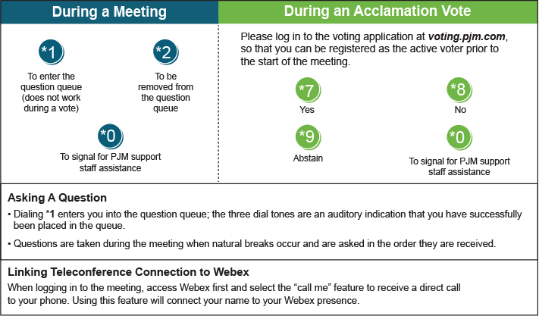

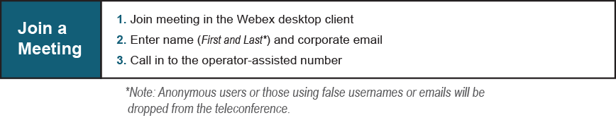

Provide feedback on the progress of this group: Facilitator Feedback Form
Visit learn.pjm.com, an easy-to-understand resource about the power industry and PJM’s role.

