January Planning Committee

**Teleconference / WebEx**

January 11, 2022

9:00 a.m. – 12:00 p.m. EPT

Administration (9:00 – 9:15)

1. Welcome, announcements and review of the Anti-trust, Code of Conduct, and Media Participation Guidelines.
2. Approve Planning Committee (PC) Agenda for this meeting.
3. Approve draft minutes from the December 14, 2021 PC meeting.
4. Review of the 2022 PC Work Plan

X. Amanda Egan, PJM, will review an update to the Voting Application to retire use of weak encryption.

Endorsements (9:15 – 10:00)

1. Interconnection Process Reform – Interconnection Process

Jack Thomas, PJM, will review the new interconnection process package(s) from the work done at the Interconnection Process Reform Task Force. **The committee will be asked to vote on the interconnection process package(s) at today’s meeting.**

Materials for task force can be found [here](https://www.pjm.com/committees-and-groups/task-forces/iprtf).

First Reads (10:00 – 11:30)

1. Interconnection Process Reform - Transition

Jack Thomas, PJM, will provide a first read of the transition package(s) from the work done at the Interconnection Process Reform Task Force. The committee will be asked to vote on the transistion package(s) at next month’s meeting.

Materials for task force can be found [here](https://www.pjm.com/committees-and-groups/task-forces/iprtf).

1. Deactivation Process Timing

Dave Egan, PJM, will provide a first read of a proposed deactivation process timing update. The committee will be asked to approve the issue charge and endorse the proposed solution as part of the Quick Fix process outlined in Section 8.6.1 of Manual 34 at next month’s meeting.

1. TO/TOP Matrix V16

Gizella Mali, PJM, will present the proposed changes to the TO/TOP Matrix. The Committee will be requested to provide a recommendation to the TOA-AC to approve the Draft TO/TOP Matrix V16 at the next meeting.

Informational Updates (11:30 – 12:00)

1. Capacity Interconnection Rights for ELCC Resoures Update

Brian Chmielewski, PJM, will provide an update of the work done during the PC special session on Capacity Interconnection Rights (CIR) for ELCC Resources.

Materials for the special sessions can be found [here](https://www.pjm.com/committees-and-groups/committees/pc).

1. Resilience Testing Update

Grace Niu, PJM, will provide an update on annual resilience testing.

1. Attachment M3 Process Update

Aaron Berner, PJM, will provide an Attachment M-3 update and facilitate a discussion with stakeholders.

1. Reliability Compliance Update  
   Becky Davis, PJM, will provide an update on the activities, issues and items of interest at NERC, SERC, and RF.

Informational Posting

Model Build Activity Update

* MMWG
  + Dynamics
    - PJM submitted the second round of generator dynamic data and Transmission Owners’ dynamic device data to PowerTech
    - PowerTech is working on dynamic cases initializations and disturbance test
* RTEP
  + Loadflow
    - Transmission Owners to provide Trial 2 updates and contingency files by January 21, 2022
  + Short Circuit
    - PJM will post the Trial 1 2024 case and associated files by January 15, 2022
* A friendly reminder - The upcoming Gen Model Window for MOD-032 data submittals for applicable Generator Owners will open on Sunday, May 1st, 2022 and end on Wednesday, June 15th, 2022

Carbon Impact Report – 2020/21 Long-Term Window 1 Update

A report posted with meeting materials summarizes the carbon impacts for the Market Efficiency projects to be submitted to the February Board meeting.

|  |  |  |  |  |
| --- | --- | --- | --- | --- |
| **Future Meeting Dates and Materials** | | | **Materials Due  to Secretary** | **Materials Published** |
| Date | Time | Meeting (Location) |
| Tuesday, January 11, 2022 | 9:00 a.m. – 12:00 p.m. | Planning Committee (TBD) | Thursday, December 30, 2021 | Tuesday, January 4, 2022 |
| Tuesday, February 8, 2022 | 9:00 a.m. – 12:00 p.m. | Planning Committee (TBD) | Thursday, January 27, 2022 | Tuesday, February 1, 2022 |
| Tuesday, March 8, 2022 | 9:00 a.m. – 12:00 p.m. | Planning Committee (TBD) | Thursday, February 24, 2022 | Tuesday, March 1, 2022 |
| Tuesday, April 12, 2022 | 9:00 a.m. – 12:00 p.m. | Planning Committee (TBD) | Thursday, March 31, 2022 | Tuesday, April 5, 2022 |
| Tuesday, May 10, 2022 | 9:00 a.m. – 12:00 p.m. | Planning Committee (TBD) | Thursday, April 28, 2022 | Tuesday, May 3, 2022 |
| Tuesday, June 7, 2022 | 9:00 a.m. – 12:00 p.m. | Planning Committee (TBD) | Thursday, May 26, 2022 | Tuesday, May 31, 2022 |

Author: Molly Mooney

Antitrust:

You may not discuss any topics that violate, or that might appear to violate, the antitrust laws including but not limited to agreements between or among competitors regarding prices, bid and offer practices, availability of service, product design, terms of sale, division of markets, allocation of customers or any other activity that might unreasonably restrain competition. If any of these items are discussed the chair will re-direct the conversation. If the conversation still persists, parties will be asked to leave the meeting or the meeting will be adjourned.

Code of Conduct:

As a mandatory condition of attendance at today's meeting, attendees agree to adhere to the PJM Code of Conduct as detailed in PJM Manual M-34 section 4.5, including, but not limited to, participants' responsibilities and rules regarding the dissemination of meeting discussion and materials.

Public Meetings/Media Participation:

Unless otherwise noted, PJM stakeholder meetings are open to the public and to members of the media. Members of the media are asked to announce their attendance at all PJM stakeholder meetings at the beginning of the meeting or at the point they join a meeting already in progress. Members of the Media are reminded that speakers at PJM meetings cannot be quoted without explicit permission from the speaker. PJM Members are reminded that "detailed transcriptional meeting notes" and white board notes from "brainstorming sessions" shall not be disseminated. Stakeholders are also not allowed to create audio, video or online recordings of PJM meetings. PJM may create audio, video or online recordings of stakeholder meetings for internal and training purposes, and your participation at such meetings indicates your consent to the same.

Participant Identification in WebEx:

When logging into the WebEx desktop client, please enter your real first and last name as well as a valid email address. Be sure to select the “call me” option.

PJM support staff continuously monitors WebEx connections during stakeholder meetings. Anonymous users or those using false usernames or emails will be dropped from the teleconference.

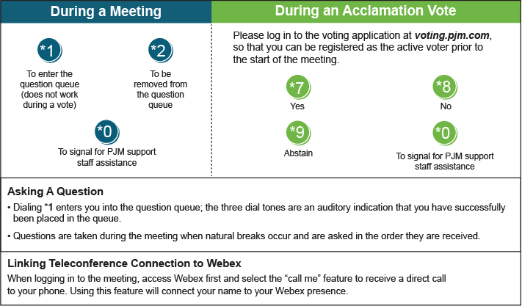

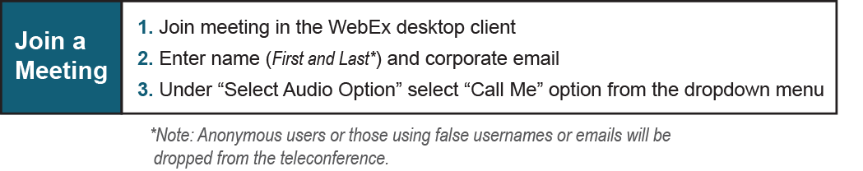

Provide feedback on the progress of this group: *Facilitator Feedback Form*   
Visit [*learn.pjm.com*](http://learn.pjm.com/), an easy-to-understand resource about the power industry and PJM’s role.