May Planning Committee

**Teleconference / WebEx**

May 10, 2022

9:00 a.m. – 12:00 p.m. EPT

Administration (9:00 – 9:15)

1. Welcome, announcements and review of the Anti-trust, Code of Conduct, and Media Participation Guidelines.
2. Approve Planning Committee (PC) Agenda for this meeting.
3. Approve draft minutes from the April 12, 2022 PC meeting.
4. Michele Greening, PJM, will provide an update on return to campus plan for stakeholder meetings.

Endorsements (9:15 – 10:30)

1. Interconnection Process Subcommittee

Jason Connell, PJM, will provide a second read of the draft charter of the Interconnection Process Subcommittee, which is being formed to continue the discussion of interconnection process improvements after the work of the IPRTF concludes. The committee will be asked to vote on the draft charter at today’s meeting.

1. RSCS Charter

Monica Burkett, PJM, will provide a second read of changes made to the Reliability Standards & Compliance Subcommittee Charter. The committee will be asked to vote on the proposed changes to the charter at today’s meeting.

1. Application of Designated Entity Agreement

Augustine Caven, PJM, will provide a second read of the proposed solution to address the application of Designated Entity Agreement. The committee will be asked to approve the Issue Charge and endorse the proposed approach as part of the Quick Fix process outlined in Section 8.6.1 of Manual 34 at today’s meeting.

First Reads (10:30 – 10:45)

1. 2022 RRS Assumptions

Jason Quevada, PJM, will present the 2022 RRS assumptions as developed in the Resource Adequacy Analysis Subcommittee. The committee will be requested to endorse the study assumptions at the June PC meeting

Informational Updates (10:45 – 12:00)

1. Capacity Interconnection Rights for ELCC Resources Update

Brian Chmielewski, PJM, will provide an update from the work done during the PC special session on Capacity Interconnection Rights (CIR) for ELCC Resources.

[Issue Tracking: CIRs for ELCC Resources](https://www.pjm.com/committees-and-groups/issue-tracking/issue-tracking-details.aspx?Issue=83aadda8-b6c1-4630-9483-025b6b93fc28)

Materials for the special sessions can be found [here](https://www.pjm.com/committees-and-groups/committees/pc).

1. Generator Deliverability Timeline Update

Jonathan Kern, PJM, will provide a generator deliverability proposal development timeline update.

1. NERC CMEP Practice Guide Update on CIP-014

Gizella Mali, PJM, will provide an update on PJM activities surrounding the NERC CMEP Practice Guide on CIP-014.

1. Grid of the Future – PJM RTEP Perspective

Sue Glatz, PJM, will discuss PJM’s report on planning for the grid of the future and the planning perspective.

1. FERC NOPR Summary

Pauline Foley, PJM, will provide a summary of the FERC Notice of Proposed Rulemaking (NOPR) Building for the Future through Electric Regional Transmission Planning and Cost Allocation and Generator Interconnection.

1. Reliability Compliance Update  
   Becky Davis, PJM, will provide an update on the activities, issues and items of interest at NERC, SERC, and RF.

Informational Posting

Model Build Activity Update

* MMWG
  + Dynamics
    - MMWG posted Trial 4 dynamic cases. Identified issues related to PJM have been resolved. MMWG will post the Pre-Final dynamic cases for review
    - EIPC FRWG has finalized 2025 Spring Minimum Load dynamic cases. FRWG also finished the survey on the largest loss of generation contingency
  + Loadflow
    - The starting cases were provided to the Transmission Owners on April 29, 2022
    - Transmission Owners will provide idevs to update the starting cases by May 27, 2022
    - Transmission Owners provided idevs to update the 2022 winter study case on April 28, 2022
    - PJM submitted the idevs to update the 2022 winter study case to PowerTech on April 29, 2022
    - There are two more trials to update the 2022 winter study case in May, the final updates are due to PowerTech on May 20, 2022
* RTEP
  + Loadflow
    - All 2022 series cases have been delivered to PJM’s Transmission Planning Department
  + Short Circuit
    - PJM delivered the Trial 3 2-year RTEP case and Trial 1 5-year RTEP case and files
    - All Transmission Owners were required to provide their feedback by April 19, 2022
    - PJM is currently reviewing the 2-year model breaker analysis and will reach out to Transmission Owners as needed
    - The Trial 2 5-year case is currently being built by applying the Transmission Owners feedback
  + Dynamics
    - PJM is currently building RTEP 2022 series dynamic cases

The upcoming Gen Model Window for MOD-032 data submittals for applicable Generator Owners will open on Sunday, May 1, 2022 and end on Wednesday, June 15, 2022

|  |  |  |  |  |
| --- | --- | --- | --- | --- |
| **Future Meeting Dates and Materials** | | | **Materials Due  to Secretary** | **Materials Published** |
| Date | Time | Meeting (Location) |
| Tuesday, June 7, 2022 | 9:00 a.m. – 12:00 p.m. | Planning Committee (TBD) | Thursday, May 26, 2022 | Tuesday, May 31, 2022 |
| Tuesday,  July 12, 2022 | 9:00 a.m. – 12:00 p.m. | Planning Committee (TBD) | Thursday, June 30, 2022 | Tuesday, July 5, 2022 |
| Tuesday, August 9, 2022 | 9:00 a.m. – 12:00 p.m. | Planning Committee (TBD) | Thursday, July 28, 2022 | Tuesday, August 2, 2022 |
| Tuesday, September 6, 2022 | 9:00 a.m. – 12:00 p.m. | Planning Committee (TBD) | Thursday, August 25, 2022 | Tuesday, August 30, 2022 |

Author: Marilyn Jayachandran

Antitrust:

You may not discuss any topics that violate, or that might appear to violate, the antitrust laws including but not limited to agreements between or among competitors regarding prices, bid and offer practices, availability of service, product design, terms of sale, division of markets, allocation of customers or any other activity that might unreasonably restrain competition. If any of these items are discussed the chair will re-direct the conversation. If the conversation still persists, parties will be asked to leave the meeting or the meeting will be adjourned.

Code of Conduct:

As a mandatory condition of attendance at today's meeting, attendees agree to adhere to the PJM Code of Conduct as detailed in PJM Manual M-34 section 4.5, including, but not limited to, participants' responsibilities and rules regarding the dissemination of meeting discussion and materials.

Public Meetings/Media Participation:

Unless otherwise noted, PJM stakeholder meetings are open to the public and to members of the media. Members of the media are asked to announce their attendance at all PJM stakeholder meetings at the beginning of the meeting or at the point they join a meeting already in progress. Members of the Media are reminded that speakers at PJM meetings cannot be quoted without explicit permission from the speaker. PJM Members are reminded that "detailed transcriptional meeting notes" and white board notes from "brainstorming sessions" shall not be disseminated. Stakeholders are also not allowed to create audio, video or online recordings of PJM meetings. PJM may create audio, video or online recordings of stakeholder meetings for internal and training purposes, and your participation at such meetings indicates your consent to the same.

Participant Identification in WebEx:

When logging into the WebEx desktop client, please enter your real first and last name as well as a valid email address. Be sure to select the “call me” option.

PJM support staff continuously monitors WebEx connections during stakeholder meetings. Anonymous users or those using false usernames or emails will be dropped from the teleconference.

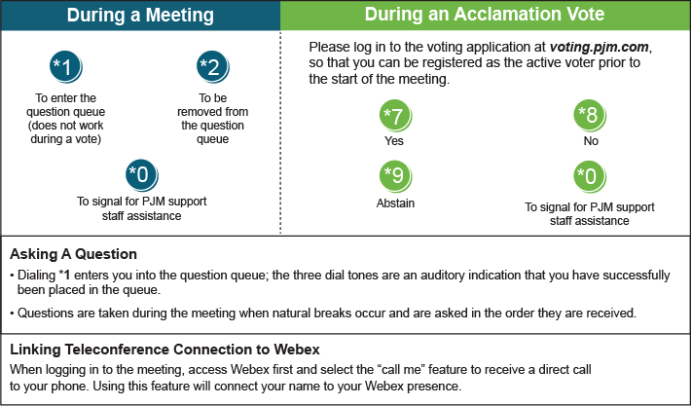

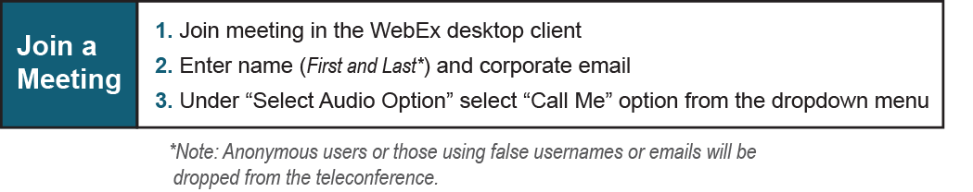

Provide feedback on the progress of this group: *Facilitator Feedback Form*   
Visit [*learn.pjm.com*](http://learn.pjm.com/), an easy-to-understand resource about the power industry and PJM’s role.