Reliability Standards and Compliance Subcommittee
Webex/Conference Call
January 15, 2021
9:00 a.m. – 10:00 a.m. EPT

Administration (9:00-9:15)
Welcome, Announcements and Introductions.
- Review of Antitrust Guidelines, Code of Conduct, Public Meetings/Media Participation, Webex Participant Identification Requirements and Compliance Disclaimer.
- Approval of Agenda.
- Approval of the Minutes from the October 16, 2020 RSCS meeting.
- Tom Foster, PJM, will provide an update on the realignment of the Compliance group at PJM.

PJM Compliance Activities (9:15-9:45)
Manual Updates
- Kevin Hatch, PJM, will provide an update on Manual 13.
- Monica Burkett, PJM, will review the 2021 RSCS schedule.
- Tee LaRosa, PJM, will review the Transmission Owner Contact List.
Mark Kuras, PJM, and Stan Sliwa, PJM, will discuss the PRC-006-3 Requirement 10.
- Mark Kuras will provide an update on the PJM CIP-002 and CIP-014 2021 IROL Letters.
- Mark Kuras will present the proposed changes to the TO/TOP Matrix.

FERC, NERC, and Regional Activities (9:45-9:55)
- Elizabeth Davis, PJM, will provide an update on FERC, NERC and regional activities.

Future Agenda Items (9:55-10:00)
Monica Burkett will solicit topics for future RSCS meetings.
Monica Burkett will solicit feedback for improvements to RSCS meetings.

Future Meeting Dates

February 18, 2021 | 9:00 a.m. | Webex
March 19, 2021 | 9:00 a.m. | Webex
April 16, 2021 | 9:00 a.m. | Webex
May 21, 2021 | 9:00 a.m. | Webex
June 11, 2021 | 9:00 a.m. | Webex
July 16, 2021 | 9:00 a.m. | TBD
August 19, 2021 | 9:00 a.m. | TBD
September 17, 2021 | 9:00 a.m. | TBD
October 15, 2021 | 9:00 a.m. | TBD
November 19, 2021 | 9:00 a.m. | TBD
December 17, 2021 | 9:00 a.m. | TBD

Author: Ashwini Bhat

Antitrust:
You may not discuss any topics that violate, or that might appear to violate, the antitrust laws including but not limited to agreements between or among competitors regarding prices, bid and offer practices, availability of service, product design, terms of sale, division of markets, allocation of customers or any other activity that might unreasonably restrain competition. If any of these items are discussed the chair will re-direct the conversation. If the conversation still persists, parties will be asked to leave the meeting or the meeting will be adjourned.

Code of Conduct:
As a mandatory condition of attendance at today's meeting, attendees agree to adhere to the PJM Code of Conduct as detailed in PJM Manual M-34 section 4.5, including, but not limited to, participants' responsibilities and rules regarding the dissemination of meeting discussion and materials.

Public Meetings/Media Participation:
Unless otherwise noted, PJM stakeholder meetings are open to the public and to members of the media. Members of the media are asked to announce their attendance at all PJM stakeholder meetings at the beginning of the meeting or at the point they join a meeting already in progress. Members of the Media are reminded that speakers at PJM meetings cannot be quoted without explicit permission from the speaker. PJM Members are reminded that "detailed transcriptional meeting notes" and white board notes from "brainstorming sessions" shall not be disseminated. Stakeholders are also not allowed to create audio, video or online recordings of PJM meetings. PJM may create audio, video or online recordings of stakeholder meetings for internal and training purposes, and your participation at such meetings indicates your consent to the same.
Participant Identification in Webex:
When logging into the Webex desktop client, please enter your real first and last name as well as a valid email address. Be sure to select the “call me” option.
PJM support staff continuously monitors Webex connections during stakeholder meetings. Anonymous users or those using false usernames or emails will be dropped from the teleconference.



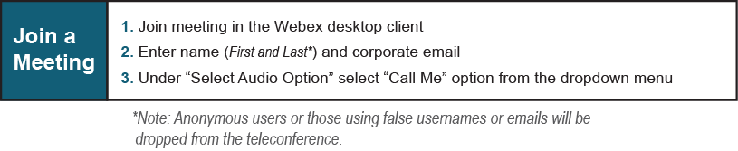
Provide feedback on the progress of this group: Facilitator Feedback Form
Visit learn.pjm.com, an easy-to-understand resource about the power industry and PJM’s role.

