Carbon Pricing Senior Task Force (CPSTF)
PJM Conference and Training Center
February 25, 2020
1:00 p.m. – 4:00 p.m. EPT

Administration (1:00-1:05)
Ms. Jen Tribulski and Ms. Suzanne Coyne will provide welcome, announcements, and review of the Antitrust, Code of Conduct, and Public Meetings/Media Participation Guidelines Text. Stakeholders will be asked to approve the draft minutes from the January 14, 2020 meeting.

Work Plan (1:05-1:10)
Ms. Suzanne Coyne will review the Carbon Pricing Senior Task Force stakeholder process Stage 1 work plan.

Education and Analysis (1:10-2:45)
PJM Study of Carbon Pricing & Potential Leakage Mitigation Mechanisms – Additional Scenarios
- Mr. Eric Hsia, PJM, will provide an executive summary of the results from the PJM study of additional carbon pricing region scenarios requested by stakeholders at the January meeting.
- Ms. Rebecca Hilderbrand, PJM, will review the assumptions, methodology, and framework of the PJM carbon study.
- Ms. Natalie Tacka and Dr. Anthony Giacomoni, PJM, will present the detailed study results from the following carbon pricing region scenarios.
  - Carbon pricing region includes New Jersey, Maryland, Delaware, and Virginia
  - Carbon pricing region includes New Jersey, Maryland, Delaware, Virginia, and Pennsylvania

Future Agenda Items (2:45-2:50)
Ms. Jen Tribulski will review meeting action items and discuss future agenda items.

Break 2:50 – 3:00

Example Problem Formulations Session (3:00-4:00)
Dr. Anthony Giacomoni, PJM, will provide information on example problem formulations for the different border adjustment options being discussed as part of the PJM carbon pricing study. The focus will be on highlighting the differences between the problem formulations for the different border adjustment options.

Future Meeting Dates
March 27, 2020 (rescheduled date) | 9:00 a.m. | PJM Conference & Training Center/ WebEx
May 19, 2020 | 9:00 a.m. | PJM Conference & Training Center/ WebEx
June 25, 2020 | 9:00 a.m. | PJM Conference & Training Center/ WebEx
Author: Suzanne Coyne

Antitrust:
You may not discuss any topics that violate, or that might appear to violate, the antitrust laws including but not limited to agreements between or among competitors regarding prices, bid and offer practices, availability of service, product design, terms of sale, division of markets, allocation of customers or any other activity that might unreasonably restrain competition. If any of these items are discussed the chair will re-direct the conversation. If the conversation still persists, parties will be asked to leave the meeting or the meeting will be adjourned.

Code of Conduct:
As a mandatory condition of attendance at today's meeting, attendees agree to adhere to the PJM Code of Conduct as detailed in PJM Manual M-34 section 4.5, including, but not limited to, participants' responsibilities and rules regarding the dissemination of meeting discussion and materials.

Public Meetings/Media Participation:
Unless otherwise noted, PJM stakeholder meetings are open to the public and to members of the media. Members of the media are asked to announce their attendance at all PJM stakeholder meetings at the beginning of the meeting or at the point they join a meeting already in progress. Members of the Media are reminded that speakers at PJM meetings cannot be quoted without explicit permission from the speaker. PJM Members are reminded that "detailed transcriptional meeting notes" and white board notes from "brainstorming sessions" shall not be disseminated. Stakeholders are also not allowed to create audio, video or online recordings of PJM meetings. PJM may create audio, video or online recordings of stakeholder meetings for internal and training purposes, and your participation at such meetings indicates your consent to the same.
Participant Identification in WebEx:
When logging into the WebEx desktop client, please enter your real first and last name as well as a valid email address. Be sure to select the “call me” option.
PJM support staff continuously monitors WebEx connections during stakeholder meetings. Anonymous users or those using false usernames or emails will be dropped from the teleconference.



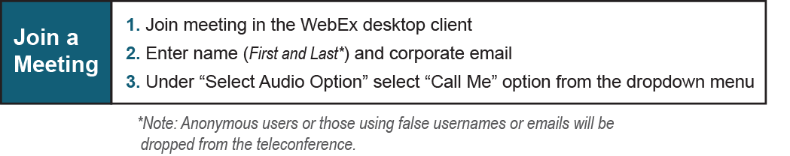
Provide feedback on the progress of this group: Facilitator Feedback Form
Visit learn.pjm.com, an easy-to-understand resource about the power industry and PJM’s role.

