Energy Price Formation Sr. Task Force
PJM Conference and Training Center
March 5, 2018
10:00 a.m. – 4:00 p.m. EPT

Administration (10:00 – 10:10)
Mr. Dave Anders and Mr. Vijay Shah will provide announcements, review the Anti-trust, Code of Conduct and PJM meeting guidelines policies and perform in-room roll-call
The Senior Task Force will be asked to approve draft minutes from the February 15, 2018 Energy Price Formation Senior Task Force meeting.

Senior Task Force Charter and Work Plan (10:10-10:30)
Mr. Anders will provide an update to the draft charter for the Energy Price Formation Sr. Task Force (EPFSTF). The first read of the draft charter was presented at the Markets and Reliability Committee meeting on February 22, 2018 meeting.
Mr. Anders will lead a discussion of the workplan and meeting schedule for the EPFSTF.

Interest Identification (10:30-12:00)
Dr. Scott Harvey, FTI Consulting, will provide a presentation reviewing the History of LMP, discussing the goals of implementing LMP pricing in the 1990s, constraints with the LMP design and implementation and the evolution of LMP.
Dr. Scott Harvey is a Consultant in the Economic Consulting segment and is located in Boston. Prior to joining FTI Consulting, he was a consultant for 12 years with LECG and 11 years with Putnam, Hayes & Bartlett, Inc. He has been actively involved at FTI Consulting, LECG, and Putnam, Hayes & Bartlett with the restructuring of the PJM, New York and New England Power Pools, the development of the MISO Stage 2 congestion management system implemented in April 2005, and the development and implementation of the California ISO's MRTU market design in April 2009.
Lunch (12:00-12:40)

Identification of Design Criteria (12:40-1:00)
Identification of Design Criteria
- Mr. Anders will lead a discussion around identification of design criteria for key work activity item 2 from the issue charge and review design criteria that were captured at the February 15, 2018 EPFSTF meeting.

Identification of Gaps for Energy and Reserve Markets (1:00-2:30)
Identification of Gaps for Energy and Reserve Markets
- Mr. Anders will lead a discussion around identification of gaps for key work activity item 3 from the issue charge.
- Mr. Adam Keech, PJM, will give a presentation on gaps to consider between EPFSTF criteria and current market design from PJM perspective.
- Mr. Anders will lead a discussion around identification of gaps for key work activity item 3 from the issue charge to capture stakeholder identification of gaps with current market design.
Break (2:30-2:40)

Options Matrix (2:40-4:00)
Mr. Anders will lead a discussion capturing design components to build the options Matrix for EPFSTF focusing on Shortage pricing and Reserves pricing.
Mr. Anders will lead a discussion capturing design components to build the options Matrix for EPFSTF focusing on Energy Price Formation.
Ms. Melissa Maxwell, PJM, will review examples of single period integer relaxation.
Meeting adjourned 4:00

Future Agenda Items

Future Meeting Dates
March 29, 2018 | 9:30 a.m. | PJM Conference & Training Center/ WebEx
April 9, 2018 | 10:00 a.m. | PJM Conference & Training Center/ WebEx
May 4, 2018 | 9:00 a.m. | The Chase Center on the Riverfront/ WebEx
May 23, 2018 | 9:30 a.m. | PJM Conference & Training Center/ WebEx
June 8, 2018 | 9:00 a.m. | PJM Conference & Training Center/ WebEx
June 25, 2018 | 10:00 a.m. | PJM Conference & Training Center/ WebEx
July 17, 2018 | 9:30 a.m. | PJM Conference & Training Center/ WebEx
August 6, 2018 | 10:00 a.m. | PJM Conference & Training Center/ WebEx
August 22, 2018 | 10:00 a.m. | PJM Conference & Training Center/ WebEx
September 10, 2018 | 10:00 a.m. | PJM Conference & Training Center/ WebEx

Author: Vijay Shah

Antitrust:
You may not discuss any topics that violate, or that might appear to violate, the antitrust laws including but not limited to agreements between or among competitors regarding prices, bid and offer practices, availability of service, product design, terms of sale, division of markets, allocation of customers or any other activity that might unreasonably restrain competition. If any of these items are discussed the chair will re-direct the conversation. If the conversation still persists, parties will be asked to leave the meeting or the meeting will be adjourned.

Code of Conduct:
As a mandatory condition of attendance at today's meeting, attendees agree to adhere to the PJM Code of Conduct as detailed in PJM Manual M-34 section 4.5, including, but not limited to, participants' responsibilities and rules regarding the dissemination of meeting discussion and materials.

Public Meetings/Media Participation:
Unless otherwise noted, PJM stakeholder meetings are open to the public and to members of the media. Members of the media are asked to announce their attendance at all PJM stakeholder meetings at the beginning of the meeting or at the point they join a meeting already in progress. Members of the Media are reminded that speakers at PJM meetings cannot be quoted without explicit permission from the speaker. PJM Members are reminded that "detailed transcriptional meeting notes" and white board notes from "brainstorming sessions" shall not be disseminated. Stakeholders are also not allowed to create audio, video or online recordings of PJM meetings. PJM may create audio, video or online recordings of stakeholder meetings for internal and training purposes, and your participation at such meetings indicates your consent to the same.
Participant Identification in WebEx:
When logging into the WebEx desktop client, please enter your real first and last name as well as a valid email address. Be sure to select the “call me” option.
PJM support staff continuously monitors WebEx connections during stakeholder meetings. Anonymous users or those using false usernames or emails will be dropped from the teleconference.



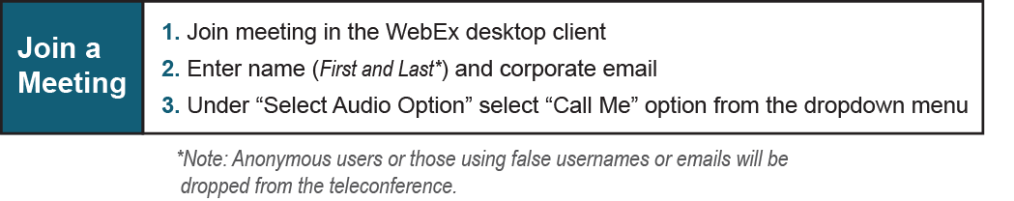

Provide feedback on the progress of this group: Facilitator Feedback Form
Visit learn.pjm.com, an easy-to-understand resource about the power industry and PJM’s role.

