PJM Business Practices
for Linden VFT Transmission Service

Table of Contents

Table of Contents 2
About These Practices 3
1. Valid Paths for the LINDEN VFT Reservations on the PJM OASIS 4
2. Acquiring Linden VFT Service 4
3. Resale of Capacity of Linden VFT Service 4
4. Submission Deadlines for Linden VFT Capacity Resales 4
5. Available Linden VFT Service Products on the OASIS 4
6. Recallability of Linden VFT ATC 4
7. Billing for Linden VFT Reservations 4
8. Losses 4
9. Rebates 4
10. Scheduling Power on the Linden VFT Line 4
11 Counter-flows 4
11.1 Ex: Rights Holder Withdrawal: PJM-NYISO 4
11.2 Ex: Rights Holder Injection: NYISO-PJM 4
11.3 Ex: Rights Holder Withdrawal and Injection: 4
11.4 Ex: Rights Holders variations: 4
12. Definitions* 4
APPENDIX A: Linden VFT Regional Practices Revisions and Updates 4

8
8
8
9
11
12
13
14
15
17

About These Practices

These practices are specifically related to service over the Linden Variable Frequency Transformer (VFT) Merchant Transmission facility, and are supplemented and complemented by the normal OASIS business practices as posted on the PJM OASIS (http://oasis.pjm.com). Updates or real-time information may also be posted to the Merchant Transmission Facilities page on the PJM OASIS. For any questions related to the PJM OASIS please contact oasisadmin@pjm.com or call the PJM OASIS hotline during business hours, 8:00AM-5:00PM at (610)-666-8972.

The Linden VFT is capable of both injecting power into and withdrawing power from PJM and the New York Independent System Operator (NYISO). In order to do this, reservations are needed on two paths to complete the transfer for either direction to the points specified by the Interconnection Service Agreement (ISA) and PJM’s Tariff Section 232. These Linden VFT Business Practices apply to the Firm and Non-Firm rights consistent with the ISA.

To move power from PJM over the Linden VFT line to NYISO, two PJM transmission service reservations are required. A transmission service reservation is required from the PJM Transmission System to the Linden VFT (“Out Service”). A second transmission service reservation over the Linden VFT (“Linden VFT Service”) is also required. The PJM Out Service is provided under Part II (or Part III for non-zonal load) of the PJM Open Access Transmissions Tariff (“Tariff”) and the PJM Regional Practices (PJM OASIS business practices). The Linden VFT Service falls under the Tariff provisions for controllable merchant facilities, Schedules 16 and 16-A of the PJM Tariff and these Linden VFT Business Practices.

To move power from NYISO over the Linden VFT line to PJM, two PJM transmission service reservations are required. A transmission service reservation is required from the Linden VFT to the PJM Transmission System (“In Service”). A second transmission service reservation over the Linden VFT (“Linden VFT Service”) is also required. The PJM In Service falls under Part II (or Part III for non-zonal load) of the PJM Open Access Transmissions Tariff (“Tariff”) and the PJM Regional Practices (PJM OASIS business practices). The Linden VFT Service falls under the Tariff provisions for controllable merchant facilities, Schedules 16 and 16-A of the PJM Tariff and these Linden VFT Business Practices.

Valid Paths for the LINDEN VFT Reservations on the PJM OASIS

Linden VFT Service, like PJM Out Service or In Service, will be acquired on the PJM OASIS. Both Linden VFT Service and either PJM Out Service or PJM In Service are required to make a complete path from PJM to NYISO or NYISO to PJM over the Linden VFT.

The PJM Out Service path is “PJM-LINDENVFT” on the PJM OASIS. This is the PJM out-service that will be used to schedule power from PJM to the Linden VFT facility. This PJM Out Service is covered by normal PJM OASIS business practices. This path provides service to the Linden VFT.

The PJM In Service path is “LINDENVFT-PJM” on the PJM OASIS. This is the PJM in-service that will be used to schedule power from the Linden VFT facility to PJM. This PJM In Service is covered by normal PJM OASIS business practices. This path provides service from the Linden VFT.

The Linden VFT Service path is either “PJM-LINDENCOGEN” (for flows from PJM to NYISO) or “LINDENCOGEN-PJM” (for flows from NYISO to PJM) on the PJM OASIS. These paths provide service over the Linden VFT. All Available Transfer Capability (ATC) over the Linden VFT is held by Primary Rights Holder(s) per Schedules 16 and 16-A of the PJM Tariff until all or a portion of the ATC is resold for purchase by other PJM members through the PJM OASIS.

  - Deliverability of Capacity and Energy to the Point of Delivery for the Out Service is maintained through ensuring Transmission Withdrawal Rights are represented in the Planning Process and ATC calculations. PJM’s approval of transmission Out Service requests for PJM-LINDENVFT is contingent upon the Transmission Customer’s acquisition of Linden VFT Service.
  - Deliverability of Capacity and Energy to the Point of Delivery for the In Service is maintained through ensuring Transmission Injection Rights are represented in the Planning Process and ATC calculations. PJM’s approval of transmission In Service requests for LINDENVFT-PJM is contingent upon the Transmission Customer’s acquisition of Linden VFT Service.
  - Because Linden VFT holds Firm Transmission Withdrawal Rights and Non-Firm Transmission Injection Rights, delivery of capacity and energy to or from the Point of Interconnection is maintained for the life of the facility.

Acquiring Linden VFT Service

Companies acquiring an In Service or Out Service reservation must also have or acquire a corresponding Linden VFT Service reservation, for the time and capacity that will be used for scheduling purposes. Transmission capability should not be held except for anticipated scheduling or resale purposes.

Linden VFT Service that does not have scheduled use (approved NERC tag) may be posted for resale by the Primary Rights Holder(s) as Firm or Non-Firm ATC using the OASIS resale functionality. Linden VFT Service that is not posted for resale and does not have scheduled use will be posted for resale by default by PJM as Non-Firm.

Postings for resale must be completed before the start of service as ATC postings by the Primary Rights Holder(s). Linden VFT Service (over the Merchant Facility) will be posted for resale as described in Section 3. Posted Linden VFT Service that is available for purchase can be viewed on the OASIS under the Display ATC link. Linden VFT Service can be requested through the PJM OASIS web or the OASIS template interface. The requester must have access to do business through the PJM OASIS and be an Eligible Customer as defined by the PJM Tariff. An Eligible customer shall execute the applicable agreements with the Transmission Provider prior to requesting access to do business through the PJM OASIS. All long term requests require an individual Transmission Service Agreement (TSA), Exhibit A of either Schedule 16 or 16-A. Short term requests can be covered under the umbrella of a single TSA.

After a request is received to purchase service on the PJM OASIS, a reservation will be created and the customer will be contacted by email with their reservation number and status. The Primary Rights Holder(s) will evaluate requests to purchase service from postings and respond in accordance with PJM’s practices (located on the OASIS homepage at http://oasis.pjm.com/) for resale of transmission service as defined in the Regional Practices section 1.12. The rate for the service is set by the Primary Rights Holder(s) and is negotiated until the request is in CONFIRMED status. The rate paid by the requestor of this service is the rate applicable, as negotiated, at the time of purchase, and will not be subject to rate changes after purchase.

Resale of Capacity of Linden VFT Service
A holder of Linden VFT Service may resell transmission service rights for use according to Schedule 16 or 16-A of the PJM Tariff. All instances (1) of rights and service released or assigned by Primary Rights Holders, (2) of holders of service who wish to resell, and (3) of default releases will be posted on the PJM OASIS as a posting of ATC for resale.

Linden VFT Service already scheduled will not be subject to default resale. All Linden VFT Service that has neither been scheduled nor already posted for resale is subject to the default resale practices identified in this document and Schedule 16 or 16-Aof the Tariff.

Linden VFT service posted for resale will be posted on the PJM OASIS under the Display ATC link for each of the respective service holders. The rates for postings of Linden VFT Service are set by the Linden VFT Service holder(s) at the time of posting. Default resales shall be charged the rate submitted by Linden VFT, or absent this submission, the lowest rate posted on OASIS for release of Linden VFT Reservations in the applicable hour. Linden VFT Service (over the Merchant Facility) that has neither been scheduled nor posted for resale will be default released (posted as ATC for resale) beginning 12:00 p.m. Eastern Prevailing Time (EPT) one business day before the operations.

The default release rate may be set or updated by Linden VFT (the merchant Transmission Owner) periodically.

The Linden VFT Service holder that retains their Linden VFT Service is obligated to pay for service. If a purchasing transmission service customer reserves the resold service, the Linden VFT Service holder will be credited and the purchasing Linden VFT Service holder will be charged the rate posted by the selling Linden VFT Service holder at the time of the purchase.

Submission Deadlines for Linden VFT Capacity Resales

Table 1.6 in the PJM Regional practices posted on the OASIS details the submittal timelines for each point-to-point transmission product. The regional practices can be viewed from the following link: http://www.pjm.com/markets-and-operations/etools/oasis.aspx

Available Linden VFT Service Products on the OASIS
- year-LINDEN VFT_F_CAP
- year-LINDEN VFT_NF_CAP
- year-LINDEN VFT_NF
- month-LINDEN VFT_F_CAP
- month-LINDEN VFT_NF_CAP
- month-LINDEN VFT_NF
- week-LINDEN VFT_F_CAP
- week-LINDEN VFT_NF_CAP
- week-LINDEN VFT_NF
- day-LINDEN VFT_F_CAP
- day-LINDEN VFT_NF_CAP
- day-LINDEN VFT_NF
- hour-LINDEN VFT_F_CAP
- hour-LINDEN VFT_NF_CAP
- hour-LINDEN VFT_NF
- hour-LINDEN VFT_NF_DEFAULT

Recallability of Linden VFT ATC
The owner of the firm Linden VFT reservation retains the right of recall for ATC resold on a non-firm basis (LINDEN VFT_NF). The firm Linden VFT Service holder has up to 2 business days before the start of service to recall the capacity. This right of recall does not apply to service that has been resold by default due to unscheduled service or to Linden VFT Service released as firm service (LINDEN VFT_F_CAP). Notwithstanding the right to recall, Firm service shall have scheduling priority over non-firm service, and schedules using firm service shall displace schedules using non-firm service as needed to prevent overuse of the Linden VFT Facility.

Billing for Linden VFT Reservations
Billing for Linden VFT Service will be done on a normal monthly basis, similar to all other Point-to-Point Transmission Service billing. For resold capacity on the Linden VFT line, the company reselling the capacity that has been purchased will be credited for the amount sold. Customers that have purchased service will be billed for the full amount of service purchased. Revenue from service that has been resold resulting from a default release will be payable to Linden VFT transmission owner. Subsection 23 of the PJM Tariff explains the process in the event a buyer does not pay for service. Any questions about this billing should be directed to the OASIS hotline, at 610-666-8972 or to the oasisadmin@pjm.com email address.

Losses
Losses across the Linden VFT (the Linden VFT Service) must be accounted for in the request for PJM Transmission Service for withdrawals. For injections, it is the responsibility of the scheduling party to determine that they are accounting for losses in the market to avoid real-time transaction exposure. The capacity reserved on the Linden VFT Service reservation is measured at LINDENCOGEN. To account for withdrawal losses, the PJM Out Service reservation includes the MW amount of the losses, rounded up to the next whole MW. To account for injection losses across the Linden VFT, the day-ahead or real-time bid for the PJM In Service reservation needs to be reduced by the MW loss amount. Losses on the PJM transmission system are financial on the NERC tag schedule. The maximum continuous scheduling capability for the Linden VFT will be set by PJM equal to the facility capability as measured at the PJM-NYIS interface, and will be posted to the OASIS as Total Transfer Capability “TTC” for both injections and withdrawals. This number will not exceed the Firm or Non-Firm Transmission Rights specified per the Interconnection Study Agreement and PJM’s Tariff Section 232.

All losses for the month on the Linden VFT facility are allocated by usage. For events where there is no flow due to scheduling or possible derates, the same billing shall apply.

Rebates
The PJM practices for rebates for Linden VFT Service, PJM In Service, and PJM Out Service are identical. These practices are listed in the PJM OASIS Regional Practices.

Scheduling Power on the Linden VFT Line
Two PJM reservations are needed to schedule power on the Linden VFT line for a complete path in either direction. For withdrawing from PJM to the NYISO, both a PJM Out Service and a Linden VFT Service reservation are needed. For injecting into PJM from the NYISO, both a PJM In Service and a Linden VFT Service reservation are needed. The Linden VFT Service reservation must have a Point of Delivery of LINDENCOGEN to match a PJM Out Service reservation and/or have a Point of Receipt of LINDENCOGEN to match a PJM In Service reservation. Additionally, either the PJM In Service reservation or the PJM Out Service reservation must be identified on the NERC Tag for all Linden VFT Schedules.
Linden VFT tags will look similar to other PJM and NYISO tags with the exception of the POR or POD on the PJM TP line in the Physical Path. Instead of “NYIS”, the POR or POD should be “LIND”; however, the GCA and LCA on the tag will still be either “PJM” or “NYIS.”

The Linden VFT Service reservation should not be included on the OASIS field on the NERC tag; it should be included in the Contract field on the PJM TP line in the Physical Path section.
To ensure that Linden VFT transactions receive the correct pricing, a PJM special exception must always be attached to the tag. This special exception should be placed on the PJM TP line in the Physical Path section of the tag. In the MISC INFO field, the Token should be “EXCEPTION” and the Value should be “LINDENVFT." Refer to table 1 for an example.

Physical Path
CA | TP | PSE | POR | POD | Sched Entities | Contract | Misc(Token/Value)
PJM |  | MyCompany | pjmsyspower |  |  | 123456
 | PJM | MyCompany | PJM | LIND
  EXCEPTION | LINDENVFT
 | NYIS | MyCompany | NYIS | NYIS
NYIS |  | MyCompany | NYIS
Table 1
The net interchange scheduled over the Linden VFT facility (Linden VFT Net Scheduled Interchange) will be capped at a maximum of 300 MW as metered at the point of receipt/delivery (LINDENCOGEN) at any given time. Transaction requests that violate this limit will not be accepted.

All schedules must match the OASIS In Service reservation or Out Service reservation start and stop times. “Sliding” transmission reservations by up to one hour due to ramp restrictions is not permitted for reservations related to merchant transmission facilities.

Counter-flows

ATC is calculated based on all Linden VFT reservations. Capacity on the Linden VFT facility may be voluntarily released allowing both Injection and Withdrawal Rights simultaneously. Schedules are permitted in both directions per service increment for Firm or Non-Firm PJM In Service or Out Service reservations. The total interchange in either direction cannot exceed the MW amount of rights specified per the Interconnection Study Agreement and PJM’s tariff section 232. On the PJM OASIS, injections and withdrawals are treated as separate paths, therefore netting does not apply. To avoid a default release, both injection and withdrawal reservations must be either voluntarily released or scheduled, to their capacity right total. See Diagram 1 and examples.

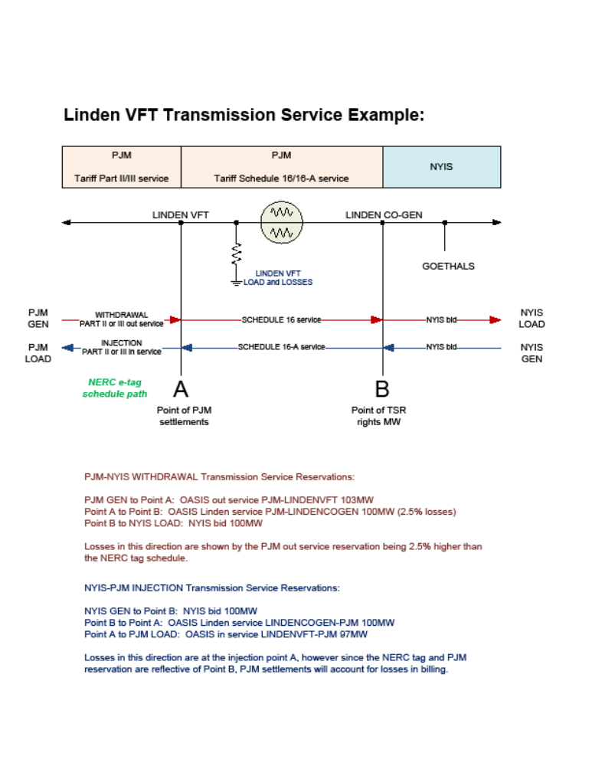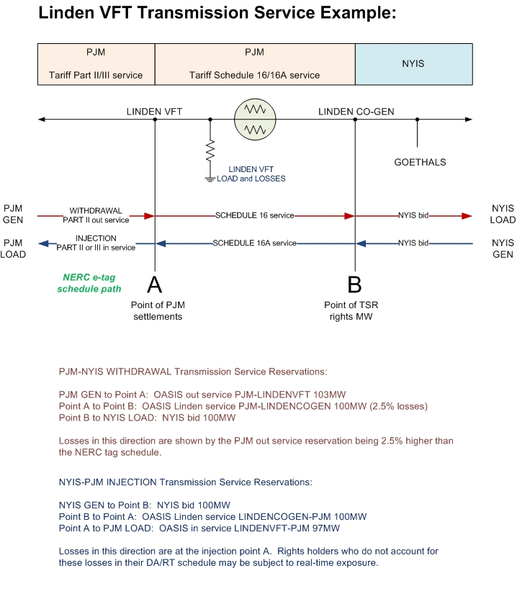
Diagram 1

Definitions*
* (capitalized terms not defined below are defined in the PJM Tariff.)

12.1 Linden VFT Reservation: A right, denoted in Megawatts and for a specified period, to request the injection or withdrawal of energy and capacity from the Transmission System at the Point of Interconnection (PSEG-VFT) and submit schedules for transmission service over the Linden VFT on a firm or non-firm basis as set forth in Schedule 16 or 16-A of the PJM Tariff.
12.2 Linden VFT Transmission Customer: An entity that (i) is an Eligible Customer (or its Designated Agent) that meets the creditworthiness requirements of the Transmission Provider set forth in Attachment Q to the Tariff and is in good-standing with respect to all payments owed under the Tariff and Operating Agreement; (ii) executes a Linden VFT Service Agreement, the form of which is attached as Exhibit A to Schedule 16 or 16-A; and (iii) holds a Linden VFT Reservation. and, in the case of a re-sale of a Linden VFT Reservation, (iv) has the applicable Attachment A-1 completed and signed by all parties.
12.3 Linden VFT facility: The Linden VFT is a controllable AC (alternating current) Merchant Transmission facility that contains variable frequency transformers and runs between the VFT Substation in Linden, New Jersey to the Linden Co-Gen Substation in Linden, New Jersey, which was the subject of Commission orders in FERC Docket No. No. ER07-543 et al. regarding operation of these transmission facilities as a merchant transmission facility and as more particularly described in the Interconnection Service Agreement among PJM Interconnection, L.L.C. and Linden VFT, L.L.C. and Public Service Electric and Gas Company, which was accepted for filing by the Commission in FERC Docket No. ER06-649

12.4 Linden VFT Schedule: The schedule for the transmission of capacity and energy on the Linden VFT Line pursuant to the terms and conditions of service set forth in Schedule 16 or 16-A.
12.5 Linden VFT Out Service Schedule: The schedule for the transmission for delivery to the Linden VFT facility using the PJM point to point out service required to schedule energy for delivery to the Linden VFT.

12.6 Linden VFT In Service Schedule: The schedule for the transmission for delivery to PJM using the PJM point to point in service required to schedule energy to PJM.
12.7 Linden VFT Transmission Owner: Linden VFT LLC, its agents, successors or assigns.
12.8 Primary Rights Holder: An entity that has been allocated rights to the use of the transmission capability of the Linden VFT facility and assigned Firm and Non-Firm Transmission Injection or Withdrawal Rights by the Linden VFT Transmission Owner in accordance with Schedule 16 or 16-A, Section 2.1 of the tariff.
12.9 Secondary Rights Holder: An entity that has been allocated rights to the use of the transmission capability of the Linden VFT facility and assigned Firm and Non-Firm Transmission Injection or Withdrawal Rights by the Primary Rights holder in accordance proper release, allocation, or reassignment rules.

  - PJM Tariff: The PJM Open Access Transmission Tariff.
  - PJM Out Service: The schedule for the transmission of capacity and energy from the PJM system to the Linden VFT facility pursuant to the terms and conditions of service set forth in Parts II and III of the PJM Tariff.
  - PJM In Service: The schedule for the transmission of capacity and energy from the Linden VFT facility to the PJM system pursuant to the terms and conditions of service set forth in Parts II and III of the PJM Tariff.

APPENDIX A: Linden VFT Regional Practices Revisions and Updates
3/1/2009 First Draft Created. Updates to multiple sections pursuant to Schedule 16 changes.
4/2/2009 Updates pertaining to release/resale functionality of PJM Regional Practices and references.
9/3/2009 Updated Section 2 Acquiring Linden VFT Service clarifying reservations required, Section 10 Scheduling Power on the Linden VFT Line clarifying sliding schedules not permitted for merchant transmission. Updated active hyperlinks throughout document. Updated Section 7 Billing for Linden VFT Reservations to clarify normal monthly billing. Updated FERC Docket reference.
8/18/2010 Updated various sections to include Injections Rights into PJM. Added counter-flow section 11. Added example table and diagram.
8/31/2010 Review and approval of draft version.
11/11/2010 Revised examples to show scheduling scenarios.
1/21/2011 Added additional various comments recommended by VFT.

