Market Implementation Committee
PJM Conference & Training Center, Audubon, PA
October 11, 2017
9:00 a.m. – 4:00 p.m. EPT

Administration (9:00-9:05)
Welcome, announcements and review of the Antitrust, Code of Conduct, and Public Meetings/Media Participation Guidelines – Ms. Christina Stotesbury and Ms. Chantal Hendrzak

The committee will be asked to approve draft minutes from the September 13, 2017 Market Implementation Committee meeting.

Ms. Christina Stotesbury, PJM, will review the active MIC issues on Issue Tracking.

Mr. Jeff Schmitt, PJM, will provide an update on the Fuel Cost Policy Annual Review and Variable Operations & Maintenance review. Updated policies are required to be approved no later than November 1, 2017.

Ms. Jennifer Tribulski, PJM, will provide an update on the proposed Virtual Transaction filing.

Endorsements/Approvals (9:05-10:30)
- Revisions to Manual 11 for Intraday Offers (9:05-9:25)
Ms. Lisa Morelli, PJM, will present revisions to Manual 11 and the Operating Agreement to amend the offer capping logic. The committee will be asked to endorse the Manual 11 revisions.

- Revisions to Manual 11 for Energy Offer Verification (9:25-9:55)
- Mr. Rami Dirani, PJM, will present revisions to Manual 11 associated with the offer verification process for the implementation of Order 831: Energy Offer Verification. The committee will be asked to endorse the Manual 11 revisions.
- Dr. Catherine Tyler, Monitoring Analytics, will present concerns related to the offer verification process.

- Proposed Credit Requirements for Regulation (9:55-10:10)
Mr. Hal Loomis, PJM, will present Tariff revisions for a proposed change in credit requirements for regulation resources. The committee will be asked to endorse the Tariff revisions.

- Winter DR Load Calculation – Problem Statement and Issue Charge (10:10-10:20)
Mr. Chuck Dugan, EKPC, will present a problem statement and issue charge related to the DR CP Winter Load calculation. The committee will be asked to endorse the problem statement and issue charge.

- Long Term FTR Market – Problem Statement and Issue Charge (10:20-10:30)
Dr. Joe Bowring, Monitoring Analytics, will review a problem statement and issue charge related to the Long Term FTR Market. The committee will be asked to endorse the problem statement and issue charge.

Break (10:30-10:45)
- Proposed FTR Credit Requirements for Transmission Upgrades (10:45-11:00)
- Mr. Hal Loomis, PJM, will present a first read of a proposed change in FTR credit requirements to reduce exposure posed by congestion reductions resulting from major transmission upgrades. The committee will be asked to endorse the proposal at the November MIC meeting.
- Mr. Bruce Bleiweis, DC Energy, will provide an update on the proposed FTR Credit requirements.

- Proposed Price Responsive Demand (11:00-11:30)
Mr. Pete Langbein, PJM, and Ms. Terri Esterly, PJM, will present a first read of a three proposals that came from the Demand Response Subcommittee to address Price Responsive Demand. The committee will be asked to endorse a proposal at the November MIC meeting.

- Manual 11, 18, 27, 28, and 29 Revisions for 5-minute Settlements (11:30-12:30)
Ms. Terri Esterly, PJM, will present a first read of revisions to Manual 18, and Mr. Ray Fernandez, PJM, will present a first read of revisions to Manuals 11, 27, 28, and 29 associated with the implementation of 5-Minute Settlements. The committee will be asked to endorse the manual revisions at the November MIC meeting.

Lunch (12:30-1:15)

Working Issues (1:15-2:45)
- Market Path/Interface Pricing Point Alignment (1:15-2:00)
Mr. John Dadourian, Monitoring Analytics, will review the Market Path/Interface Pricing Point Alignment issue and present a proposed solution.

- Transmission Penalty Factors (2:00-2:45)
Mr. Devendra Canchi, Monitoring Analytics, will review the Transmission Penalty Factors issue approved at the August 9 MIC, and provide education.

Additional Updates (2:45-3:30)
- Offer Cap Balancing Ratio (2:45-3:05)
Mr. Jeff Bastian, PJM, will review the proposal to address an offer cap balancing ratio issue identified for the next BRA.

- Interregional Coordination Activity (3:05-3:15)
Mr. Tim Horger, PJM, will provide an update on Interregional Coordination efforts.

- Ohio Valley Electric Corporation (OVEC) Integration (3:15-3:30)
Mr. Scott Cunningham, OVEC, will provide an update on the OVEC integration proposal.

Informational Section
Credit Subcommittee (CS)
Meeting materials will be posted to the CS website.

Demand Response Subcommittee (DRS)
Meeting materials will be posted to the DRS web site.

Intermittent Resources Subcommittee (IRS)
Meeting materials will be posted to the IRS web site.

Manual 03 Revisions – Transmission Operations
Mr. Yuri Smolanitsky, PJM, will be available to answer questions related to Manual 03, version 52 revisions.
Materials are posted as informational only.

Market Settlements Subcommittee (MSS)
Meeting materials are posted to the MSS web site.

Report on Market Operations
The Report on Market Operations will be reviewed during the MC Webinar.

Future Meeting Dates
November 8, 2017 | 9:00 a.m. | PJM Interconnection – Conference & Training Center
December 13, 2017 | 9:00 a.m. | PJM Interconnection – Conference & Training Center
January 10, 2018 | 9:00 a.m. | PJM Interconnection – Conference & Training Center
February 7, 2018 | 9:00 a.m. | PJM Interconnection – Conference & Training Center
March 7, 2018 | 9:00 a.m. | PJM Interconnection – Conference & Training Center
April 4, 2018 | 9:00 a.m. | PJM Interconnection – Conference & Training Center
May 2, 2018 | 9:00 a.m. | PJM Interconnection – Conference & Training Center
June 6, 2018 | 9:00 a.m. | PJM Interconnection – Conference & Training Center

Author: Christina Stotesbury

Antitrust:
You may not discuss any topics that violate, or that might appear to violate, the antitrust laws including but not limited to agreements between or among competitors regarding prices, bid and offer practices, availability of service, product design, terms of sale, division of markets, allocation of customers or any other activity that might unreasonably restrain competition. If any of these items are discussed the chair will re-direct the conversation. If the conversation still persists, parties will be asked to leave the meeting or the meeting will be adjourned.

Code of Conduct:
As a mandatory condition of attendance at today's meeting, attendees agree to adhere to the PJM Code of Conduct as detailed in PJM Manual 34 Section 4.5, including, but not limited to, participants' responsibilities and rules regarding the dissemination of meeting discussion and materials.

Public Meetings/Media Participation:
Unless otherwise noted, PJM stakeholder meetings are open to the public and to members of the media. Members of the media are asked to announce their attendance at all PJM stakeholder meetings at the beginning of the meeting or at the point they join a meeting already in progress. Members of the Media are reminded that speakers at PJM meetings cannot be quoted without explicit permission from the speaker. PJM Members are reminded that "detailed transcriptional meeting notes" and white board notes from "brainstorming sessions" shall not be disseminated. Stakeholders are also not allowed to create audio, video or online recordings of PJM meetings. PJM may create audio, video or online recordings of stakeholder meetings for internal and training purposes, and your participation at such meeting indicates your consent to the same.

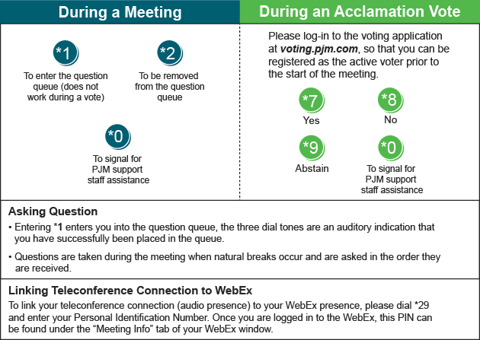
Provide feedback on the progress of this group: Facilitator Feedback Form
Visit learn.pjm.com, an easy-to-understand resource about the power industry and PJM’s role.

