Members Committee Webinar
PJM Conference and Training Center, Audubon, PA
March 18, 2019
1:00 p.m. – 5:00 p.m. EPT

Administration (1:00-1:05)
Welcome, announcements and Anti-trust and Code of Conduct announcement – Ms. Janell Fabiano

Informational Updates (1:05 – 1:45)
- PJM Homepage Redesign (1:05-1:15)
Mr. Chad Hutchinson will provide an update on the pjm.com homepage redesign.
- Interregional Coordination (1:15-1:25)
Mr. Phil D’Antonio will provide an update on interregional coordination activities

- Data Redistribution & PJM Connext Update (1:25-1:35)
Mr. Fran Barrett will provide an update on PJM Connext and data redistribution efforts.

Upcoming Stakeholder Process Items (1:35-1:40)
Stakeholder Process Super Forum scheduled for April 4, 2019.

Reports (1:40-4:55)
- State Activities (1:40-1:50)
Receive report on recent activities of the Organization of PJM States, Inc. – Mr. Gregory Carmean
- Market Monitoring Report (1:50–2:00)
Receive report of the Independent Market Monitor – Mr. Joe Bowring
- PJM Updates (2:00-2:30)
- Receive report on market operations – Ms. Jennifer Freeman
- Receive report on system operations – Mr. Stephanie Monzon
- Receive report on recent regulatory activities – Mr. Jim Burlew

- Stakeholder Group Reports (2:30 – 4:55)
- Markets and Reliability Committee (MRC) – Mr. Dave Anders
- Stakeholder Process Super Forum (MC) – Ms. Rebecca Carroll
- Market Implementation Committee (MIC) – Ms. Bhavana Keshavamurthy
- Operating Committee (OC) – Mr. Don Wallin
- Planning Committee (PC) – Ms. Anisha Fernandes
- Energy Price Formation Sr. Task Force (EPFSTF) – Mr. Dave Anders
- Governing Document Enhancement & Clarification Subcommittee (GDECS) – Mr. Rami Dirani
- Market Efficiency Process Enhancement Task Force (MEPETF) – Mr. Jack Thomas
- Modeling Generation Sr. Task Force (MGSTF) – Ms. Megan McLaverty

Future Agenda Items (4:55 – 5:00)

Future Meeting Dates
April 22, 2019 | 1:00 p.m. | Valley Forge, PA
June 24, 2019 | 1:00 p.m. | Valley Forge, PA
August 19, 2019 | 1:00 p.m. | Valley Forge, PA
September 23, 2019 | 1:00 p.m. | Valley Forge, PA
October 30, 2019 | 1:00 p.m. | Valley Forge, PA
December 2, 2019 | 1:00 p.m. | Valley Forge, PA

Author: J.L. Fabiano

Antitrust:
You may not discuss any topics that violate, or that might appear to violate, the antitrust laws including but not limited to agreements between or among competitors regarding prices, bid and offer practices, availability of service, product design, terms of sale, division of markets, allocation of customers or any other activity that might unreasonably restrain competition. If any of these items are discussed the chair will re-direct the conversation. If the conversation still persists, parties will be asked to leave the meeting or the meeting will be adjourned.

Code of Conduct:
As a mandatory condition of attendance at today's meeting, attendees agree to adhere to the PJM Code of Conduct as detailed in PJM Manual M-34 section 4.5, including, but not limited to, participants' responsibilities and rules regarding the dissemination of meeting discussion and materials.

Public Meetings/Media Participation:
Unless otherwise noted, PJM stakeholder meetings are open to the public and to members of the media. Members of the media are asked to announce their attendance at all PJM stakeholder meetings at the beginning of the meeting or at the point they join a meeting already in progress. Members of the Media are reminded that speakers at PJM meetings cannot be quoted without explicit permission from the speaker. PJM Members are reminded that "detailed transcriptional meeting notes" and white board notes from "brainstorming sessions" shall not be disseminated. Stakeholders are also not allowed to create audio, video or online recordings of PJM meetings. PJM may create audio, video or online recordings of stakeholder meetings for internal and training purposes, and your participation at such meetings indicates your consent to the same.

Participant Identification in WebEx:
When logging into the WebEx desktop client, please enter your real first and last name as well as a valid email address. Be sure to select the “call me” option.
PJM support staff continuously monitors WebEx connections during stakeholder meetings. Anonymous users or those using false usernames or emails will be dropped from the teleconference.



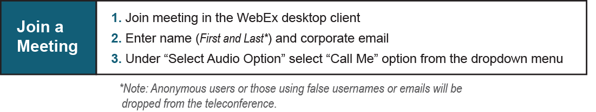

Provide feedback on the progress of this group: Facilitator Feedback Form
Visit learn.pjm.com, an easy-to-understand resource about the power industry and PJM’s role.

