Special MIC: Operating Reserve Clarification for Resources Operating as Requested by PJM
WebEx Only
May 13, 2024
1:00 p.m. – 4:00 p.m. EPT

Administration (1:00 - 1:15)
Nick DiSciullo, facilitator, will provide a welcome to the meeting.
Joseph Tutino, secretary, will review the Antitrust, Code of Conduct, Public Meetings/Media Participation and the WebEx Participant Identification Requirements as detailed at the end of this agenda as well as seek endorsement of the minutes from the last meeting.
Issue Tracking: Operating Reserve Clarification for Resources Operating as Requested by PJM

Consensus Based Issue Resolution (1:15 – 3:45)
- Nick DiSciullo, PJM, will review the previously discussed topics and solicit feedback.
- Joel Luna, IMM, will review the Tracking Ramp Limited Desired calculation.
- Brian Weathers, PJM, will review detailed Tracking Ramp Limited Desired examples with respect to manual dispatch instructions.

Additional Items (3:45 – 4:00)
The facilitation team will review action items from the meeting and take requests for future agenda items.
Future Meeting Dates and Materials |  |  | Materials Due  to Secretary | Materials Published
Date | Time | Location
 |  |  | 5:00 p.m. EPT deadline*
June 10 | 1:00 – 4:00 | WebEx Only | June 3 | June 5
July 15 | 1:00 – 4:00 | WebEx Only | July 8 | July 10
*Materials received after 12:00 p.m. EPT are not guaranteed timely posting by 5:00 p.m. EPT on the same day.
Author: Nick DiSciullo

Antitrust:
You may not discuss any topics that violate, or that might appear to violate, the antitrust laws including but not limited to agreements between or among competitors regarding prices, bid and offer practices, availability of service, product design, terms of sale, division of markets, allocation of customers or any other activity that might unreasonably restrain competition. If any of these items are discussed the chair will re-direct the conversation. If the conversation still persists, parties will be asked to leave the meeting or the meeting will be adjourned.
Code of Conduct:
As a mandatory condition of attendance at today's meeting, attendees agree to adhere to the Code of Conduct as detailed in PJM Manual M-34 section 4.5, including, but not limited to, participants' responsibilities and rules regarding the dissemination of meeting discussion and materials. Expectations for participating in PJM activities are further detailed in the PJM Code of Conduct.

Public Meetings/Media Participation:
Unless otherwise noted, PJM stakeholder meetings are open to the public and to members of the media. Members of the media are asked to announce their attendance at all PJM stakeholder meetings at the beginning of the meeting or at the point they join a meeting already in progress. Members of the Media are reminded that speakers at PJM meetings cannot be quoted without explicit permission from the speaker. PJM Members are reminded that "detailed transcriptional meeting notes" and white board notes from "brainstorming sessions" shall not be disseminated. Stakeholders are also not allowed to create audio, video or online recordings of PJM meetings. PJM may create audio, video or online recordings of stakeholder meetings for internal and training purposes, and your participation at such meetings indicates your consent to the same.
Participant Identification in Webex:
When logging into the Webex desktop client, please enter your real first and last name as well as a valid email address. Be sure to select the “call me” option.
PJM support staff continuously monitors Webex connections during stakeholder meetings. Anonymous users or those using false usernames or emails will be dropped from the teleconference.
Participant Use of Webex Chat:
The use of the Webex chat feature during meetings shall be primarily reserved for administrative and logistical purposes, such as managing a question or comment queue, noting technical difficulties, and meeting support or management purposes. Utilizing Webex chat for any other commentary should be limited to short phrases. Detailed commentary or substantive dialog shall be shared orally by entering the speaker queue.



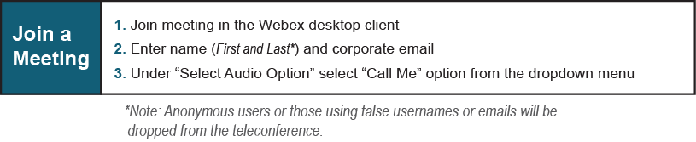
Provide feedback on the progress of this group: Facilitator Feedback Form
Visit learn.pjm.com, an easy-to-understand resource about the power industry and PJM’s role.

