Planning Committee
PJM Conference and Training Center
March 07, 2019
9:00 a.m. – 12:00 p.m. EPT

Administration (9:00-9:15)
- Welcome, announcements and review of the Anti-trust, Code of Conduct, and Media Participation Guidelines
- Approve Planning Committee (PC) Agenda for this meeting
- Approve draft minutes from the February 7th, 2019 PC meeting

Endorsements (9:15-9:20)
- Manual 20 Updates
Mr. Jason Quevada, PJM, will present updates to Manual 20 Resource Adequacy Analysis. The Committee will be requested to endorse these updates.

First Reads (9:20-10:00)
- Market Efficiency Process Enhancement Task Force
Mr. Brian Chmielewski, PJM, will present the Market Efficiency phase 2 proposal developed at the Market Efficiency Process Enhancement Task Force (MEPETF), and the associated OATT revisions. The Committee will be requested to endorse the proposal and Tariff revisions at the next meeting.
Issue Tracking: RTEP Market Efficiency Analysis
- Manual 21 Proposed Revisions
Mr. Jerry Bell and Patricio Rocha-Garrido, PJM, will present proposed revisions to PJM Manual 21 Rules & Procedures for Determination of Generating Capability, including the revisions from the recent ELCC Analysis discussions. The committee will be requested to endorse these revisions at the next meeting.

Informational Updates (10:00-12:00)
Cost Commitment Status and Next Steps
Mr. Mark Sims, PJM, will provide an update on the status and next steps for the Consideration of Cost Commitment for Evaluation of Competitive Transmission Proposals.
Issue Tracking: Cost Containment
FERC Order No. 845 Update
Ms. Susan McGill, PJM, will provide an update on FERC Order No. 845.
AE2 Queue Update
Mr. Jason Connell, PJM, will provide an update on the AE2 queue.
Planning Modeling Update and MOD-32 Update
Mr. Kyle Clifford, PJM, will provide an update on the MOD-032 data requirements including revisions to the documentation available for the MOD-032 process and the 2019 schedule, along with updates on the current model build activities.
Merchant Transmission Interconnection Process and Off-Shore Wind
Ms. Sue Glatz, PJM, will provide information on the Special PC sessions scheduled to work on the Problem Statement that was endorsed at last month’s PC meeting.
Issue Tracking: Merchant Transmission and Off-Shore Wind
RTEP Process Enhancements – Upgrade Modeling
Mr. Aaron Berner, PJM, will present a problem statement related to the process for removal of a network upgrade, baseline or Supplemental Project from the RTEPP, to be worked on at upcoming scheduled PC Special Sessions.
PJM.com Homepage Redesign
Mr. Chad Hutchinson, PJM, will provide a live demo of the new PJM.com homepage redesign.

Information Only
2018 RTEP Report
PJM is notifying stakeholders that the 2018 RTEP Report has been published on PJM.com and can be viewed here: 2018 RTEP Report

Future Meeting Dates
March 22, 2019 | 9:00 a.m. – 3:00 p.m. | Special PC: RTEP Process Enhancements – Upgrade Modeling | PJM Conference & Training Center/ WebEx
March 29, 2019 | 1:00 p.m. – 4:00 p.m. | Special PC: RTEP Process Enhancements – Upgrade Modeling | Teleconference/WebEx
April 11, 2019 | 9:00 a.m. – 12:00 p.m. | Planning Committee | PJM Conference & Training Center/ WebEx
April 12, 2019 | 1:00 p.m. – 4:00 p.m. | Special PC: M-3 Process Lessons Learned | PJM Conference & Training Center/ WebEx
April 16, 2019 | 1:00 p.m. – 4:00 p.m. | Special PC: Merchant Transmission and Off-Shore Wind | PJM Conference & Training Center/ WebEx
May 3, 2019 | 1:00 p.m. – 4:00 p.m. | Special PC: Merchant Transmission and Off-Shore Wind | PJM Conference & Training Center/ WebEx
May 16, 2019 | 9:00 a.m. – 12:00 p.m. | Planning Committee | PJM Conference & Training Center/ WebEx
May 31, 2019 | 1:00 p.m. – 4:00 p.m. | Special PC: Merchant Transmission and Off-Shore Wind | PJM Conference & Training Center/ WebEx
June 13, 2019 | 9:00 a.m. – 12:00 p.m. | Planning Committee | PJM Conference & Training Center/ WebEx
June 28, 2019 | 1:00 p.m. – 4:00 p.m. | Special PC: Merchant Transmission and Off-Shore Wind | PJM Conference & Training Center/ WebEx
July 11, 2019 | 9:00 a.m. – 12:00 p.m. | Planning Committee | PJM Conference & Training Center/ WebEx
July12, 2019 | 9:00 a.m. – 12:00 p.m. | Special PC: M-3 Process Lessons Learned | PJM Conference & Training Center/ WebEx
July 24, 2019 | 1:00 p.m. – 4:00 p.m. | Special PC: Merchant Transmission and Off-Shore Wind | PJM Conference & Training Center/ WebEx
August 8, 2019 | 9:00 a.m. – 12:00 p.m. | Planning Committee | PJM Conference & Training Center/ WebEx
September 12, 2019 | 9:00 a.m. – 12:00 p.m. | Planning Committee | PJM Conference & Training Center/ WebEx
October 11, 2019 | 9:00 a.m. – 12:00 p.m. | Special PC: M-3 Process Lessons Learned | PJM Conference & Training Center/ WebEx
October 17, 2019 | 9:00 a.m. – 12:00 p.m. | Planning Committee | PJM Conference & Training Center/ WebEx
November 14, 2019 | 9:00 a.m. – 12:00 p.m. | Planning Committee | PJM Conference & Training Center/ WebEx
December 12, 2019 | 9:00 a.m. – 12:00 p.m. | Planning Committee | PJM Conference & Training Center/ WebEx

Author: Anisha Fernandes

Antitrust:
You may not discuss any topics that violate, or that might appear to violate, the antitrust laws including but not limited to agreements between or among competitors regarding prices, bid and offer practices, availability of service, product design, terms of sale, division of markets, allocation of customers or any other activity that might unreasonably restrain competition. If any of these items are discussed the chair will re-direct the conversation. If the conversation still persists, parties will be asked to leave the meeting or the meeting will be adjourned.

Code of Conduct:
As a mandatory condition of attendance at today's meeting, attendees agree to adhere to the PJM Code of Conduct as detailed in PJM Manual M-34 section 4.5, including, but not limited to, participants' responsibilities and rules regarding the dissemination of meeting discussion and materials.

Public Meetings/Media Participation:
Unless otherwise noted, PJM stakeholder meetings are open to the public and to members of the media. Members of the media are asked to announce their attendance at all PJM stakeholder meetings at the beginning of the meeting or at the point they join a meeting already in progress. Members of the Media are reminded that speakers at PJM meetings cannot be quoted without explicit permission from the speaker. PJM Members are reminded that "detailed transcriptional meeting notes" and white board notes from "brainstorming sessions" shall not be disseminated. Stakeholders are also not allowed to create audio, video or online recordings of PJM meetings. PJM may create audio, video or online recordings of stakeholder meetings for internal and training purposes, and your participation at such meetings indicates your consent to the same.
Participant Identification in WebEx:
When logging into the WebEx desktop client, please enter your real first and last name as well as a valid email address. Be sure to select the “call me” option.
PJM support staff continuously monitors WebEx connections during stakeholder meetings. Anonymous users or those using false usernames or emails will be dropped from the teleconference.

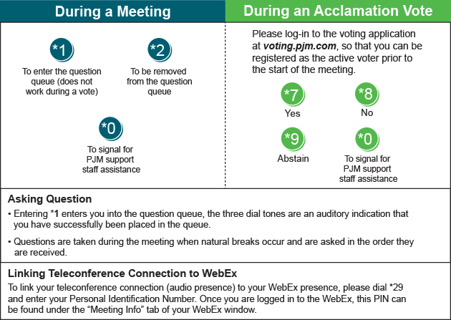

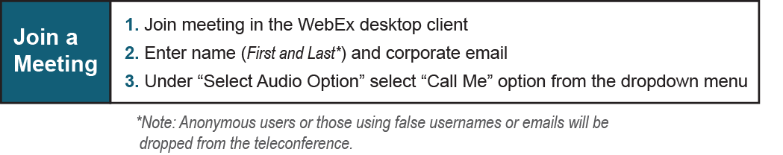
Provide feedback on the progress of this group: Facilitator Feedback Form
Visit learn.pjm.com, an easy-to-understand resource about the power industry and PJM’s role.

