As of May 21, 2026
Critical Issue Fast Path – Reliability Backstop Procurement / Connect and Manage – Stage 3
PJM Conference & Training Center, Audubon, PA / Webex
May 27, 2026
8:30 a.m. – 3:30 p.m. EPT

Administration
- Dave Anders, facilitator, and Matt Connolly, secretary, will welcome participants, make announcements, and review the Antitrust, Code of Conduct, and Public Meetings/Media Participation Guidelines.
Stakeholders will be asked to approve the draft minutes from May 4 and 5, 2026 Stage 2/3 CIFP – Reliability Backstop Procurement (RBP) meetings.
- Adam Keech will discuss combining the PJM Connect and Manage Issue Charge with the CIFP – RBP.
- Dave Anders will review the updated CIFP Work Plan.

Connect and Manage Updates
- Tim Horger and Chris Pilong will provide updates to the PJM solution package and matrix addressing the Connect and Manager framework.

Reliability Backstop Procurement (RBP) Updates
- PJM will provide updates to the PJM solution package and matrix addressing the Reliability Backstop Procurement.
- Dean Koujak, Charles River Associates, will provide an update on the bilateral matching RFP process and timelines.
Lunch and breaks will be taken at appropriate times.

Next Steps
- Dave Anders will discuss next steps.

Future Meeting Dates and Materials |  |  |  | Materials Due  to Secretary | Materials Published
Date | Time | Location
Date | Time | Location | 5:00 p.m. EPT deadline*
June 10, 2026 | 9:00 am – 4:00 pm | PJM Conference & Training Center / Webex | June 2, 2026 |  | June 5, 2026
June 11, 2026 | 9:00 am – 4:00 pm | PJM Conference & Training Center / Webex | June 2, 2026 |  | June 5, 2026
June 30, 2026 | 9:00 am – 2:00 pm | PJM Conference & Training Center / Webex | June 18, 2026 |  | June 23, 2026
*Materials received after 12:00 p.m. EPT are not guaranteed timely posting by 5:00 p.m. EPT on the same day.

Author: M. Connolly

Antitrust:
It is PJM’s policy to comply with applicable antitrust laws. Participants must not disclose or exchange non-public, competitively sensitive information about their individual business strategies. Prohibited topics include, but are not limited to:
- Non-public individual pricing strategies, bidding strategies, or offer practices  - Non-public forecasts of prices, costs, output, or market behavior | - Non-public information about the availability, output or production costs of specific resources or services  - Confidential terms or conditions of sale, service, or trading strategies | - Planned or potential allocation of specific customers, suppliers, or markets among competitors  - Agreements or understandings between or among competitors to limit supply, coordinate bidding, fix prices, divide markets, or refuse to deal with particular entities | - Any other communication that could unreasonably restrain competition or coordinate competitive behavior among market participants
Discussion of PJM-administered market rules, tariff provisions, system operations, and public market outcomes is appropriate, provided individual confidential business information is not shared. These permitted discussions may include advocacy positions, including those reflecting state regulatory responsibilities or consistent with the obligations and interests of state-regulated entities. These discussions occur in a context where resulting rule changes may be submitted to FERC for approval, or may reflect regulatory mandates established by state authorities.
If prohibited topics are raised, the Chair will redirect the conversation. If the discussion continues, participants may be asked to leave the meeting or the meeting may be adjourned. For more information, please refer to PJM’s Antitrust Guidelines for Stakeholder Meetings, which are posted on PJM’s Committees and Groups page.

Code of Conduct:  As a mandatory condition of attendance at today's meeting, attendees agree to adhere to the Code of Conduct as detailed in PJM Manual M-34 section 4.5, including, but not limited to, participants' responsibilities and rules regarding the dissemination of meeting discussion and materials. Expectations for participating in PJM activities are further detailed in the PJM Code of Conduct.  Public Meetings/Media Participation:  Unless otherwise noted, PJM stakeholder meetings are open to the public and to members of the media. Members of the media are asked to announce their attendance at all PJM stakeholder meetings at the beginning of the meeting or at the point they join a meeting already in progress. Members of the Media are reminded that speakers at PJM meetings cannot be quoted without explicit permission from the speaker. PJM Members are reminded that "detailed transcriptional meeting notes" and white board notes from "brainstorming sessions" shall not be disseminated. Stakeholders are also not allowed to create audio, video or online recordings of PJM meetings. PJM may create audio, video or online recordings of stakeholder meetings for internal and training purposes, and your participation at such meetings indicates your consent to the same. | Participant Identification in Webex:  When logging into the Webex desktop client, please enter your real first and last name as well as a valid email address. Be sure to select the “call me” option.  PJM support staff continuously monitors Webex connections during stakeholder meetings. Anonymous users or those using false usernames or emails will be dropped from the teleconference.  Participant Use of Webex Chat:  The use of the Webex chat feature during meetings shall be primarily reserved for administrative and logistical purposes, such as managing a question or comment queue, noting technical difficulties, and meeting support or management purposes. Utilizing Webex chat for any other commentary should be limited to short phrases. Detailed commentary or substantive dialogue shall be shared orally by entering the speaker queue.

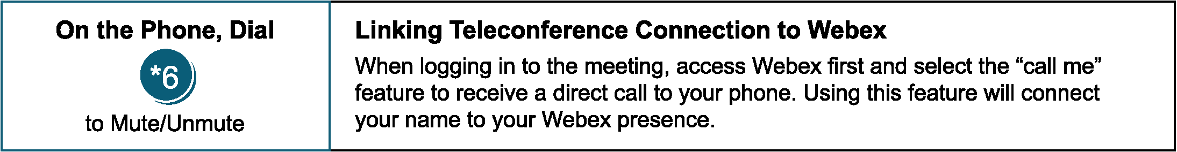

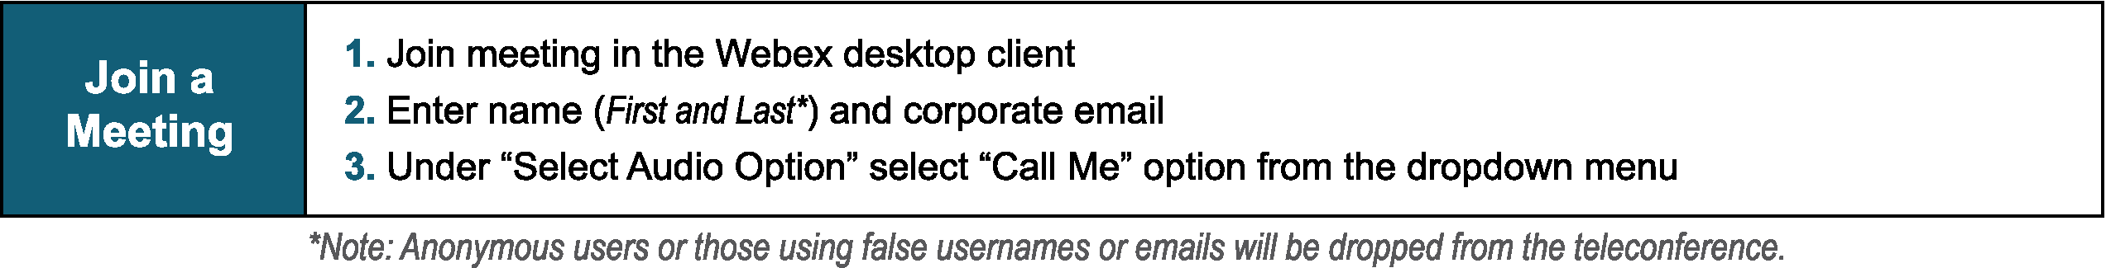
Provide feedback on the progress of this group: Facilitator Feedback Form
Visit learn.pjm.com, an easy-to-understand resource about the power industry and PJM’s role.

