Members Committee
Two Hundred Seventeenth Meeting
Webex Only
November 17, 2021
1:15 p.m. – 5:00 p.m. EPT
*Operator assisted phone lines will be opened 30 minutes prior to the start of the meeting. Due to the high volume of remote participation, stakeholders are asked to connect early to allow additional time for operator queue processing.

Administration (1:15-1:25)
- Announce sector selections of new members since the last meeting. – David Anders
- Confirm the presence of a quorum of representatives or designated alternates for this meeting – David Anders
- Anti-trust, Code of Conduct, Meeting Participation, and Safety announcements – David Anders

Consent Agenda (1:25-1:30)
- Approve draft minutes of the October 20, 2021 Members Committee meeting.
- Endorse the 2021 Reserve Requirement Study results (IRM, FPR).
- Endorse/Approve proposed revisions in Manual 15: Cost Development Guidelines, the Operating Agreement, and the Tariff to address incremental and no load energy offers.
- Endorse proposed Tariff revisions addressing behind the meter generation business rules on status changes.
Issue Tracking: Behind the Meter Generation Business Rules on Status Changes
- Endorse proposed Tariff revisions to address changes related to ARRs, FTRs, and transparency.
Issue Tracking: ARR/FTR Market Review

Endorsements (1:30-1:45)
- Motion Regarding West Virginia PSC Attendance at Liaison Committee Meetings (1:30-1:45)
Members may move and second the following motion:
Do Members object to the request of the Public Service Commission of West Virginia (as an ex officio non-voting member of the Standing Committees) to attend the Liaison Committee as an observer?
Jackie Roberts, West Virginia PSC, will discuss the motion. The committee may be asked to endorse this motion upon first read.

Reports (1:45-2:00)
- MC Vice Chair Report (1:45-1:55)
- Provide an update on the Members Committee Annual Plan – Becky Robinson
- Provide a report on the plans for the February 2022 Liaison Committee meeting with the PJM Board of Managers – Becky Robinson
- Webinar Feedback (1:55-2:00)
Stakeholders may raise any items identified for further discussion from the September 27, 2021 Members Committee Webinar.

Future Agenda Items (2:00)
Future Meeting Dates and Materials |  |  |  | Materials Due  to Secretary |  | Materials Published
Date | Time | Location
December 15, 2021 | 1:15 p.m. | WebEx | December 3, 2021 |  | December 8, 2021
January 26, 2022 | 1:15 p.m. | TBD | January 14, 2022 |  | January 19, 2022
February 24, 2022 | 1:15 p.m. | TBD | February 14, 2022 |  | February 17, 2022
March 23, 2022 | 1:15 p.m. | TBD | March 11, 2022 |  | March 16, 2022
April 27, 2022 | 1:15 p.m. | TBD | April 15, 2022 |  | April 20, 2022
May 17, 2022 | 10:00 a.m. | TBD | May 5, 2022 |  | May 10, 2022
June 29, 2022 | 1:15 p.m. | TBD | June 17, 2022 |  | June 22, 2022

Author: M. Greening

Antitrust:
You may not discuss any topics that violate, or that might appear to violate, the antitrust laws including but not limited to agreements between or among competitors regarding prices, bid and offer practices, availability of service, product design, terms of sale, division of markets, allocation of customers or any other activity that might unreasonably restrain competition. If any of these items are discussed the chair will re-direct the conversation. If the conversation still persists, parties will be asked to leave the meeting or the meeting will be adjourned.

Code of Conduct:
As a mandatory condition of attendance at today's meeting, attendees agree to adhere to the PJM Code of Conduct as detailed in PJM Manual M-34 section 4.5, including, but not limited to, participants' responsibilities and rules regarding the dissemination of meeting discussion and materials.

Public Meetings/Media Participation:
Unless otherwise noted, PJM stakeholder meetings are open to the public and to members of the media. Members of the media are asked to announce their attendance at all PJM stakeholder meetings at the beginning of the meeting or at the point they join a meeting already in progress. Members of the Media are reminded that speakers at PJM meetings cannot be quoted without explicit permission from the speaker. PJM Members are reminded that "detailed transcriptional meeting notes" and white board notes from "brainstorming sessions" shall not be disseminated. Stakeholders are also not allowed to create audio, video or online recordings of PJM meetings. PJM may create audio, video or online recordings of stakeholder meetings for internal and training purposes, and your participation at such meetings indicates your consent to the same.
Participant Identification in Webex:
When logging into the Webex desktop client, please enter your real first and last name as well as a valid email address. Be sure to select the “call me” option.
PJM support staff continuously monitors Webex connections during stakeholder meetings. Anonymous users or those using false usernames or emails will be dropped from the teleconference.

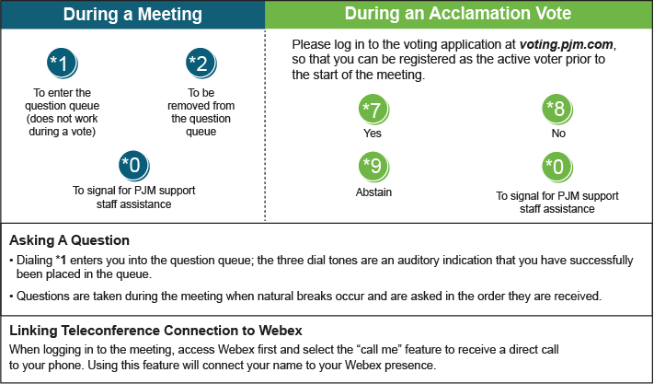

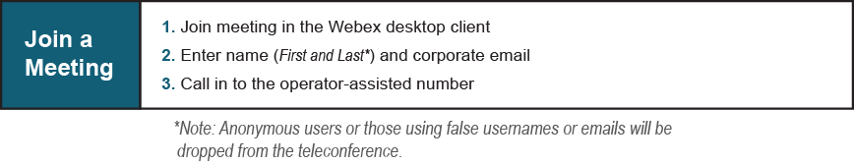
Provide feedback on the progress of this group: Facilitator Feedback Form
Visit learn.pjm.com, an easy-to-understand resource about the power industry and PJM’s role.

