Special Session of the Market Implementation Committee –Fuel Cost Policy Update
PJM Conference & Training Center, Audubon, PA
August 17, 2016
9:00 a.m. – 10:00 a.m. EPT

Administration (9:00-9:05)
- Welcome, announcements and review of the Antitrust, Code of Conduct, and Public Meetings/Media Participation Guidelines – Ms. Christina Stotesbury and Ms. Chantal Hendrzak

Discussion (9:05-10:00)
- Fuel Cost Policy Updates (9:05-10:00)
Mr. Stu Bresler, PJM, and Mr. Jeff Schmitt, PJM, will provide an update and answer questions on the PJM Fuel Cost Policy process and requirements related to the proposed revisions of the Tariff and Operating Agreement in response to FERC Docket ER16-372 regarding Offer Flexibility.

Informational Section
MIC Materials
August Market Implementation Committee Materials.

Author: Christina Stotesbury

Antitrust:
You may not discuss any topics that violate, or that might appear to violate, the antitrust laws including but not limited to agreements between or among competitors regarding prices, bid and offer practices, availability of service, product design, terms of sale, division of markets, allocation of customers or any other activity that might unreasonably restrain competition. If any of these items are discussed the chair will re-direct the conversation. If the conversation still persists, parties will be asked to leave the meeting or the meeting will be adjourned.

Code of Conduct:
As a mandatory condition of attendance at today's meeting, attendees agree to adhere to the PJM Code of Conduct as detailed in PJM Manual M-34 section 4.5, including, but not limited to, participants' responsibilities and rules regarding the dissemination of meeting discussion and materials.

Public Meetings/Media Participation:
Unless otherwise noted, PJM stakeholder meetings are open to the public and to members of the media. Members of the media are asked to announce their attendance at all PJM stakeholder meetings at the beginning of the meeting or at the point they join a meeting already in progress. Members of the Media are reminded that speakers at PJM meetings cannot be quoted without explicit permission from the speaker. PJM Members are reminded that "detailed transcriptional meeting notes" and white board notes from "brainstorming sessions" shall not be disseminated. Stakeholders are also not allowed to create audio, video or online recordings of PJM meetings.

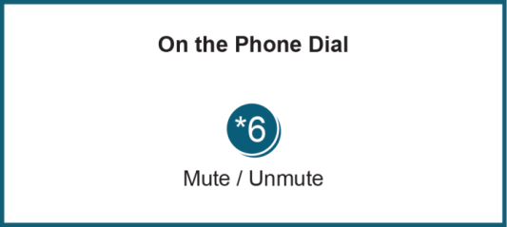
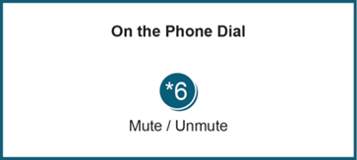

Facilitator Feedback Form: http://www.pjm.com/committees-and-groups/committees/form-facilitator-feedback.aspx

