Special Session of the Market Implementation Committee: Market Operations Price Transparency
PJM Conference & Training Center, Audubon, PA
February 24, 2017
1:00 p.m. – 4:00 p.m. EPT

Administration (1:00-1:05)
- Welcome, announcements and review of the Antitrust, Code of Conduct, and Public Meetings/Media Participation Guidelines.

Discussion (1:05-4:00)
- Background (1:05-1:10)
Mr. Rami Dirani, PJM, will provide background information on PJM’s transparency initiative.

- Price Setting (1:10-2:00)
Ms. Rebecca Carroll, PJM, will provide an overview on Real-Time LMP and impacts on uplift.

- PJM Commitment Process (2:00-3:00)
Mr. Joe Ciabattoni, PJM, will discuss the current PJM commitment process.

- RTOs Reporting (3:00-3:30)
Mr. Rami Dirani, PJM, will provide examples of what PJM and other RTOs/ISOs post with respect to operational commitments and uplift.

- PJM Data Confidentiality (3:30-3:45)
Mr. Tom Zadlo, PJM, will provide an overview of PJM’s current policies and practices for data postings and confidentiality.

- Interest Identification (3:45-4:00)
Mr. Rami Dirani, PJM, will lead the discussion to identify interests.

Antitrust:
You may not discuss any topics that violate, or that might appear to violate, the antitrust laws including but not limited to agreements between or among competitors regarding prices, bid and offer practices, availability of service, product design, terms of sale, division of markets, allocation of customers or any other activity that might unreasonably restrain competition. If any of these items are discussed the chair will re-direct the conversation. If the conversation still persists, parties will be asked to leave the meeting or the meeting will be adjourned.

Code of Conduct:
As a mandatory condition of attendance at today's meeting, attendees agree to adhere to the PJM Code of Conduct as detailed in PJM Manual M-34 section 4.5, including, but not limited to, participants' responsibilities and rules regarding the dissemination of meeting discussion and materials.

Public Meetings/Media Participation:
Unless otherwise noted, PJM stakeholder meetings are open to the public and to members of the media. Members of the media are asked to announce their attendance at all PJM stakeholder meetings at the beginning of the meeting or at the point they join a meeting already in progress. Members of the Media are reminded that speakers at PJM meetings cannot be quoted without explicit permission from the speaker. PJM Members are reminded that "detailed transcriptional meeting notes" and white board notes from "brainstorming sessions" shall not be disseminated. Stakeholders are also not allowed to create audio, video or online recordings of PJM meetings.
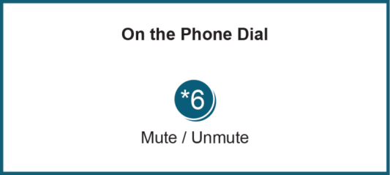

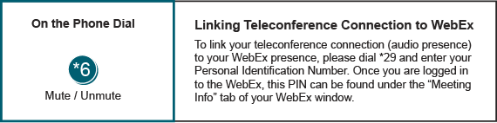

Facilitator Feedback Form: http://www.pjm.com/committees-and-groups/committees/form-facilitator-feedback.aspx

