Market Implementation Committee
WebEx Only
April 7, 2021
9:00 a.m. – 2:00 2:30 p.m. EPT

Administration (9:00 – 9:15)
Nicholas DiSciullo will review the Antitrust, Code of Conduct, Public Meetings/Media Participation and the WebEx Participant Identification Requirements.

The Committee will be asked to approve the draft minutes from the March 10, 2021 Market Implementation Committee meeting.

Nick DiSciullo will provide an update on the MIC Work Plan.

Dave Anders will provide an update on the voting protocols for Board elections at the May Members Committee meeting.

First Readings (9:15 – 10:40)
- Reactive Supply and Voltage Control Compensation (9:15 – 10:00)
- Jim Davis, Dominion Energy, will provide a second first read of the Problem Statement and Issue Charge addressing Compensation for Reactive Supply and Voltage Control service.
- Joe Bowring, IMM, will review an alternate Problem Statement and Issue Charge addressing Compensation for Reactive Supply and Voltage Control service.
The committee will be asked to vote on the Dominion Energy and IMM Issue Charges at its next meeting.

- Manual 11, Manual 18 and Manual 28: Fast-Start Pricing Changes (10:00 – 10:20)
Nicole Militello and Rebecca Stadelmeyer will provide a first read of updates to Manual 11: Energy & Ancillary Services Market Operations, Manual 18: PJM Capacity Market and Manual 28: Operating Agreement Accounting. The committee will be asked to endorse these revisions at its next meeting.

- Regulation for Virtual Combined Cycles (10:20 – 10:40)
Becky Robinson, Vistra, will provide a first read of the Problem Statement and Issue Charge addressing Regulation for Virtual Combined Cycles. The committee will be asked to endorse these revisions approve the issue charge at its next meeting.

Working Items (10:40 – 12:10)
- RPM Capacity Transfer Rights (10:40 – 11:40)
- Jeff Bastian will provide education on the status quo approach to the determination and allocation of CTRs.
- Kevin Zemanek, Buckeye Power, will provide education on the RPM Capacity Transfer Rights Issue Charge.
- Joe Bowring, IMM will provide education on RPM Capacity Transfer Rights.
Issue Tracking: Capacity Transfer Rights in RPM

- Market Suspension (11:40 – 12:10)
- Stefan Starkov will provide an update on the Market Suspension scenario table and an overview of PJM’s proposed solution options.
- Lisa Morelli will facilitate a discussion on proposed solution options and begin the process of developing packages on the Market Suspension matrix as part of the Consensus Based Issue Resolution process.
Issue Tracking: Rules Related to Market Suspension

Lunch (12:10 – 12:50)

Additional Items (12:50 – 2:00 2:20)
- Real Time Value (RTV) Markets Gateway Process Update (12:50 – 1:00)
Tong Zhao will provide a review of the recent change to the RTV submittal process in Markets Gateway following the change to the RTV market rules.

- Synchronized Reserve Event Actions and Expectations (1:00 – 1:15)
Michael Zhang will provide an update on the newly formed Synchronized Reserve Deployment Task Force (SRDTF).

- Markets Certification Exam Update Survey (1:15 – 1:20)
Troy Cawley will provide details on the Markets Certification Exam Update Survey.

- nGEM Project Update (1:20 – 1:35)
Ray Fernandez will provide an update on the Next Generation Energy Market (nGEM)
Software replacement project.

- Emerging Technologies Survey (1:35 – 1:40)
Scott Baker will provide an informational announcement about a forthcoming stakeholder survey related to emerging technologies.

- Freeze Date FERC Filing (1:40 – 1:50)
Joe Rushing will provide an update on the Freeze Date, FFE Solution FERC filing.

- Posting Timeline Trial (1:50 – 2:00)
Michele Greening will review information related to a proposed posting timeline trial period.

- Market Seller Offer Cap (2:00 – 2:20)
PJM will discuss next steps regarding the March 18, 2021 FERC Order on the Market Seller Offer Cap complaints.

Informational Section
Interregional Coordination Update
Materials are posted as informational only.

IROL-CIP Cost Recovery
Darrell Frogg will be providing a second read on Interconnection Reliability Operating Limits-Critical Infrastructure Protection (IROL-CIP) Cost Recovery at the Operating Committee tomorrow. Problem Statement and Issue Charge will be up for endorsement then.

2021/2022 Operating Reserve Demand Curves - Effective 5/1/2022 to 5/31/2022
Materials are posted as informational only.

Shortage Pricing – Price Formation Explanation
Materials are posted as informational only.

Effective Load Carrying Capability (ELCC): Conforming Manual Language Changes
Materials are posted as informational only.

Manual 03 Updates
Updates to PJM Manual 03, Revision 59 – Transmission Operations are posted as informational only with meeting materials.

PJM Manual 03 Attachment E Automatic Sectionalizing Schemes
The PJM Manual 03 Attachment E Automatic Sectionalizing Schemes Pending Approval and Recent Changes document has been posted as an Information Only item to the April meeting website.

ARR FTR Market Task Force (AFMTF)
Meeting materials are posted to the AFMTF website.

Cost Development Subcommittee (CDS)
Meeting materials are posted to the CDS website.

Demand Response Subcommittee (DRS)
Meeting materials are posted to the DRS website.

DER & Inverter-based Resources Subcommittee (DIRS)
Meeting materials are posted to the DIRS website.

Market Settlements Subcommittee (MSS)
Meeting materials are posted to the MSS website.

Report on Market Operations
The Report on Market Operations will be reviewed during the MC Webinar.

Future Meeting Dates
May 13, 2021 | 9:00 a.m. | WebEx
June 9, 2021 | 9:00 a.m. | WebEx
July 14, 2021 | 9:00 a.m. | WebEx
August 11, 2021 | 9:00 a.m. | WebEx
September 9, 2021 | 9:00 a.m. | WebEx
October 6, 2021 | 9:00 a.m. | WebEx
November 3, 2021 | 9:00 a.m. | WebEx
December 1, 2021 | 9:00 a.m. | WebEx

Author: Nick DiSciullo

Antitrust:
You may not discuss any topics that violate, or that might appear to violate, the antitrust laws including but not limited to agreements between or among competitors regarding prices, bid and offer practices, availability of service, product design, terms of sale, division of markets, allocation of customers or any other activity that might unreasonably restrain competition. If any of these items are discussed the chair will re-direct the conversation. If the conversation still persists, parties will be asked to leave the meeting or the meeting will be adjourned.

Code of Conduct:
As a mandatory condition of attendance at today's meeting, attendees agree to adhere to the PJM Code of Conduct as detailed in PJM Manual M-34 section 4.5, including, but not limited to, participants' responsibilities and rules regarding the dissemination of meeting discussion and materials.

Public Meetings/Media Participation:
Unless otherwise noted, PJM stakeholder meetings are open to the public and to members of the media. Members of the media are asked to announce their attendance at all PJM stakeholder meetings at the beginning of the meeting or at the point they join a meeting already in progress. Members of the Media are reminded that speakers at PJM meetings cannot be quoted without explicit permission from the speaker. PJM Members are reminded that "detailed transcriptional meeting notes" and white board notes from "brainstorming sessions" shall not be disseminated. Stakeholders are also not allowed to create audio, video or online recordings of PJM meetings. PJM may create audio, video or online recordings of stakeholder meetings for internal and training purposes, and your participation at such meetings indicates your consent to the same.
Participant Identification in WebEx:
When logging into the WebEx desktop client, please enter your real first and last name as well as a valid email address. Be sure to select the “call me” option.
PJM support staff continuously monitors WebEx connections during stakeholder meetings. Anonymous users or those using false usernames or emails will be dropped from the teleconference.
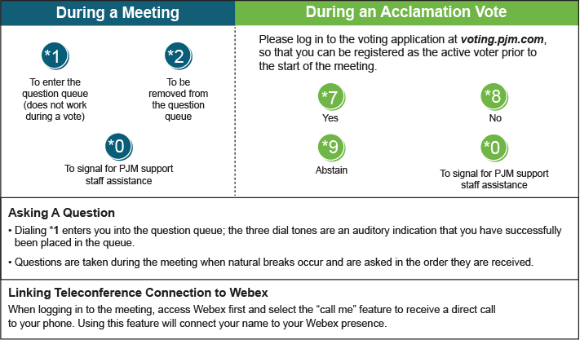

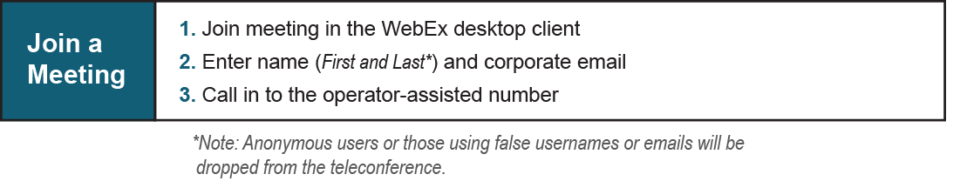
Provide feedback on the progress of this group: Facilitator Feedback Form
Visit learn.pjm.com, an easy-to-understand resource about the power industry and PJM’s role.

