Markets and Reliability Committee – Special Meeting – Energy Market Offer Caps
PJM Conference and Training Center, Audubon, PA
September 24, 2015
9:00 a.m. – 12:00 noon EPT

Administration (9:00-9:05)
Welcome, announcements and Anti-trust and Code of Conduct announcement – Mr. Dave Anders

Endorsements/Approvals (9:05-9:10)
- Draft Minutes (9:05-9:10)
Approve minutes of the September 9, 2015 Markets and Reliability Committee (MRC) meeting.

First Readings/Informational Items (9:10-12:00)
- Energy Market Offer Cap Proposal Discussion (9:10-11:30)
The committee will discuss updates to proposed revisions to the Energy Market Offer Cap provided by the following parties. The committee will be asked to vote on proposals at its next meeting.
- Mr. Jeff Whitehead, Direct Energy.
- Mr. Steve Lieberman, ODEC.
- Mr. Glen Thomas, P3, and Mr. Dave Scarpignato, Calpine.
- Dr. Joe Bowring, Independent Market Monitor.
- Paths Forward (11:30-12:00)
Mr. Dave Anders will lead a discussion of potential paths toward consensus on revisions to the Energy Market Offer Cap issue.

Future Agenda Items (4:00)

Future Meeting Dates

October 1, 2015 | 9:00 a.m. | PJM Conference & Training Center, Audubon, PA
October 22, 2015 | 9:00 a.m. | Wilmington, DE
November 19, 2015 | 9:00 a.m. | Wilmington, DE
December 17, 2015 | 9:00 a.m. | Wilmington, DE

Author: D. A. Anders

Anti-trust:
You may not discuss any topics that violate, or that might appear to violate, the antitrust laws including but not limited to agreements between or among competitors regarding prices, bid and offer practices, availability of service, product design, terms of sale, division of markets, allocation of customers or any other activity that might unreasonably restrain competition. If any of these items are discussed the chair will re-direct the conversation. If the conversation still persists, parties will be asked to leave the meeting or the meeting will be adjourned.

Code of Conduct:
As a mandatory condition of attendance at today's meeting, attendees agree to adhere to the PJM Code of Conduct as detailed in PJM Manual M-34 section 4.5, including, but not limited to, participants' responsibilities and rules regarding the dissemination of meeting discussion and materials.

Public Meetings/Media Participation:
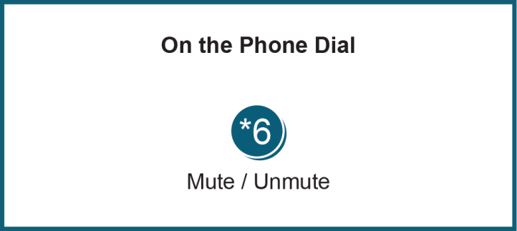
Unless otherwise noted, PJM stakeholder meetings are open to the public and to members of the media. Members of the media are asked to announce their attendance at all PJM stakeholder meetings at the beginning of the meeting or at the point they join a meeting already in progress. Members of the Media are reminded that speakers at PJM meetings cannot be quoted without explicit permission from the speaker. PJM Members are reminded that "detailed transcriptional meeting notes" and white board notes from "brainstorming sessions" shall not be disseminated. Stakeholders are also not allowed to create audio, video or online recordings of PJM meetings.

