Special MRC – Reliability Resource Initiative (RRI) and Capacity Market Adjustments
PJM Conference and Training Center, Audubon, PA / WebEx
November 7, 2024
9:00 a.m. – 4:00 p.m. EPT

Administration (9:00-9:05)
Welcome, announcements and Anti-trust, Code of Conduct, and Public Meetings/Media Participation – Lisa Drauschak and Dave Anders

Capacity Market Adjustments (9:05-2:30)
- Issue Introdcution and Background (9:05-9:20)
Stu Bresler will provide indroductory remarks and a review of the issue background.
- Capacity Market Adjustments (9:20-2:30)
Adam Keech will discuss PJM’s proposed capacity market adjustments.
Lunch Break 12:00-1:00

Reliability Resource Initiative and Surplus Interconnection Process (2:30-4:00)
- Issue Introduction and Background (2:30-2:45)
Aftab Khan will provide introductory remarks and a review of the issue background.
- Reliability Resource Initiative (2:45-3:55)
Donnie Bielak will discuss PJM’s proposal regarding the reliability resource initiative and surplus interconnection process.
- Next Steps (3:55-4:00)
Dave Anders will review next steps for the November 21, 2024 Members Committee meeting.

Future Agenda Items
Future MRC Meeting Dates and Materials |  |  | Materials Due  to Secretary | Materials Published
Date | Time | Location | Materials Due  to Secretary | Materials Published
Date | Time | Location | 5:00 p.m. EPT deadline*
November 21, 2024 | 9:00 a.m. | PJM Conference & Training Center and WebEx | November 11, 2024 | November 14, 2024
December 18, 2024 | 9:00 a.m. | PJM Conference & Training Center and WebEx | December 6, 2024 | December 11, 2024
January 23, 2025 | 9:00 a.m. | PJM Conference & Training Center and WebEx | January 13, 2025 | January 16, 2025
February 20, 2025 | 9:00 a.m. | PJM Conference & Training Center and WebEx | February 10, 2025 | February 13, 2025
March 19, 2025 | 9:00 a.m. | PJM Conference & Training Center and WebEx | March 7, 2025 | March 12, 2025
April 23, 2025 | 9:00 a.m. | PJM Conference & Training Center and WebEx | April 11, 2025 | April 16, 2025
May 21, 2025 | 9:00 a.m. | PJM Conference & Training Center and WebEx | May 9, 2025 | May 14, 2025
June 18, 2025 | 9:00 a.m. | PJM Conference & Training Center and WebEx | June 6, 2025 | June 11, 2025
July 23, 2025 | 9:00 a.m. | PJM Conference & Training Center and WebEx | July 11, 2025 | July 16, 2025
August 20, 2025 | 9:00 a.m. | PJM Conference & Training Center and WebEx | August 8, 2025 | August 13, 2025
October 1, 2025 | 9:00 a.m. | PJM Conference & Training Center and WebEx | September 19, 2025 | September 24, 2025
October 23, 2025 | 9:00 a.m. | PJM Conference & Training Center and WebEx | October 13, 2025 | October 16, 2025
November 20, 2025 | 9:00 a.m. | PJM Conference & Training Center and WebEx | November 10, 2025 | November 13, 2025
December 17, 2025 | 9:00 a.m. | PJM Conference & Training Center and WebEx | December 5, 2025 | December 10, 2025
*Materials received after 12:00 p.m. EPT are not guaranteed timely posting by 5:00 p.m. EPT on the same day.

Author: M. Greening

Antitrust:
You may not discuss any topics that violate, or that might appear to violate, the antitrust laws including but not limited to agreements between or among competitors regarding prices, bid and offer practices, availability of service, product design, terms of sale, division of markets, allocation of customers or any other activity that might unreasonably restrain competition. If any of these items are discussed the chair will re-direct the conversation. If the conversation still persists, parties will be asked to leave the meeting or the meeting will be adjourned.

Code of Conduct:
As a mandatory condition of attendance at today's meeting, attendees agree to adhere to the Code of Conduct as detailed in PJM Manual M-34 section 4.5, including, but not limited to, participants' responsibilities and rules regarding the dissemination of meeting discussion and materials. Expectations for participating in PJM activities are further detailed in the PJM Code of Conduct.
Public Meetings/Media Participation:
Unless otherwise noted, PJM stakeholder meetings are open to the public and to members of the media. Members of the media are asked to announce their attendance at all PJM stakeholder meetings at the beginning of the meeting or at the point they join a meeting already in progress. Members of the Media are reminded that speakers at PJM meetings cannot be quoted without explicit permission from the speaker. PJM Members are reminded that "detailed transcriptional meeting notes" and white board notes from "brainstorming sessions" shall not be disseminated. Stakeholders are also not allowed to create audio, video or online recordings of PJM meetings. PJM may create audio, video or online recordings of stakeholder meetings for internal and training purposes, and your participation at such meetings indicates your consent to the same.
Participant Identification in Webex:
When logging into the Webex desktop client, please enter your real first and last name as well as a valid email address. Be sure to select the “call me” option.
PJM support staff continuously monitors Webex connections during stakeholder meetings. Anonymous users or those using false usernames or emails will be dropped from the teleconference.
Participant Use of Webex Chat:
The use of the Webex chat feature during meetings shall be primarily reserved for administrative and logistical purposes, such as managing a question or comment queue, noting technical difficulties, and meeting support or management purposes. Utilizing Webex chat for any other commentary should be limited to short phrases. Detailed commentary or substantive dialogue shall be shared orally by entering the speaker queue.

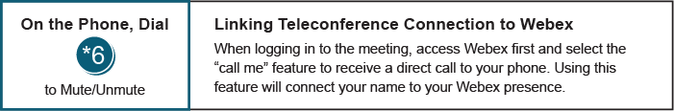

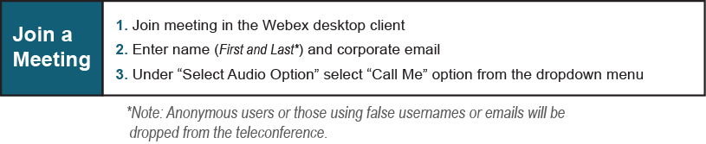
Provide feedback on the progress of this group: Facilitator Feedback Form
Visit learn.pjm.com, an easy-to-understand resource about the power industry and PJM’s role.

