As of July 2, 2026
Operating Committee
PJM Conference and Training Center/Webex
July 9, 2026
9:00 a.m. – 12:00 p.m. EPT

Administration (9:00 – 9:10)
Lauren Strella Wahba, PJM, will provide announcements; review the Antitrust, Code of Conduct, Public Meetings/Media Participation, and the WebEx Participant Identification Requirement.
  - Review and approve draft minutes from the June 4, 2026 Operating Committee meeting.
  - Review 2026 OC Work Plan

Endorsements (9:10 – 9:40)
- Manual 14D: Generator Operational Requirements (9:10 – 9:40)
Ryan Nice, PJM, will review proposed revisions to Manual 14D: Generator Operational Requirements addressing alignment with NERC Reliability Standards
The Operating Committee will be asked to endorse these changes at today’s meeting.

Review of Operations (9:40 – 10:35)
- Operating Metrics (9:40 – 10:00)
Timothy Smoker, PJM, and David Kimmel, PJM, will review the June 2026 PJM operating metrics slides. Metrics include PJM’s load forecast error, BAAL performance, and transmission / generation outage statistics.
- Hot Weather Update (10:00 – 10:30)
Paul Dajewski, PJM, will provide an update regarding the hot weather operations during June 29th – July 3rd.

- Security Update (10:30 – 10:35)
Jim Gluck, PJM, will provide the latest security briefing.

Additional Items (10:35 – 12:00)
- Reliability Compliance Update (10:35 – 10:45)
Gizella Mali & Becky Davis, PJM, will provide a compliance update on FERC/NERC and Regional activities.
- eDART Auto Ticket Creation (10:45 – 11:05)
Mike Kelly, PJM, will provide an update regarding the auto ticket creation feature in eDART.

- Regulation Re-Design Phase 2 Update (11:05 – 11:20)
Michael Olaleye, PJM, will provide an update regarding the timeline for Phase 2 of the Regulation Market Re-Design.

- Winter Generator Site Preparedness Visits (11:20 – 11:35)
John Wolff, PJM, will provide an update regarding winter preparedness generator site visits with ReliabilityFirst.

- NERC Project 2026-02 Computational Load – PJM Outreach (11:35 – 11:55)
Matt Wharton, PJM, will provide an update NERC’s recent standard to address reliability risks associated with rapidly growing large loads.

- System Operations Subcommittee (SOS) Charter Update (11:55 – 12:00)
Madalin How, PJM, will provide an update regarding the Periodic Review of the SOS Charter.

Informational Only Postings
- DLR Updates
Informational posting of upcoming DLR changes.
- Fuel Inventory Data Request Results
Informational posting of the recent Summer 2026 Fuel Inventory data request for coal and oil resources.

- Day-Ahead Survey Results
Informational posting summarizing the results of the most recent Day-Ahead Timing Survey.

OC Subcommittee/Task Force Informational Section
System Operations Subcommittee (SOS): SOS Website
Distributed Resources Subcommittee (DISRS): DISRS Website

Future Meeting Dates and Materials |  |  | Materials Due  to Secretary | Materials Published
Date | Time | Location | Materials Due  to Secretary | Materials Published
Date | Time | Location | 5:00 p.m. EPT deadline*
July 9, 2026 | 9 a.m. | PJM Conference & Training Center and Webex | June 29, 2026 | July 2, 2026
August 6, 2026 | 9 a.m. | PJM Conference & Training Center and Webex | July 27, 2026 | July 30, 2026
September 10, 2026 | 9 a.m. | PJM Conference & Training Center and Webex | August 31, 2026 | September 3, 2026
October 8, 2026 | 9 a.m. | PJM Conference & Training Center and Webex | September 28, 2026 | October 1, 2026
November 5, 2026 | 9 a.m. | PJM Conference & Training Center and Webex | October 26, 2026 | October 29, 2026
December 3, 2026 | 9 a.m. | PJM Conference & Training Center and Webex | November 23, 2026 | November 26, 2026
*Materials received after 12:00 p.m. EPT are not guaranteed timely posting by 5:00 p.m. EPT on the same day.

Author: D. Mroz

Antitrust:
It is PJM’s policy to comply with applicable antitrust laws. Participants must not disclose or exchange non-public, competitively sensitive information about their individual business strategies. Prohibited topics include, but are not limited to:
- Non-public individual pricing strategies, bidding strategies, or offer practices  - Non-public forecasts of prices, costs, output, or market behavior | - Non-public information about the availability, output or production costs of specific resources or services  - Confidential terms or conditions of sale, service, or trading strategies | - Planned or potential allocation of specific customers, suppliers, or markets among competitors  - Agreements or understandings between or among competitors to limit supply, coordinate bidding, fix prices, divide markets, or refuse to deal with particular entities | - Any other communication that could unreasonably restrain competition or coordinate competitive behavior among market participants
Discussion of PJM-administered market rules, tariff provisions, system operations, and public market outcomes is appropriate, provided individual confidential business information is not shared. These permitted discussions may include advocacy positions, including those reflecting state regulatory responsibilities or consistent with the obligations and interests of state-regulated entities. These discussions occur in a context where resulting rule changes may be submitted to FERC for approval, or may reflect regulatory mandates established by state authorities.
If prohibited topics are raised, the Chair will redirect the conversation. If the discussion continues, participants may be asked to leave the meeting or the meeting may be adjourned. For more information, please refer to PJM’s Antitrust Guidelines for Stakeholder Meetings, which are posted on PJM’s Committees and Groups page.
Code of Conduct:  As a mandatory condition of attendance at today's meeting, attendees agree to adhere to the Code of Conduct as detailed in PJM Manual M-34 section 4.5, including, but not limited to, participants' responsibilities and rules regarding the dissemination of meeting discussion and materials. Expectations for participating in PJM activities are further detailed in the PJM Code of Conduct.  Public Meetings/Media Participation:  Unless otherwise noted, PJM stakeholder meetings are open to the public and to members of the media. Members of the media are asked to announce their attendance at all PJM stakeholder meetings at the beginning of the meeting or at the point they join a meeting already in progress. Members of the Media are reminded that speakers at PJM meetings cannot be quoted without explicit permission from the speaker. PJM Members are reminded that "detailed transcriptional meeting notes" and white board notes from "brainstorming sessions" shall not be disseminated. Stakeholders are also not allowed to create audio, video or online recordings of PJM meetings. PJM may create audio, video or online recordings of stakeholder meetings for internal and training purposes, and your participation at such meetings indicates your consent to the same. | Participant Identification in Webex:  When logging into the Webex desktop client, please enter your real first and last name as well as a valid email address. Be sure to select the “call me” option.  PJM support staff continuously monitors Webex connections during stakeholder meetings. Anonymous users or those using false usernames or emails will be dropped from the teleconference.  Participant Use of Webex Chat:  The use of the Webex chat feature during meetings shall be primarily reserved for administrative and logistical purposes, such as managing a question or comment queue, noting technical difficulties, and meeting support or management purposes. Utilizing Webex chat for any other commentary should be limited to short phrases. Detailed commentary or substantive dialogue shall be shared orally by entering the speaker queue.

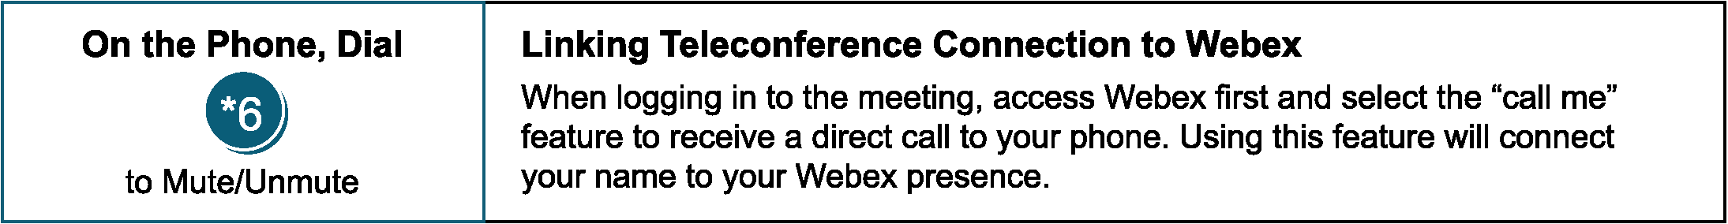

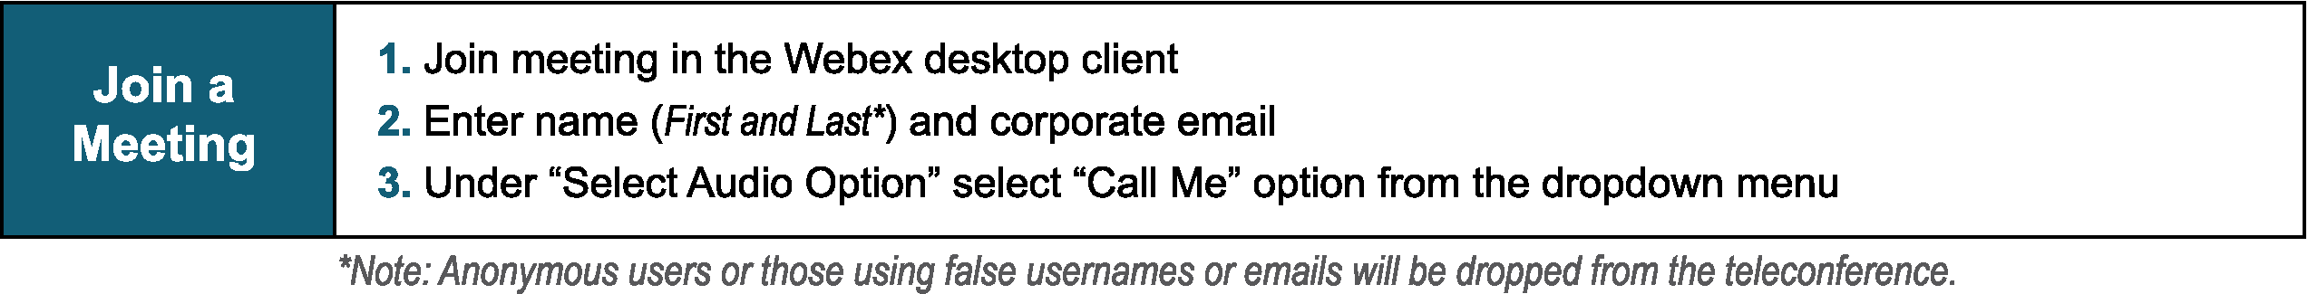
Provide feedback on the progress of this group: Facilitator Feedback Form
Visit learn.pjm.com, an easy-to-understand resource about the power industry and PJM’s role.

