Planning Committee
PJM Conference and Training Center, Audubon, PA
January 7, 2016
9:30 a.m. – 12:15 p.m. [EPT]

Administration (9:30 – 9:40)
- Welcome, announcements and review of the Anti-trust, Code of Conduct, Media Participation Guidelines. - Mr. Steve Herling
- Approve draft minutes from the December 3, 2015 Planning Committing (PC) meeting.
- Report Card Update – Ms. Amber Thomas
- ‘Concierge’ Kiosk Update – Ms. Thomas

Endorsements/Approvals (9:40 – 10:40)
- Voltage Threshold and Administrative Update
Ms. Sue Glatz will be reviewing draft Operating Agreement language regarding voltage threshold and administrative change. The committee will be asked to endorse these Operating Agreement changes.
- Long Term Firm Transmission Service Task Force
Mr. Aaron Berner will review the solution package to modify existing and expand Long Term Firm Transmission Service methodologies. The committee will be asked to endorse the solution package including manual changes.
- PARTF Update
Mr. Berner will review Manual 14 series updates regarding PAR withdrawal and inject rights. The committee will be asked to endorse the manual changes.
- DEDSTF Update
Mr. Michael Herman will review the DEDSTF Charter. The committee will be asked to endorse the charter.

Informational Updates (10:40 – 11:40)
- NERC/RRO Update
Mr. Srinivas Kappagantula will provide an update to the membership on the activities, issues and items of interest at NERC, SERC, and RFC.
- RTEP Proposal Window Update
Mr. Herman will discuss 2016 RTEP Proposal Window implementation and communication enhancements.
- Order 1000 Lessons Learned
Mr. Frank Koza will discuss Order 1000 process improvements and next steps.
Issue Tracking: Order 1000 Lessons Learned
- 2016 RTEP Assumptions and Preparation
Mr. Mark Sims will discuss Transmission Owner updates in coordination with 2016 RTEP analysis.

Informational Section
Model On Demand Update
Review of Model On Demand data submittals by TOs is well under way. Upon completion of the data submittals, preliminary cases for the 2016 series of MMWG cases will be put together for base case years 1, 2, 5, and 10 and TOs will be asked to review these cases. The anticipated timeframe for the model builds is the second week in January. For questions or comments, please email MOD@PJM.com
Load Forecast Update
The 2016 Load Forecast has been posted and can be found at the Load Forecast Development Process website. Load Forecast Material
Probability Risk Assessment (PRA) Update
2015 PJM PRA 500/230 kV spare transformer assessment summary has been posted under the January 7, 2016 Planning Committee Material. The assessment found PJM existing 500/230 kV spare transformer levels adequately mitigate projected risk. Planning Committee website

Subcommittee/Task Force Updates
Earlier Queue Submittal Task Force (EQSTF)
At the 11/23 meeting of the EQSTF, education was provided to outline the implications of various options discussed to date. Additional options were also solicited and discussed. The next meeting of the EQSTF is 1/19. EQSTF website
Designated Entity Design Standards Task Force (DEDSTF)
At the 12/16 meeting of the DEDSTF educational topics included an overview of the DEA and IC documentation; guidelines developed by the TSS; and the MISO and SPP minimum design standard development process. The group also discussed PJM Manual 07 as it pertains to Relay and Protection standards that this group could potentially adopt as design standards. The next meeting of the DEDSTF is 1/21. DEDSTF website
Resource Adequacy Analysis Subcommitte (RAAS)
At the December 9th, 2015 RAAS meeting, Patricio Rocha continued education covering the primary drivers of the IRM and FPR. The recording of the can be found at the Reserve Requirement Process Change page. The January 26, 2016 RAAS meeting will focus on initial discussions regarding modeling assumptions for the 2016 RRS. RAAS website

Future Meeting Dates
February 11, 2016 | 9:30 a.m. | PJM Conference and Training Center, Audubon, PA
March 10, 2016 | 9:30 a.m. | PJM Conference and Training Center, Audubon, PA
April 7, 2016 | 9:30 a.m. | PJM Conference and Training Center, Audubon, PA
May 12, 2016 | 9:30 a.m. | PJM Conference and Training Center, Audubon, PA
June 9, 2016 | 9:30 a.m. | PJM Conference and Training Center, Audubon, PA
July 14, 2016 | 9:30 a.m. | PJM Conference and Training Center, Audubon, PA
August 11, 2016 | 9:30 a.m. | PJM Conference and Training Center, Audubon, PA
September 15, 2016 | 9:30 a.m. | PJM Conference and Training Center, Audubon, PA
October 6, 2016 | 9:30 a.m. | PJM Conference and Training Center, Audubon, PA
November 3, 2016 | 9:30 a.m. | PJM Conference and Training Center, Audubon, PA
December 15, 2016 | 9:30 a.m. | PJM Conference and Training Center, Audubon, PA

Author: Amber Thomas

Anti-trust:
You may not discuss any topics that violate, or that might appear to violate, the antitrust laws including but not limited to agreements between or among competitors regarding prices, bid and offer practices, availability of service, product design, terms of sale, division of markets, allocation of customers or any other activity that might unreasonably restrain competition. If any of these items are discussed the chair will re-direct the conversation. If the conversation still persists, parties will be asked to leave the meeting or the meeting will be adjourned.

Code of Conduct:
As a mandatory condition of attendance at today's meeting, attendees agree to adhere to the PJM Code of Conduct as detailed in PJM Manual M-34 section 4.5, including, but not limited to, participants' responsibilities and rules regarding the dissemination of meeting discussion and materials.

Public Meetings/Media Participation:
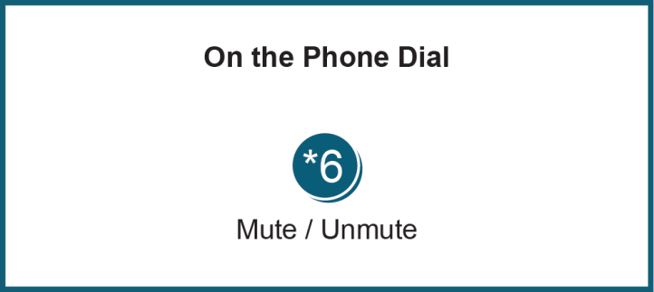
Unless otherwise noted, PJM stakeholder meetings are open to the public and to members of the media. Members of the media are asked to announce their attendance at all PJM stakeholder meetings at the beginning of the meeting or at the point they join a meeting already in progress. Members of the Media are reminded that speakers at PJM meetings cannot be quoted without explicit permission from the speaker. PJM Members are reminded that "detailed transcriptional meeting notes" and white board notes from "brainstorming sessions" shall not be disseminated. Stakeholders are also not allowed to create audio, video or online recordings of PJM meetings.

