Long-Term Transmission Planning Reform Workshop - Session 4
Webex
May 10, 2022
3:00 p.m. – 5:00 p.m. EPT

Administration (3:00 - 3:05)
- Jen Tribulski and Molly Mooney will provide a welcome, announcements and Anti-trust, Code of Conduct, and Public Meetings/Media Participation Guidelines.
- Review draft minutes from the March 29, 2022 Long-Term Transmission Planning Workshop.

Meeting Materials (3:05 – 4:55)
- Gabe Tabek, American Clean Power, will provide comments on Long-Term Transmission Planning Reform. (3:05 – 3:20)
- Aaron Berner, PJM, will discuss the updated discussion paper including any updates since the draft version. (3:20 – 3:40)
- Matthew Bernstein, PJM, will review topics from the recent FERC/State Transmission Task Force meeting. (3:40 – 3:55)
- Pauline Foley, PJM, will provide a summary of the FERC’s notice of proposed rulemaking (NOPR) on long-range electric transmission planning. Stakeholders will be asked to provide feedback and we will engage in discussion on this item. (3:55 – 4:55)

Closing Remarks and Next Steps (4:55 - 5:00)
- Jen Tribulski will provide closing remarks and will discuss next steps.

Informational Postings
The feedback received through the feedback request form is posted in a non-attributed manner with meeting materials.
PJM Initial Questions on the NOPR for Stakeholder Discussion

Future Meeting Dates and Materials |  |  | Materials Due  to Secretary | Materials Published
Date | Time | Meeting (Location) |  | Materials Published
Tuesday, June 7, 2022 | 3:00 p.m. – 5:00 p.m. | Long Term Transmission Planning Policy Workshop – Session 5 | Monday, May 30, 2022 | Thursday, June 2, 2022
Tuesday, July 12, 2022 | 3:00 p.m. – 5:00 p.m. | Long Term Transmission Planning Policy Workshop – Session 6 | Tuesday, July 5, 2022 | Thursday, July 7, 2022

Author: M.Mooney

Antitrust:
You may not discuss any topics that violate, or that might appear to violate, the antitrust laws including but not limited to agreements between or among competitors regarding prices, bid and offer practices, availability of service, product design, terms of sale, division of markets, allocation of customers or any other activity that might unreasonably restrain competition. If any of these items are discussed the chair will re-direct the conversation. If the conversation still persists, parties will be asked to leave the meeting or the meeting will be adjourned.

Code of Conduct:
As a mandatory condition of attendance at today's meeting, attendees agree to adhere to the PJM Code of Conduct as detailed in PJM Manual M-34 section 4.5, including, but not limited to, participants' responsibilities and rules regarding the dissemination of meeting discussion and materials.

Public Meetings/Media Participation:
Unless otherwise noted, PJM stakeholder meetings are open to the public and to members of the media. Members of the media are asked to announce their attendance at all PJM stakeholder meetings at the beginning of the meeting or at the point they join a meeting already in progress. Members of the Media are reminded that speakers at PJM meetings cannot be quoted without explicit permission from the speaker. PJM Members are reminded that "detailed transcriptional meeting notes" and white board notes from "brainstorming sessions" shall not be disseminated. Stakeholders are also not allowed to create audio, video or online recordings of PJM meetings. PJM may create audio, video or online recordings of stakeholder meetings for internal and training purposes, and your participation at such meetings indicates your consent to the same.
Participant Identification in Webex:
When logging into the Webex desktop client, please enter your real first and last name as well as a valid email address. Be sure to select the “call me” option.
PJM support staff continuously monitors Webex connections during stakeholder meetings. Anonymous users or those using false usernames or emails will be dropped from the teleconference.

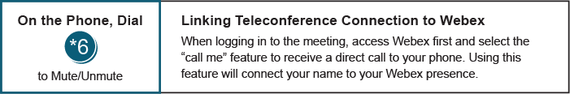

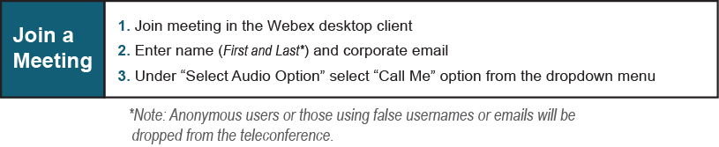

Provide feedback on the progress of this group: Facilitator Feedback Form
Visit learn.pjm.com, an easy-to-understand resource about the power industry and PJM’s role.

