As of September 1, 2026
Planning Committee
Webex / PJM Conference and Training Center
September 8, 2026
9:00 a.m. – 12:00 p.m. EPT

Administration (9:00 - 9:10)
- Welcome, announcements, and review of the Anti-trust, Code of Conduct, and Media Participation Guidelines.
- Review and approve draft minutes from August 4, 2026 Planning Committee meeting.

Endorsements (9:10-11:00)
- Fuel Switching for Projects with GIA

  - Christina Catalano, PJM, will provide pre-approval education regarding post-agreement fuel changes.

  - Justin Radl, Invenergy, will discuss a Fuel Switch Problem Statement and Issue Charge.

  - Brian Lynn, PJM, will provide PJM’s position on post-agreement fuel changes.

The committee will be asked to approve the Issue Charge at this meeting.

- Manual 21B Periodic Review

Joshua Bruno, PJM, will provide updates on Manual 21B: PJM Rules and Procedures for Determination of Generating Capability as part of its periodic review. The committee will be asked to endorse these changes at this meeting.

Informational Updates (11:00 – 12:00)
- Large Load Ride Through

PJM will discuss proposed manual and tariff revisions for large computation load ride-through requirements as part of PJM’s intended response to the June 18, 2026 large load show cause order.

- Preliminary 2027 Capital Project Budget

James Snow, PJM, will review the Preliminary 2027 Capital Project Budget.

- Storage as a Transmission Asset Update

Jeff Schmitt, PJM, will provide an update on the previously approved Storage as a Transmission Asset package.

- Reliability Compliance Update

Gizella Mali, PJM, will provide an update on the activities, issues, and items of interest at NERC, SERC, and RF.

Informational Posting
- Model Build Activity Update
- RTEP
  - 2026 Series Dynamics
    - PJM is currently building the 2031 SUM and 2031 SLL dynamics cases.
  - 2027 Series Power Flow
    - PJM provided seedcase by August 26th.
    - TOs to provide initial feedback by September 18th.
    - PJM to provide Trial 1 cases by October 9th.
- MMWG
  - 2026 Series Power Flow
    - TOs submitted Trial 3 feedback by August 28th.
    - PJM submitted Trial 3 feedback to PowerTech by September 4th.
    - PowerTech to post prefinal cases by September 11th.
    - PowerTech to post final cases by September 25th.
  - 2026 Series Dynamics
    - PJM collected additional and updated dynamics data and uploaded to the MMWG SDDB database on August 28th.
    - PJM requested TO dynamics data on August 28th.
    - TOs to submit dynamic device data by September 25th.
    - TOs to submit dynamic load models by October 30th.
Future Meeting Dates and Materials |  |  | Materials Due  to Secretary | Materials Published
Date | Time | Location | Materials Due  to Secretary | Materials Published
Date | Time | Location | 5:00 p.m. EPT deadline*
Tuesday,  October 6, 2026 | 9:00 a.m. – 12:00 p.m. | PJM Conference & Training Center and Webex | Thursday,  September 24, 2026 | Tuesday,  September 29, 2026
Tuesday,  November 3, 2026 | 9:00 a.m. – 12:00 p.m. | PJM Conference & Training Center and Webex | Thursday,  October 22, 2026 | Tuesday,  October 27, 2026
Tuesday,  December 1, 2026 | 9:00 a.m. – 12:00 p.m. | PJM Conference & Training Center and Webex | Thursday,  November 19, 2026 | Tuesday,  November 24, 2026
*Materials received after 12:00 p.m. EPT are not guaranteed timely posting by 5:00 p.m. EPT on the same day.

Author: Nicole Bugay

Antitrust:
It is PJM’s policy to comply with applicable antitrust laws. Participants must not disclose or exchange non-public, competitively sensitive information about their individual business strategies. Prohibited topics include, but are not limited to:
- Non-public individual pricing strategies, bidding strategies, or offer practices  - Non-public forecasts of prices, costs, output, or market behavior | - Non-public information about the availability, output or production costs of specific resources or services  - Confidential terms or conditions of sale, service, or trading strategies | - Planned or potential allocation of specific customers, suppliers, or markets among competitors  - Agreements or understandings between or among competitors to limit supply, coordinate bidding, fix prices, divide markets, or refuse to deal with particular entities | - Any other communication that could unreasonably restrain competition or coordinate competitive behavior among market participants
Discussion of PJM-administered market rules, tariff provisions, system operations, and public market outcomes is appropriate, provided individual confidential business information is not shared. These permitted discussions may include advocacy positions, including those reflecting state regulatory responsibilities or consistent with the obligations and interests of state-regulated entities. These discussions occur in a context where resulting rule changes may be submitted to FERC for approval or may reflect regulatory mandates established by state authorities.
If prohibited topics are raised, the Chair will redirect the conversation. If the discussion continues, participants may be asked to leave the meeting, or the meeting may be adjourned. For more information, please refer to PJM’s Antitrust Guidelines for Stakeholder Meetings, which are posted on PJM’s Committees and Groups page.

Code of Conduct:  As a mandatory condition of attendance at today's meeting, attendees agree to adhere to the Code of Conduct as detailed in PJM Manual M-34 section 4.5, including, but not limited to, participants' responsibilities and rules regarding the dissemination of meeting discussion and materials. Expectations for participating in PJM activities are further detailed in the PJM Code of Conduct.  Public Meetings/Media Participation:  Unless otherwise noted, PJM stakeholder meetings are open to the public and to members of the media. Members of the media are asked to announce their attendance at all PJM stakeholder meetings at the beginning of the meeting or at the point they join a meeting already in progress. Members of the Media are reminded that speakers at PJM meetings cannot be quoted without explicit permission from the speaker. PJM Members are reminded that "detailed transcriptional meeting notes" and whiteboard notes from "brainstorming sessions" shall not be disseminated. Stakeholders are also not allowed to create audio, video or online recordings of PJM meetings. PJM may create audio, video or online recordings of stakeholder meetings for internal and training purposes, and your participation at such meetings indicates your consent to the same. | Participant Identification in Webex:  When logging into the Webex desktop client, please enter your real first and last name as well as a valid email address. Be sure to select the “call me” option.  PJM support staff continuously monitors Webex connections during stakeholder meetings. Anonymous users or those using false usernames or emails will be dropped from the teleconference.  Participant Use of Webex Chat:  The use of the Webex chat feature during meetings shall be primarily reserved for administrative and logistical purposes, such as managing a question or comment queue, noting technical difficulties, and meeting support or management purposes. Utilizing Webex chat for any other commentary should be limited to short phrases. Detailed commentary or substantive dialogue shall be shared orally by entering the speaker queue.

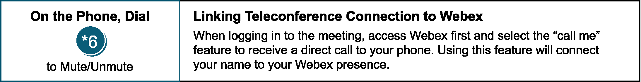

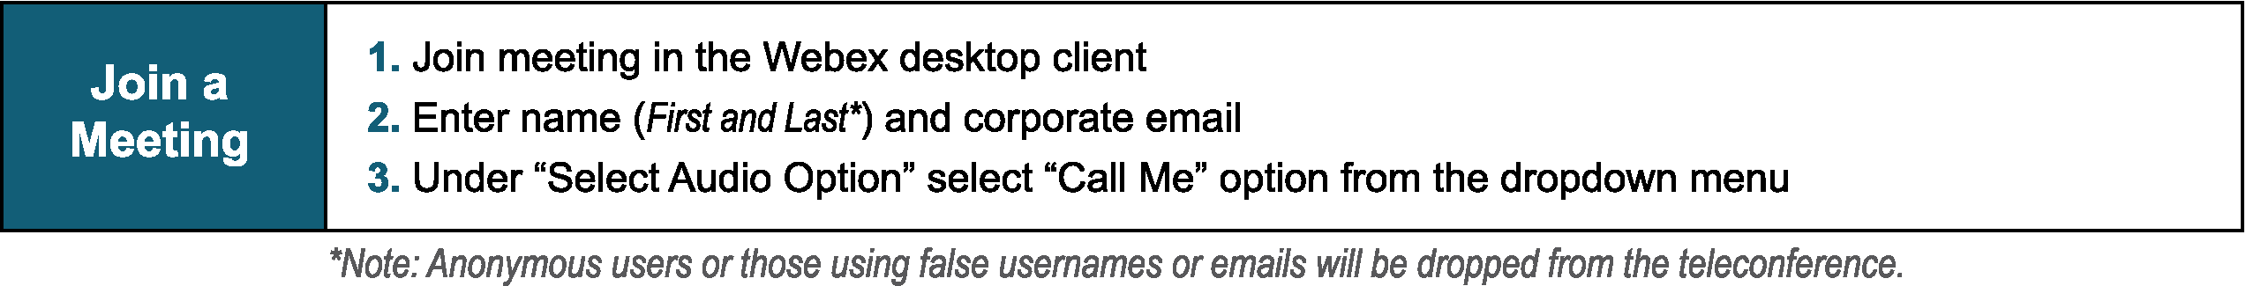

Provide feedback on the progress of this group: Facilitator Feedback Form
Visit learn.pjm.com, an easy-to-understand resource about the power industry and PJM’s role.
.

