Risk Management Committee
Webex
July 27, 2021
1:00 p.m. – 3:00 p.m. EPT

Administration (1:00-1:10)
Jim Gluck and Emmy Messina will provide welcome, announcements, and review the Antitrust, Code of Conduct, Public Meetings/Media Participation, and the Webex Participant Identification Requirements.
The Committee will be asked to approve the draft minutes from the June 22, 2021 Risk Management Committee meeting.
- Emmy Messina will review the Risk Management Committee work plan.

First Readings (1:10-1:15)
Bankruptcy Protections (1:10-1:15)
Jess Troiano, PJM, will review a Problem Statement and Issue Charge addressing potential opportunities to enhance bankruptcy protections. The committee will be asked to approve the issue charge at its next meeting.

Working Items (1:15-1:45)
Winter Weather Credit and Risk Management Issue Charge (1:15 – 1:45)
Lisa Drauschak, PJM, will review updates to the Issue Charge addressing potential opportunities to enhance credit/risk mechanisms in emergency circumstances.
4A. ISO/RTO Council Update
Jesse Diaz, PJM, will provide an update on recent discussions regarding credit/risk and the winter 2021 events that have taken place at the ISO/RTO Council.

Additional Items (2:15-2:45)
- Key Risk Metrics (2:15 – 2:45)
Gwen Kelly will review key risk metrics for the committee’s consideration and feedback.

Future Topics
- FTR Bilateral Reporting Requirements and Transfers
- Limit Market Participation

Future Meeting Dates and Materials |  |  | Materials Due  to Secretary | Materials Published
Date | Time | Location |  | Materials Published
August 24 | 1:00 p.m. | Webex | August 12 | August 17
September 28 | 1:00 p.m. | Webex | September 16 | September 21
October 19 | 1:00 p.m. | Webex | October 7 | October 12
November 16 | 1:00 p.m. | Webex | November 4 | November 9
December 14 | 1:00 p.m. | Webex | December 2 | December 7

Author: Emmy Messina

Antitrust:
You may not discuss any topics that violate, or that might appear to violate, the antitrust laws including but not limited to agreements between or among competitors regarding prices, bid and offer practices, availability of service, product design, terms of sale, division of markets, allocation of customers or any other activity that might unreasonably restrain competition. If any of these items are discussed the chair will re-direct the conversation. If the conversation still persists, parties will be asked to leave the meeting or the meeting will be adjourned.

Code of Conduct:
As a mandatory condition of attendance at today's meeting, attendees agree to adhere to the PJM Code of Conduct as detailed in PJM Manual M-34 section 4.5, including, but not limited to, participants' responsibilities and rules regarding the dissemination of meeting discussion and materials.

Public Meetings/Media Participation:
Unless otherwise noted, PJM stakeholder meetings are open to the public and to members of the media. Members of the media are asked to announce their attendance at all PJM stakeholder meetings at the beginning of the meeting or at the point they join a meeting already in progress. Members of the Media are reminded that speakers at PJM meetings cannot be quoted without explicit permission from the speaker. PJM Members are reminded that "detailed transcriptional meeting notes" and white board notes from "brainstorming sessions" shall not be disseminated. Stakeholders are also not allowed to create audio, video or online recordings of PJM meetings. PJM may create audio, video or online recordings of stakeholder meetings for internal and training purposes, and your participation at such meetings indicates your consent to the same.
Participant Identification in Webex:
When logging into the Webex desktop client, please enter your real first and last name as well as a valid email address. Be sure to select the “call me” option.
PJM support staff continuously monitors Webex connections during stakeholder meetings. Anonymous users or those using false usernames or emails will be dropped from the teleconference.

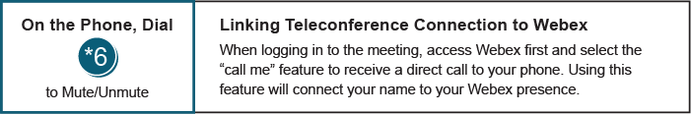

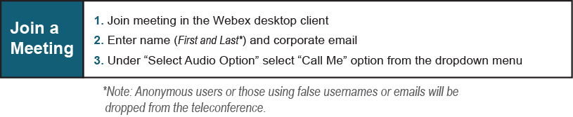
Provide feedback on the progress of this group: Facilitator Feedback Form
Visit learn.pjm.com, an easy-to-understand resource about the power industry and PJM’s role.

