As of Nov. 25, 2025
Risk Management Committee
PJM Conference and Training Center
December 2, 2025
1:00 p.m. – 3:00 p.m. EPT

Administration (1:00-1:10)
- Susan McGill and Julia Spatafore, PJM, will provide a welcome, announcements, and review the Antitrust, Code of Conduct, Public Meetings/Media Participation, and the Webex Participant Identification Requirements.
The Committee will be asked to approve the draft minutes from the October 22, 2025, Risk Management Committee (RMC) meeting.
Susan McGill, PJM, will provide a verbal update on the RMC work plan.

Informational Update (1:10-2:05)
- Membership and KYC Update (1:10-1:40)
Amanda Egan and Chad Wineland PJM, will provide an update on Member Recertification efforts, review responsibilities of Authorized Representatives, Officers and Maintenance Managers, and review Member data requirements.
- Back-Testing of FTR HSIM Model Update (1:40-2:00)
James Waweru, PJM, will provide an update on back-testing of the FTR historical simulation initial margin (HSIM) model.
- Stakeholder Profile and Requested Actions Update (2:00-2:05)
Matt Connolly, PJM, will review a new stakeholder profile and requested actions.
- Credit Observations on Summer 2025 Demand Response Performance (2:05-2:30)
Gwen Kelly, PJM, will provide an update regarding credit observations on the summer 2025 DR performance.

Informational Postings
Key Risk Metrics
Key risk metrics have been posted for the committee’s consideration and feedback.
Credit Observations on Summer 2025 Demand Response Performance
Credit observations on the summer 2025 DR performance have been posted for the committee’s consideration and feedback.

Future Agenda Items

Future Meeting Dates and Materials |  |  |  | Materials Due  to Secretary | Materials Published
Date | Time | Location
Date | Time | Location | 5:00 p.m. EPT deadline*
January 21, 2026 | 1:00 p.m. | PJM Conference & Training Center/Webex | January 9, 2026 |  | January 14, 2026
February 18, 2026 | 9:00 a.m. | PJM Conference & Training Center/Webex | February 6, 2026 |  | February 11, 2026
March 24, 2026 | 1:00 p.m. | PJM Conference & Training Center/Webex | March 12, 2026 |  | March 17, 2026
April 21, 2026 | 1:00 p.m. | PJM Conference & Training Center/Webex | April 9, 2026 |  | April 14, 2026
May 19, 2026 | 1:00 p.m. | PJM Conference & Training Center/Webex | May 7, 2026 |  | May 12, 2026
June 23, 2026 | 1:00 p.m. | PJM Conference & Training Center/Webex | June 11, 2026 |  | June 16, 2026
July 22, 2026 | 1:00 p.m. | PJM Conference & Training Center/Webex | July 10, 2026 |  | July 15, 2026
August 18, 2026 | 1:00 p.m. | PJM Conference & Training Center/Webex | August 6, 2026 |  | August 11, 2026
September 23, 2026 | 1:00 p.m. | PJM Conference & Training Center/Webex | September 11, 2026 |  | September 16, 2026
October 27, 2026 | 1:00 p.m. | PJM Conference & Training Center/Webex | October 15, 2026 |  | October 20, 2026
November 19, 2026 | 9:00 a.m. | PJM Conference & Training Center/Webex | November 9, 2026 |  | November 12, 2026
December 15, 2026 | 1:00 p.m. | PJM Conference & Training Center/Webex | December 3, 2026 |  | December 8, 2026
*Materials received after 12:00 p.m. EPT are not guaranteed timely posting by 5:00 p.m. EPT on the same day.

Author: Julia Spatafore

Antitrust:
It is PJM’s policy to comply with applicable antitrust laws. Participants must not disclose or exchange non-public, competitively sensitive information about their individual business strategies. Prohibited topics include, but are not limited to:
- Non-public individual pricing strategies, bidding strategies, or offer practices  - Non-public forecasts of prices, costs, output, or market behavior | - Non-public information about the availability, output or production costs of specific resources or services  - Confidential terms or conditions of sale, service, or trading strategies | - Planned or potential allocation of specific customers, suppliers, or markets among competitors  - Agreements or understandings between or among competitors to limit supply, coordinate bidding, fix prices, divide markets, or refuse to deal with particular entities | - Any other communication that could unreasonably restrain competition or coordinate competitive behavior among market participants
Discussion of PJM-administered market rules, tariff provisions, system operations, and public market outcomes is appropriate, provided individual confidential business information is not shared. These permitted discussions may include advocacy positions, including those reflecting state regulatory responsibilities or consistent with the obligations and interests of state-regulated entities. These discussions occur in a context where resulting rule changes may be submitted to FERC for approval, or may reflect regulatory mandates established by state authorities.
If prohibited topics are raised, the Chair will redirect the conversation. If the discussion continues, participants may be asked to leave the meeting or the meeting may be adjourned. For more information, please refer to PJM’s Antitrust Guidelines for Stakeholder Meetings, which are posted on PJM’s Committees and Groups page.

Code of Conduct:  As a mandatory condition of attendance at today's meeting, attendees agree to adhere to the Code of Conduct as detailed in PJM Manual M-34 section 4.5, including, but not limited to, participants' responsibilities and rules regarding the dissemination of meeting discussion and materials. Expectations for participating in PJM activities are further detailed in the PJM Code of Conduct.  Public Meetings/Media Participation:  Unless otherwise noted, PJM stakeholder meetings are open to the public and to members of the media. Members of the media are asked to announce their attendance at all PJM stakeholder meetings at the beginning of the meeting or at the point they join a meeting already in progress. Members of the Media are reminded that speakers at PJM meetings cannot be quoted without explicit permission from the speaker. PJM Members are reminded that "detailed transcriptional meeting notes" and white board notes from "brainstorming sessions" shall not be disseminated. Stakeholders are also not allowed to create audio, video or online recordings of PJM meetings. PJM may create audio, video or online recordings of stakeholder meetings for internal and training purposes, and your participation at such meetings indicates your consent to the same. | Participant Identification in Webex:  When logging into the Webex desktop client, please enter your real first and last name as well as a valid email address. Be sure to select the “call me” option.  PJM support staff continuously monitors Webex connections during stakeholder meetings. Anonymous users or those using false usernames or emails will be dropped from the teleconference.  Participant Use of Webex Chat:  The use of the Webex chat feature during meetings shall be primarily reserved for administrative and logistical purposes, such as managing a question or comment queue, noting technical difficulties, and meeting support or management purposes. Utilizing Webex chat for any other commentary should be limited to short phrases. Detailed commentary or substantive dialogue shall be shared orally by entering the speaker queue.

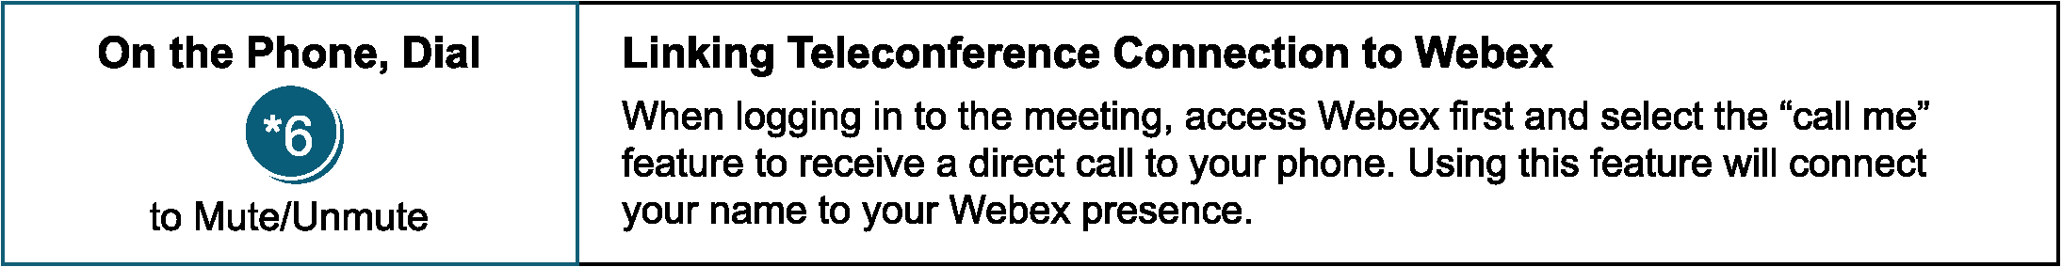

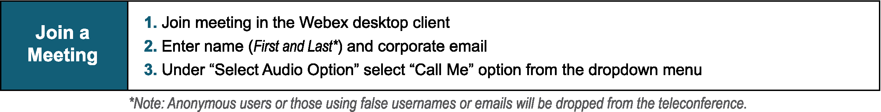
Provide feedback on the progress of this group: Facilitator Feedback Form
Visit learn.pjm.com, an easy-to-understand resource about the power industry and PJM’s role.

