Sub-regional RTEP Committee for PJM South
Via teleconference
Thursday December 12th, 2024
9:00 p.m. – 12:00 p.m. EPT

Administration
- Welcome, Announcements and Review of the Anti-trust, Code of Conduct, and Media Participation Guidelines
Review Agenda for this meeting

RTEP Updates
- PJM Reliability Update
PJM will provide an update on Reliability Analysis
- Dominion Energy Planning Assumptions
Dominion will present 2025 Local Planning Assumptions
- Dominion Supplemental Projects
Dominion will present 1 potential solution

Informational Only
- Informational Only - M-3 Process Needs Status
This spreadsheet allows stakeholders to track process defined in Open Access Transmission Tariff, Attachment M-3 and leading to the development of the supplemental projects.
- Informational Only – Aggregate Maps for Supplemental Projects
Aggregate geographic representation of supplemental projects not previously included in Local Plan.
- Informational Only – Planning Community Open Questions
Open questions regarding M-3 projects received through Planning Community.

Meeting Wrap Up
- Discussion and Comments Regarding the Conduct of the Meeting

Future Meeting Dates
January 16th, 2025 | 1:00 p.m. – 4:00 p.m. | Teleconference
February 13th, 2025 | 1:00 p.m. – 4:00 p.m. | Teleconference
March 13th, 2025 | 1:00 p.m. – 4:00 p.m. | Teleconference

Antitrust, Code of Conduct and WebEx Instructions
Antitrust:
You may not discuss any topics that violate, or that might appear to violate, the antitrust laws including but not limited to agreements between or among competitors regarding prices, bid and offer practices, availability of service, product design, terms of sale, division of markets, allocation of customers or any other activity that might unreasonably restrain competition. If any of these items are discussed the chair will re-direct the conversation. If the conversation still persists, parties will be asked to leave the meeting or the meeting will be adjourned.
Code of Conduct:
As a mandatory condition of attendance at today's meeting, attendees agree to adhere to the PJM Code of Conduct as detailed in PJM Manual M-34 section 4.5, including, but not limited to, participants' responsibilities and rules regarding the dissemination of meeting discussion and materials.
Public Meetings/Media Participation:
Unless otherwise noted, PJM stakeholder meetings are open to the public and to members of the media. Members of the media are asked to announce their attendance at all PJM stakeholder meetings at the beginning of the meeting or at the point they join a meeting already in progress. Members of the Media are reminded that speakers at PJM meetings cannot be quoted without explicit permission from the speaker. PJM Members are reminded that "detailed transcriptional meeting notes" and white board notes from "brainstorming sessions" shall not be disseminated. Stakeholders are also not allowed to create audio, video or online recordings of PJM meetings. PJM may create audio, video or online recordings of stakeholder meetings for internal and training purposes, and your participation at such meetings indicates your consent to the same.
Participant Identification in WebEx:
When logging into the WebEx desktop client, please enter your real first and last name as well as a valid email address. Be sure to select the “call me” option.
PJM support staff continuously monitors WebEx connections during stakeholder meetings. Anonymous users or those using false usernames or emails will be dropped from the teleconference.

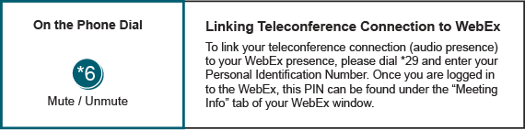
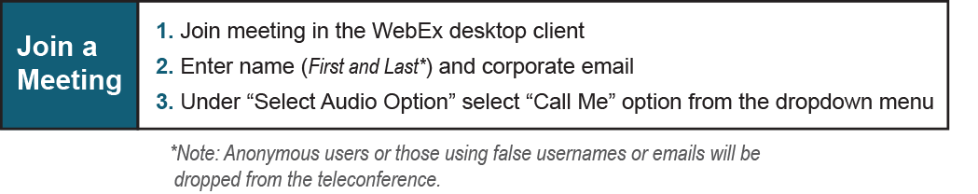
Provide feedback on the progress of this group: Facilitator Feedback Form
Visit learn.pjm.com, an easy-to-understand resource about the power industry and PJM’s role.

