As of December 9th, 2025
Sub-regional RTEP Committee for PJM West
Via teleconference
Friday December 12th, 2025
1:00 p.m. – 4:00 p.m. EPT

Administration (1:00-1:05)
Welcome, announcements and review of the Anti-trust, Code of Conduct, and Media Participation Guidelines. Review SRRTEP Committee Agenda for this meeting.
Review Agenda for this meeting

RTEP & Supplemental Project Updates (1:05-4:00)
- 2026 DLC Local Planning Assumptions
DLC will present their 2026 Local Planning Assumptions

- 2026 Exelon Local Planning Assumptions
Exelon will present their 2026 Local Planning Assumptions

- 2026 FirstEnergy Local Planning Assumptions
FirstEnergy will present their 2026 Local Planning Assumpti ons

- 2026 AEP Local Planning Assumptions
AEP will present their 2026 Local Planning Assumptions
- 2026 WVPA Local Planning Assumptions
WVPA will present their 2026 Local Planning Assumptions

- 2026 AMPT Local Planning Assumptions
AMPT will present their 2026 Local Planning Assumptions

- 2026 DAY Local Planning Assumptions
Dayton will present their 2026 Local Planning Assumptions

- 2026 DEOK Local Planning Assumptions
DEOK will present their 2026 Local Planning Assumptions

- 2026 EKPC Local Planning Assumptions
EKPC will present their 2026 Local Planning Assumptions

- 2026 NEET MidAtlantic Local Planning Assumptions
NEET MidAtlantic will present their 2026 Local Planning Assumptions

- 2026 OVEC Local Planning Assumptions
OVEC will present their 2026 Local Planning Assumptions

- DEOK Supplemental Projects
DEOK will present 1 need.

- ATSI Supplemental Projects
ATSI will present 3 needs, 6 potential solutions.

- APS Supplemental Projects
APS will present 2 potential solutions, 1 project cancellation.

- AEP Supplemental Projects
AEP will present 1 potential solution.

- SRRTEP – West – Reliability Analysis Update
PJM Transmission Planning will present the reliability analysis update.

Informational Only
- Informational Only - M-3 Process Needs Status
This spreadsheet allows stakeholders to track process defined in Open Access Transmission Tariff, Attachment M-3 and leading to the development of the supplemental projects.
- Informational Only - First Energy End Of Life Project Methodology TPP-REF-023 R2
- Informational Only - FirstEnergy System Performance Excellence Methodology TPP-REF-024 R3

Meeting Wrap Up
- Discussion and Comments Regarding the Conduct of the Meeting

Future Meeting Dates and Materials |  |  | Supplemental Materials Due  to Secretary | Supplemental Materials Published
Date | Time | Location | Supplemental Materials Due  to Secretary | Supplemental Materials Published
Date | Time | Location | 5:00 p.m. EPT deadline*
January 16th, 2026 | 1:00 p.m. – 4:00 p.m. | Teleconference | January 1st, 2026 | January 6th, 2026
February 13th, 2026 | 1:00 p.m. – 4:00 p.m. | Teleconference | January 29th, 2026 | February 3rd, 2026
*Materials received after 12:00 p.m. EPT are not guaranteed timely posting by 5:00 p.m. EPT on the same day.

Antitrust, Code of Conduct and WebEx Instructions

Author: Katherine Graham

Antitrust:
It is PJM’s policy to comply with applicable antitrust laws. Participants must not disclose or exchange non-public, competitively sensitive information about their individual business strategies. Prohibited topics include, but are not limited to:
- Non-public individual pricing strategies, bidding strategies, or offer practices  - Non-public forecasts of prices, costs, output, or market behavior | - Non-public information about the availability, output or production costs of specific resources or services  - Confidential terms or conditions of sale, service, or trading strategies | - Planned or potential allocation of specific customers, suppliers, or markets among competitors  - Agreements or understandings between or among competitors to limit supply, coordinate bidding, fix prices, divide markets, or refuse to deal with particular entities | - Any other communication that could unreasonably restrain competition or coordinate competitive behavior among market participants
Discussion of PJM-administered market rules, tariff provisions, system operations, and public market outcomes is appropriate, provided individual confidential business information is not shared. These permitted discussions may include advocacy positions, including those reflecting state regulatory responsibilities or consistent with the obligations and interests of state-regulated entities. These discussions occur in a context where resulting rule changes may be submitted to FERC for approval, or may reflect regulatory mandates established by state authorities.
If prohibited topics are raised, the Chair will redirect the conversation. If the discussion continues, participants may be asked to leave the meeting or the meeting may be adjourned. For more information, please refer to PJM’s Antitrust Guidelines for Stakeholder Meetings, which are posted on PJM’s Committees and Groups page.

Code of Conduct:  As a mandatory condition of attendance at today's meeting, attendees agree to adhere to the Code of Conduct as detailed in PJM Manual M-34 section 4.5, including, but not limited to, participants' responsibilities and rules regarding the dissemination of meeting discussion and materials. Expectations for participating in PJM activities are further detailed in the PJM Code of Conduct.  Public Meetings/Media Participation:  Unless otherwise noted, PJM stakeholder meetings are open to the public and to members of the media. Members of the media are asked to announce their attendance at all PJM stakeholder meetings at the beginning of the meeting or at the point they join a meeting already in progress. Members of the Media are reminded that speakers at PJM meetings cannot be quoted without explicit permission from the speaker. PJM Members are reminded that "detailed transcriptional meeting notes" and white board notes from "brainstorming sessions" shall not be disseminated. Stakeholders are also not allowed to create audio, video or online recordings of PJM meetings. PJM may create audio, video or online recordings of stakeholder meetings for internal and training purposes, and your participation at such meetings indicates your consent to the same. | Participant Identification in Webex:  When logging into the Webex desktop client, please enter your real first and last name as well as a valid email address. Be sure to select the “call me” option.  PJM support staff continuously monitors Webex connections during stakeholder meetings. Anonymous users or those using false usernames or emails will be dropped from the teleconference.  Participant Use of Webex Chat:  The use of the Webex chat feature during meetings shall be primarily reserved for administrative and logistical purposes, such as managing a question or comment queue, noting technical difficulties, and meeting support or management purposes. Utilizing Webex chat for any other commentary should be limited to short phrases. Detailed commentary or substantive dialogue shall be shared orally by entering the speaker queue.

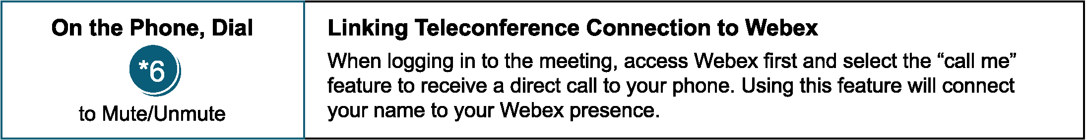


Provide feedback on the progress of this group: Facilitator Feedback Form
Visit learn.pjm.com, an easy-to-understand resource about the power industry and PJM’s role.
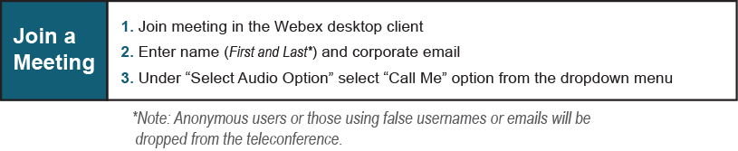
Provide feedback on the progress of this group: Facilitator Feedback Form
Visit learn.pjm.com, an easy-to-understand resource about the power industry and PJM’s role.

