PJM Interconnection eDART and eDART XML Forum
WebEx Link: https://webex.pjm.com – Meeting Center
WebEx Password: pGPmDhHR334
Conference Call: (844) 992-4726
Passcode: 2339 202 8806
Date: November 21, 2023
Time: 10:00 a.m. - 12:00 p.m. EPT

Administration (10:00 -10:05)
- Introduction
- Craig Lowe will review the topics that will be discussed during the meeting.

General (10:05 -10:30)
- Chidi Ofoegbu will provide an update on the following topics:
- Legacy Browserless Retirement
- Winter 2023 Model Build Timeline
- Future enhancements

Recent Enhancements (10:30 – 10:55)
- Chidi Ofoegbu will provide an update on the following recent enhancements:
- XML File Download from UI
- ‘cdwshortname’ parameter

eDART Throttling Functionality (10:55 – 11:15)
- Chidi Ofoegbu will provide an overview of throttling functionality impacting eDART file and XML downloads.

eDART User Account Migration to Account Manager (11:15 – 11:40)
- Chidi Ofoegbu will provide a status update on migration of eDART user accounts to Account Manager currently underway.
- Participants welcome to offer input and questions on account migration.

Question and Answer Session (11:40 – 12:00)
This time will be an opportunity for participants to present any other eDART-related questions.

Future Meetings
March 2024 | Time TBD | eDART XML Forum
March 2024 | Time TBD | eDART Forum
Antitrust:
You may not discuss any topics that violate, or that might appear to violate, the antitrust laws including but not limited to agreements between or among competitors regarding prices, bid and offer practices, availability of service, product design, terms of sale, division of markets, allocation of customers or any other activity that might unreasonably restrain competition. If any of these items are discussed the chair will re-direct the conversation. If the conversation still persists, parties will be asked to leave the meeting or the meeting will be adjourned.

Code of Conduct:
As a mandatory condition of attendance at today's meeting, attendees agree to adhere to the PJM Code of Conduct as detailed in PJM Manual M-34 section 4.5, including, but not limited to, participants' responsibilities and rules regarding the dissemination of meeting discussion and materials.

Public Meetings/Media Participation:
Unless otherwise noted, PJM stakeholder meetings are open to the public and to members of the media. Members of the media are asked to announce their attendance at all PJM stakeholder meetings at the beginning of the meeting or at the point they join a meeting already in progress. Members of the Media are reminded that speakers at PJM meetings cannot be quoted without explicit permission from the speaker. PJM Members are reminded that "detailed transcriptional meeting notes" and white board notes from "brainstorming sessions" shall not be disseminated. Stakeholders are also not allowed to create audio, video or online recordings of PJM meetings. PJM may create audio, video or online recordings of stakeholder meetings for internal and training purposes, and your participation at such meetings indicates your consent to the same.
Participant Identification in WebEx:
When logging into the WebEx desktop client, please enter your real first and last name as well as a valid email address. Be sure to select the “call me” option.
PJM support staff continuously monitors WebEx connections during stakeholder meetings. Anonymous users or those using false usernames or emails will be dropped from the teleconference.

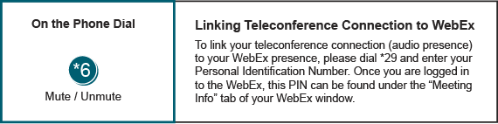

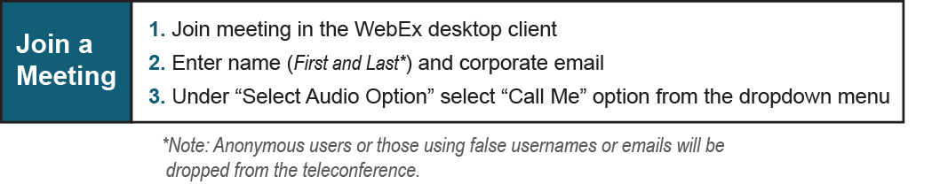
Provide feedback on the progress of this group: Facilitator Feedback Form
Visit learn.pjm.com, an easy-to-understand resource about the power industry and PJM’s role.

