Agenda

PJM General Session
Fundamental Electric Energy Industry Changes

What Does the Future Look Like?
Baltimore Marriott Waterfront, Baltimore, Maryland
May 12, 2026 | 8:15–11:30 a.m. (Eastern)
8:15 a.m. | Welcome  Jason Barker, Chair, Members Committee
8:20 a.m. | Panel 1 – PJM Fast Forward: What does industry success look like in 2035?  Moderator – David Mills, President & CEO, PJM Interconnection  Panelists – Bob Blue, Chair, President and Chief Executive Officer, Dominion Energy  Joe Dominguez, President and Chief Executive Officer, Constellation Energy Group  Dylan Seff, Head of Utilities and Sustainable Energy, Americas, Vitol Inc.  Kelly Speakes-Backman, Director, Maryland Energy Administration  Evan Vaughan, Executive Director, MAREC
9:40 a.m. | Panel 2 – PJM Now: What actions should we be contemplating?  Moderator – David Mills, President & CEO, PJM Interconnection  Panelists – Dennis Deters, OPSI President, Commissioner, Public Utilities Commission of Ohio  Nate Hanson, President, LS Power  Kim Janas, CAPS President, IL Attorney General’s Office  Carim Khouzami, EVP Transmission & Development, Exelon  Josh Levi, President, Data Center Coalition  Eran Mahrer, Chief Commercial Officer, Leeward Renewable Energy  Kristen Senechal, President and CEO, NOVEC
11:00 a.m. | Remarks of FERC Chair  Laura V. Swett, Chair, Federal Energy Regulatory Commission
11:30 a.m. | Closing Remarks  Paula Conboy, Board Chair, PJM Interconnection


Robert M. Blue
Robert M. Blue is chair, president, and chief executive officer of Dominion Energy.
Blue became chair of the Dominion Energy board of directors in April 2021. Before becoming CEO and president in October 2020, Blue was Dominion Energy’s executive vice president and co-chief operating officer, and president–Dominion Energy Virginia, the company’s vertically integrated electric utility in Virginia and North Carolina.
Blue joined Dominion Energy in 2005 and has held a succession of services and operational executive roles since his promotion to officer in 2007, including vice president-State and Federal Affairs; senior vice president–Public Policy and Corporate Communications; senior vice president–Regulation, Law, Energy Solutions, & Policy; and president–Dominion Virginia Power.
Prior to joining Dominion Energy, Blue served as counselor to the Governor and director of policy for Virginia Governor Mark Warner and as an attorney at Hogan & Hartson.
Blue has been a board member of a wide range of community and industry organizations. He currently serves as chair of the board of directors of the Institute of Nuclear Power Operations. He also is a member of the board of directors for the Edison Electric Institute, the Nuclear Energy Institute, the AEGIS Insurance Services, Inc., the Federal Reserve Bank of Richmond, the Greater Washington Partnership, Sports Backers, and Communities in Schools of Virginia.
Blue is a graduate of the University of Virginia and Yale Law School. He also earned his master’s degree in business administration from the University of Virginia’s Darden School of Business.

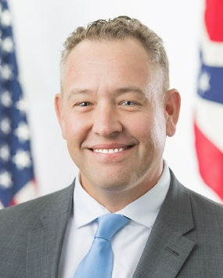
Dennis P. Deters
Dennis P. Deters was appointed to the Public Utilities Commission of Ohio (PUCO) by Governor Mike DeWine in 2019 and reappointed in 2021 and 2026.
Prior to joining the PUCO, Commissioner Deters served in local government for the last decade, most recently as a judge on Ohio’s First District Court of Appeals. Deters also has served as a Colerain Township Trustee, a Hamilton County Commissioner, and a trial attorney representing local government interests.
In these positions, Deters oversaw local regulation of basic public service, adopted and enforced administrative regulation of local services, worked to solve public service disputes, and represented individuals and businesses navigating government regulation.
Commissioner Deters is a member of the Mid-Atlantic Conference of Regulatory Utilities Commissioners (MACRUC), the National Association of Regulatory Utility Commissioners (NARUC) and the Organization of PJM States, Inc (OPSI). In June 2025, Commissioner Deters was elected as President of MACRUC after having served as First Vice President from June 2024 through June 2025. In October 2025, he was appointed President of OPSI by the PJM States, after serving as Vice President for the previous year. He currently serves on the NARUC Committee on International Relations, which manages outreach activities across the globe, including partnerships with numerous countries in Eastern Europe, Africa and Bangladesh. He is also a member of the NARUC Committee on Critical Infrastructure, which analyzes and supports protection of the nation’s energy and telecommunications infrastructure. Deters focuses extensively on cybersecurity as it relates to utility services.
Commissioner Deters was selected by his peers to work on the 2025 Federal and State Current Issues Taskforce, a joint effort between NARUC and the Federal Energy Regulatory Commission made up of 10 Utility Commissioners from across the United States. This Taskforce, the N10, is working to find solutions to challenges created by multijurisdictional regulation of the Nation’s energy systems and markets.
Commissioner Deters has earned his Bachelor of Arts, English and Government, from the University of Notre Dame, and his law degree from the University of Cincinnati.

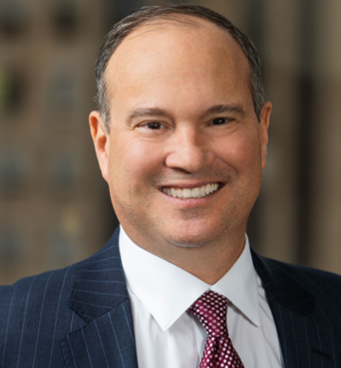
Joseph Dominguez
Joseph Dominguez is the President and Chief Executive Officer of Constellation, which employs 14,000 workers, has generating capacity of more than 32,400 megawatts and serves more than 16 million homes and businesses with clean energy. With revenues of more than $17 billion and total assets of $49 billion, Constellation comprises both the nation's lowest-carbon fleet among large power producers and the largest competitive energy supplier. Together, they are America's clean energy leader, producing about 10% of the nation's clean energy and helping America transition to a clean, sustainable future.
As CEO, Dominguez oversees Constellation's clean energy fleet of nuclear, wind, solar. hydroelectric and natural gas facilities in 19 states. and the nation's top competitive retail and commodities business. which provides electricity, natural gas and other energy-related products and services to two million residential. public sector and business customers nationwide, including more than three-fourths of the Fortune 100.

Professional Background
Previously, Dominguez served as CEO of ComEd. an Exelon company, which powers the lives of more than four million residential and business customers. or 70 percent of Illinois' population. In that role, he was responsible for the safe and reliable delivery of electricity to customers and oversight of the management of the electric grid for over four million customers in Chicago and most of northern Illinois.
Prior to joining ComEd, Dominguez served as executive vice president of governmental and regulatory affairs and public policy for Exelon, where he led the development and implementation of federal. state, and regional governmental, regulatory, and public policy strategies.
Prior to joining Exelon. Dominguez was a partner in the law firm of White and Williams. LLP. with a broad-based litigation practice counseling large and small corporations, institutions, and government entities. He is a former assistant U.S. Attorney, Eastern District of Pennsylvania.
Dominguez currently serves on the board of directors for the Electric Power Research Institute (EPRI). a nonprofit organization that conducts research. development and demonstration projects for the energy industry. He is a board member of KBR, which partners with government and industry clients to provide purposeful and comprehensive solutions with an emphasis on efficiency and safety. Dominguez also serves on the board of directors for AEGIS. a leading mutual insurance company for the energy industry, as well as for the Institute of Nuclear Power Operations (INPO) and the World Association of Nuclear Operators (WANO).

Educational background
Dominguez earned his bachelor's degree in mechanical engineering from the New Jersey Institute of Technology. He earned his law degree from Rutgers University School of Law, where he graduated magna cum laude, and was recognized as a Dean's Scholar.


Nate Hanson
Nate Hanson joined LS Power in 2011 and was named President of LS Power Generation in 2022, overseeing the asset management, energy management, and regulatory affairs of the Firm’s generation fleet. Mr. Hanson is also a member of the firm’s Management and Investment Committees. Prior to LS Power, Mr. Hanson was a Vice President in NextEra Energy Resource’s power marketing division, responsible for wholesale load-serving transactions and commodity hedge strategies. In addition, he had asset management and development responsibilities, including mergers and acquisitions, for their Northeast portfolio. Previously, Mr. Hanson worked for Intercontinental Energy Corporation, focusing on power plants and large industrial development and asset management. He began his career with General Electric, where he focused on training and operations of power plants utilized in the Naval Nuclear program.


Kim Janas
Kim Janas is Counsel to the Attorney General at the Illinois Attorney General's office in Chicago. She also currently serves as the President of the Consumer Advocates of the PJM States (CAPS). At the Illinois AG's office, Kim represents the People of the State of Illinois in electric utility proceedings before the Illinois Commerce Commission and the Federal Energy Regulatory Commission. Kim is also a representative of small electricity users on the NERC Standards Committee. Prior to joining the Attorney General's office, Kim served in a variety of positions in Illinois State government, including Secretary of the Illinois Workers' Compensation Commission and Associate General Counsel at the Illinois State Senate. Kim holds a Juris Doctorate from the University of Illinois College of Law at Urbana-Champaign and a bachelor's degree from the University of Illinois at Urbana-Champaign.


Carim V. Khouzami
Carim V. Khouzami is the executive vice president of Transmission and Development for Exelon, focused on preparing Exelon’s transmission operations to meet the unprecedented growth in energy demand and ensuring the organization has the resources and services needed to fulfill Exelon’s long-term strategic plan.

Professional History
Khouzami previously served as the president and chief executive officer of Baltimore Gas and Electric (BGE), the nation’s first gas utility, where he oversaw safety, reliability, customer service and financial performance. He also served as the chief operating officer of Exelon Utilities, overseeing the daily administrative and operational functions for Exelon’s six regulated utilities, including BGE, as well as managing large investment projects that span all the Exelon utilities. Prior to that, Khouzami served as the chief financial officer of Exelon Utilities, responsible for overseeing the treasury, financial planning and analysis, and accounting functions for the six Exelon utility companies. He has held other leadership roles within financial, strategic and operations at Exelon and BGE.

Civic Involvement
Khouzami is very active in the Baltimore community, currently serving on a number of prominent local non-profit boards, including the Johns Hopkins Hospital, Downtown Partnership of Baltimore board, and Bridges Baltimore.

Education
Khouzami earned a bachelor’s degree in economics and communications studies from Vanderbilt University, and a master’s degree in business administration from Columbia University.


Josh Levi
Josh Levi is president & CEO of the Data Center Coalition (DCC), the membership association for the U.S. data center industry. DCC’s members are leading data center owners and operators who provide the digital infrastructure that enables the applications, capabilities, and services that support the modern economy, including cloud computing and artificial intelligence.
As the voice of the data center industry, DCC empowers and champions the data center community through public policy advocacy, education, thought leadership, and community engagement. DCC is headquartered in Virginia and its members maintain data center infrastructure, teams and investment across the country. As president, Josh leads the organization and executes all aspects of the DCC’s strategy, operations, and growth.
Prior to assuming his current role in 2019, Josh was vice president for policy at the Northern Virginia Technology Council (NVTC), a nationally-recognized regional trade association, where he spent nearly 20 years supporting Northern Virginia’s vibrant technology community.
Josh was awarded a bachelor’s degree in political science from Virginia Tech, graduated cum laude from the University of Richmond School of Law, and is a member of the Virginia State Bar.

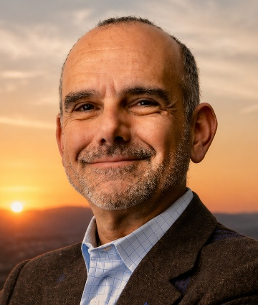
Eran Mahrer
Eran Mahrer brings more than 20 years’ experience, including over 15 years in the renewable energy industry. He is responsible for leading LRE (Leeward Renewable Energy) corporate and technology strategy, origination, procurement, government affairs, public affairs, ESG and communications functions.
Prior to joining LRE, Mr. Mahrer worked at First Solar for more than six years where he served as Vice President of Market Origination and Government Affairs. During this time, he was responsible for First Solar’s U.S. origination team positioning the company’s modules, development assets and power marketing with focus on asset owners and electric utilities. He also led the company’s Government Affairs organization, engaging nationally working to ensure that solar energy resources were appropriately considered and leveraged as part of the nation’s sustainable energy transition. Mr. Mahrer and his team worked across all stakeholder groups to ensure that solar technologies were well understood, appropriately valued, and thoughtfully integrated.


Dylan Seff
Dylan Seff is Head of Utilities for the Americas, Global Head of Sustainable Energy and a member of the Executive Committee.
He joined Vitol in 2010 and has over 20 years’ experience trading energy commodities specialising in power, gas, and environmental products.
Previously he was a Managing Director at both Citigroup and Cinergy where he oversaw cross-commodity trading businesses in the energy space. Dylan holds a Bachelors in Neurobiology from Harvard University.

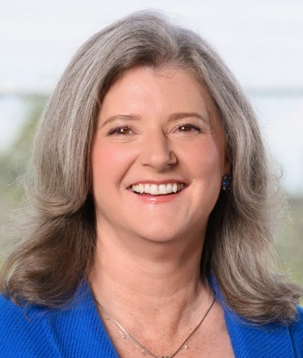
Kirsten Senechal
Kristen Senechal was named President and CEO of Northern Virginia Electric Cooperative (NOVEC) in 2025, after more than 15 years of experience in the electric utility industry. Before joining NOVEC, she served as Executive Vice President of Transmission and Chief Operating Officer at the Lower Colorado River Authority (LCRA) in Austin, Texas.
At LCRA, she was responsible for overseeing more than 750 employees across various disciplines, including transmission design, system operations, and project management. Prior to her tenure at LCRA, she worked in strategic planning at CenterPoint Energy in Houston, Texas.
Senechal holds a Master of Business Administration from the University of Houston’s Bauer College of Business, a Doctor of Philosophy in molecular biology from the University of California, Los Angeles, and a Bachelor of Science in molecular biology from the University of Texas, Austin.

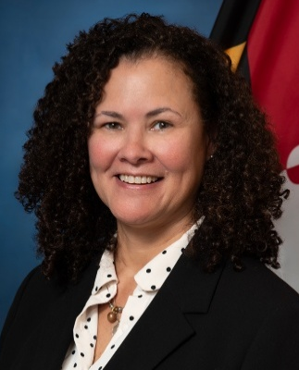
Kelly Speakes-Backman
Kelly Speakes-Backman is the Director of the Maryland Energy Administration under the Moore-Miller administration. A nationally recognized energy executive with over 25 years of experience in energy and environmental issues, her experience spans public, NGO and private sectors, including most recently building and managing a public affairs organization at Invenergy, an American-based multinational power generation development and operations company.
Prior to this, Kelly served as Acting Assistant Secretary and Principal Deputy Assistant Secretary for the Office of Energy Efficiency and Renewable Energy at the U.S. Department of Energy. She was the first CEO of the Energy Storage Association, where she led policy, external relations, and industry leadership efforts for the organization. She was also a commissioner of the Maryland Public Service Commission in the O'Malley-Brown administration, where, as an adjunct to the commission, she served as Chair of the Board of Directors of the Regional Greenhouse Gas Initiative, Co-Vice Chair of the NARUC (National Association of Regulatory Utility Commissioners) Committee on Energy Resources and the Environment, and member of the EPRI Energy Efficiency & Grid Modernization Public Advisory Group. Kelly has held leadership positions in the private sector at United Technologies, Wärtsilä, SunEdison, and The Alliance to Save Energy.

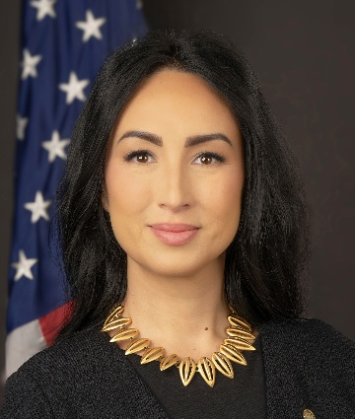
Laura V. Swett
Laura V. Swett was nominated by President Trump on June 2, 2025, and confirmed by the Senate on October 7, 2025, to serve on the Commission for a term expiring on June 30, 2030. President Trump designated her as Chairman of the Commission on October 23, 2025.
Chairman Swett has litigated FERC law for the past 15 years, which has included representation of generating utilities, transmission owners, and natural gas and liquids pipelines, most recently at Vinson & Elkins. Additionally, she previously served at FERC, advising a former Chairman and Commissioner, and as a lead attorney in FERC’s Office of Enforcement.
Chairman Swett holds a Bachelor of Arts from the University of Virginia and a Juris Doctor, with honors, from Georgetown University Law Center. She resides in Virginia with her family.

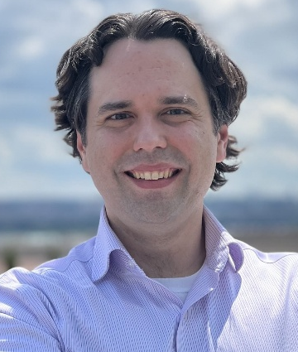
Evan Vaughan
Evan Vaughan is the Executive Director of MAREC Action, where he leads legislative and regulatory advocacy across nine PJM states on behalf of over 50 utility-scale wind, solar, and energy storage companies. In this role, he collaborates with policymakers, regulators, and stakeholders to advance clean energy deployment and grid modernization throughout the Mid-Atlantic region. Prior to joining MAREC Action, Evan served as Manager of Media Relations at the American Wind Energy Association (now part of the American Clean Power Association), where he directed national media engagement strategies to elevate the profile of the wind energy industry. Evan holds a Master of Arts in Global Environmental Policy from American University in Washington, DC, and a Bachelor of Arts in Government and World Affairs from the University of Tampa.

