Credit Subcommittee
PJM Conference & Training Center/WebEx
March 14, 2018
9:00 a.m. – 11:00 a.m. EPT

Administration (9:00 – 9:05)
In lieu of an attendance roll call, PJM will use WebEx registrations to record attendance. Participants not registered on WebEx may email PJM after the meeting and indicate their participation.
PJM will ask for comments and or questions on the February 12, 2018 CS meeting minutes.
Members are requested to adhere to the Anti-Trust Policy, Code of Conduct, Public Meetings/Media Participation and Participant Identification guidelines listed below.

Working Issues (9:05 – 10:50)
Surety Bonds
PJM will provide an update on the use of surety bonds to satisfy PJM credit requirements.
Issue Tracking: Surety Bonds Opportunity
RPM Credit Requirements for At-Risk Existing Resources
The Subcommittee will be asked to vote on endorsement of the Problem Statement and Issue Charge to consider possible credit requirements for existing capacity resources that are at risk of default. Pending approval of the Problem Statement and Issue Charge, PJM will initiate discussion of the issue using a matrix to identify interests and design components.
Issue Tracking: RPM Credit Requirement for At-Risk Existing Resources
FTR Credit Requirements
Bridgid Cummings will present preliminary analysis of the undiversified adder alternative and the possible per-MWH minimum FTR Credit requirement.
Issue Tracking: Financial Transmission Rights Undiversified Credit Requirement

Future Agenda Items (10:50 – 11:00)
RPM Credit and Deliverability Requirements for External Resources
PJM will propose a change to the credit policy to conform to recent changes in deliverability requirements for external resources.
PRD Credit Requirements
PJM will propose a change to PRD credit requirements in conjunction with the change to RPM rules for PRD. RPM discussion of PRD changes is currently on hold pending discussion of summer-only resources.
- Default Liquidation Provisions
PJM will continue discussion of this topic.
RPM Seller Credit
PJM will describe an upcoming change to the calculation of RPM Seller Credit.

Members are welcome to request additional discussion items at this or any future meeting.

Future Meeting Dates
April 10, 2018 | 9:30 a.m. – 11:30 a.m. |  |  | Teleconference Only
Author: Mark Million
Antitrust:
You may not discuss any topics that violate, or that might appear to violate, the antitrust laws including but not limited to agreements between or among competitors regarding prices, bid and offer practices, availability of service, product design, terms of sale, division of markets, allocation of customers or any other activity that might unreasonably restrain competition. If any of these items are discussed the chair will re-direct the conversation. If the conversation still persists, parties will be asked to leave the meeting or the meeting will be adjourned.

Code of Conduct:
As a mandatory condition of attendance at today's meeting, attendees agree to adhere to the PJM Code of Conduct as detailed in PJM Manual M-34 section 4.5, including, but not limited to, participants' responsibilities and rules regarding the dissemination of meeting discussion and materials.

Public Meetings/Media Participation:
Unless otherwise noted, PJM stakeholder meetings are open to the public and to members of the media. Members of the media are asked to announce their attendance at all PJM stakeholder meetings at the beginning of the meeting or at the point they join a meeting already in progress. Members of the Media are reminded that speakers at PJM meetings cannot be quoted without explicit permission from the speaker. PJM Members are reminded that "detailed transcriptional meeting notes" and white board notes from "brainstorming sessions" shall not be disseminated. Stakeholders are also not allowed to create audio, video or online recordings of PJM meetings. PJM may create audio, video or online recordings of stakeholder meetings for internal and training purposes, and your participation at such meetings indicates your consent to the same.
Participant Identification in WebEx:
When logging into the WebEx desktop client, please enter your real first and last name as well as a valid email address. Be sure to select the “call me” option.
PJM support staff continuously monitors WebEx connections during stakeholder meetings. Anonymous users or those using false usernames or emails will be dropped from the teleconference.

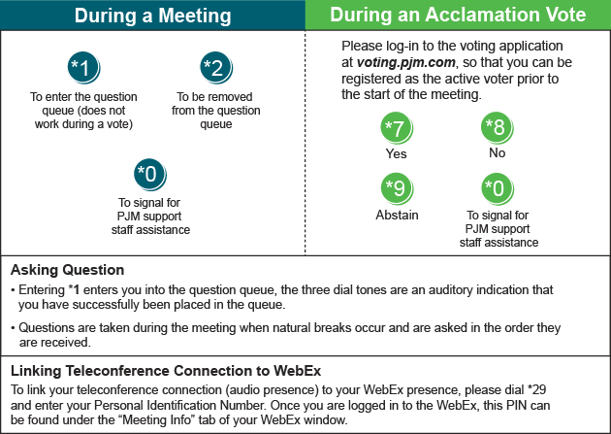
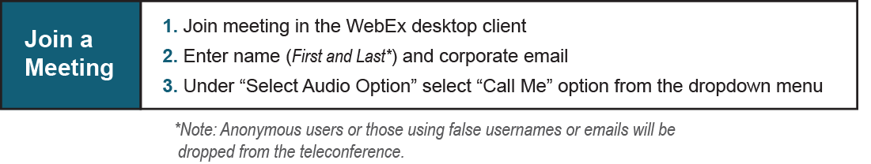
Provide feedback on the progress of this group: Facilitator Feedback Form
Visit learn.pjm.com, an easy-to-understand resource about the power industry and PJM’s role.

