Demand Response Subcommittee
WebEx/Conference Call
Jun 2, 2022
1:00 pm – 4:00 pm EPT

Administration (1:00 - 1:15)
- Welcome, Announcements and Anti-trust and Code of Conduct announcement
- WebEx report will be used for attendance
- Review prior minutes – 5/9/2022 meeting
- Request for any additional agenda items
- Brief update/discussion of DR related activity in other stakeholder groups – MIC, OC, PC, or other

(1:15 – 1:30) Review draft Problem Statement/Issue Charge for “Alternative DR/PRD Compliance Construct for Weather Sensitive Load”
- Sharon Midgley from Exelon will review a draft Issue Charge and Problem Statement related to a potential alternative DR/PRD Compliance construct for weather sensitive load in the capacity market. DRS members are requested to provide input so it can be considered before the June MIC first read.

(1:30 – 2:00) Critical Gas Infrastructure participation as DR in PJM markets
- Jack O’Neill will continue discussion on proposed changes to participation rules for Critical Gas Infrastructure loads.

Future Agenda Items
Participants will have the opportunity to request the addition of any new item(s) to the agenda of a future meeting.

Future Meeting Dates
Author: Shane Watts

Future Meeting Dates and Materials |  |  | Materials Due  to Secretary | Materials Published
Date | Time | Location |  | Materials Published
6/2/2022 | 1:00 pm to 4:00 pm | WebEx / Teleconference | 5/25/2022 | 5/30/2022
7/7/2022 | 1:00 pm to 4:00 pm | WebEx / Teleconference | 6/29/2022 | 7/4/2022
8/2/2022 | 1:00 am to 4:00 pm | WebEx / Teleconference | 7/25/2022 | 7/28/2022
9/2/2022 | 9:00 am to 12:00 pm | WebEx / Teleconference | 8/25/2022 | 8/30/2022
10/3/2022 | 9:00 am to 12:00 pm | WebEx / Teleconference | 9/23/2022 | 9/28/2022
11/9/2022 | 9:00 am to 12:00 pm | WebEx / Teleconference | 11/1/2022 | 11/4/2022
12/5/2022 | 1:00 pm to 4:00 pm | WebEx / Teleconference | 11/22/2022 | 11/30/2022

Antitrust:

You may not discuss any topics that violate, or that might appear to violate, the antitrust laws including but not limited to agreements between or among competitors regarding prices, bid and offer practices, availability of service, product design, terms of sale, division of markets, allocation of customers or any other activity that might unreasonably restrain competition. If any of these items are discussed the chair will re-direct the conversation. If the conversation still persists, parties will be asked to leave the meeting or the meeting will be adjourned.

Code of Conduct:
As a mandatory condition of attendance at today's meeting, attendees agree to adhere to the PJM Code of Conduct as detailed in PJM Manual M-34 section 4.5, including, but not limited to, participants' responsibilities and rules regarding the dissemination of meeting discussion and materials.

Public Meetings/Media Participation:
Unless otherwise noted, PJM stakeholder meetings are open to the public and to members of the media. Members of the media are asked to announce their attendance at all PJM stakeholder meetings at the beginning of the meeting or at the point they join a meeting already in progress. Members of the Media are reminded that speakers at PJM meetings cannot be quoted without explicit permission from the speaker. PJM Members are reminded that "detailed transcriptional meeting notes" and white board notes from "brainstorming sessions" shall not be disseminated. Stakeholders are also not allowed to create audio, video or online recordings of PJM meetings. PJM may create audio, video or online recordings of stakeholder meetings for internal and training purposes, and your participation at such meetings indicates your consent to the same.
Participant Identification in WebEx:
When logging into the WebEx desktop client, please enter your real first and last name as well as a valid email address. Be sure to select the “call me” option.
PJM support staff continuously monitors WebEx connections during stakeholder meetings. Anonymous users or those using false usernames or emails will be dropped from the teleconference.

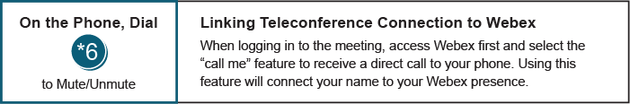

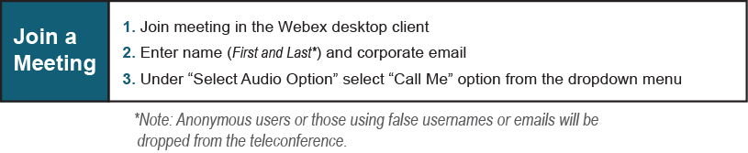

Provide feedback on the progress of this group: Facilitator Feedback Form
Visit learn.pjm.com, an easy-to-understand resource about the power industry and PJM’s role.

