Load Analysis Subcommittee
Teleconference / WebEx
June 26, 2023
1:00 p.m. – 4:00 p.m. EPT

Administration (1:00-1:10)
- Welcome, announcements and review of the Anti-trust, Code of Conduct, and Media Participation Guidelines.
- Approve draft minutes from the November 29, 2022 LAS meeting.

Meeting Materials (1:10-4:00)
- Dominion Data Center – Table in 2023 Load Forecast (B9) (1:10 – 1:30)
Molly Mooney, PJM, will discuss method used to show updated adjustment values that now reflects the amount that the forecast is increased considering the adjustment above what would have been embedded.

- Impact of Forecasted Large Load Adjustments in RTEP (1:30 – 2:00)
Michael Herman and Stan Sliwa, PJM, will discuss the need to include load adjustments and resulting growth in the forecast to help drive RTEP and projects that need long lead-times.

- Dominion Load Adjustment: Method/Results (2:00 – 2:45)
Stan Blackwell, Dominion, will review topics related to Dominion’s data center forecast including a high level overview of their forecast framework and methods.

- Updates to Manual 19: Attachment B (2:45 – 3:30)
Molly Mooney will discuss updates to Manual 19: Load Forecasting and Analysis, specifically Attachment B: Load Forecast Adjustment Guidelines.
- Electrification/State Policy (3:30 – 4:00)
Andrew Gledhill, PJM, will discuss electrification scenario used in the Energy Transition in PJM: Resource Retirements, Replacements & Risks paper along with current/pending state electrification policies.
Future Meeting Dates and Materials |  |  | Materials Due  to Secretary | Materials Published
Date | Time | Location |  | Materials Published
7.19.2023 | 9:00 a.m. – 12:00 p.m. | Teleconference/Webex | 7.11.2023 | 7.14.2023
10.18.2023 | 9:00 a.m. – 12:00 p.m. | Teleconference/Webex | 10.10.2023 | 10.13.2023
11.27.2023 | 9:00 a.m. - 12:00 p.m. | Teleconference/Webex | 11.17.2023 | 11.22.2023
Author: Molly Mooney

Antitrust:
You may not discuss any topics that violate, or that might appear to violate, the antitrust laws including but not limited to agreements between or among competitors regarding prices, bid and offer practices, availability of service, product design, terms of sale, division of markets, allocation of customers or any other activity that might unreasonably restrain competition. If any of these items are discussed the chair will re-direct the conversation. If the conversation still persists, parties will be asked to leave the meeting or the meeting will be adjourned.

Code of Conduct:
As a mandatory condition of attendance at today's meeting, attendees agree to adhere to the PJM Code of Conduct as detailed in PJM Manual M-34 section 4.5, including, but not limited to, participants' responsibilities and rules regarding the dissemination of meeting discussion and materials.

Public Meetings/Media Participation:
Unless otherwise noted, PJM stakeholder meetings are open to the public and to members of the media. Members of the media are asked to announce their attendance at all PJM stakeholder meetings at the beginning of the meeting or at the point they join a meeting already in progress. Members of the Media are reminded that speakers at PJM meetings cannot be quoted without explicit permission from the speaker. PJM Members are reminded that "detailed transcriptional meeting notes" and white board notes from "brainstorming sessions" shall not be disseminated. Stakeholders are also not allowed to create audio, video or online recordings of PJM meetings. PJM may create audio, video or online recordings of stakeholder meetings for internal and training purposes, and your participation at such meetings indicates your consent to the same.
Participant Identification in Webex:
When logging into the Webex desktop client, please enter your real first and last name as well as a valid email address. Be sure to select the “call me” option.
PJM support staff continuously monitors Webex connections during stakeholder meetings. Anonymous users or those using false usernames or emails will be dropped from the teleconference.

Participant Use of Webex Chat:
The use of the Webex chat feature during meetings shall be primarily reserved for administrative and logistical purposes, such as managing a question or comment queue, noting technical difficulties, and meeting support or management purposes. Utilizing Webex chat for any other commentary should be limited to short phrases. Detailed commentary or substantive dialog shall be shared orally by entering the speaker queue.

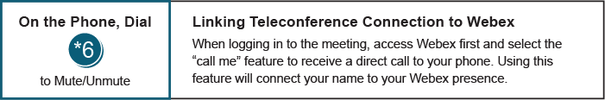

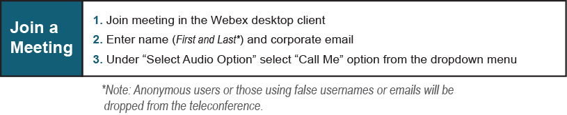

Provide feedback on the progress of this group: Facilitator Feedback Form
Visit learn.pjm.com, an easy-to-understand resource about the power industry and PJM’s role.

