Load Analysis Subcommittee
Teleconference / WebEx
September 29th, 2026
9:00 a.m. – 4:00 p.m. EPT

Administration (9:00 - 9:10)
- Welcome, announcements and review of the Anti-trust, Code of Conduct, and Media Participation Guidelines.
- Approve draft minutes from the July 13th, 2026 LAS meeting.
- Approve draft minutes from the August 26th, 2026 LAS meeting.

Meeting Materials (9:10 - 12:00)
- Introduction
Andrew Gledhill will review the Large Load Adjustment timeline, as well as the purpose of this LAS meeting.
- Large Load Adjustment Requests for the 2027 Forecast
A representative from each requesting entity for a large load adjustment for the 2027 load forecast will present on their specific load request.
- Dominion
  - Data Centers – David Walker
  - Voltage Optimization – Abijit Rajan & Edmund Hall
- NOVEC – James Jones
- Rappahannock Electric Cooperative – Chris Lybolt
- ODEC – Brandon Newbill
- PPL – George Khoury
- AEP – Kayla Zellers & Dan White

Lunch (12:00 - 1:00)

Meeting Materials (1:00 - 4:00)
- Large Load Adjustment Requests for the 2027 Forecast (continued)
A representative from each requesting entity for a large load adjustment for the 2027 load forecast will present on their specific load request.
- Duquesne Light – Jason Hitt
- First Energy – Maelene Mays-Rodriguez
- Exelon – David Apostol & Trey Greiser
- Dayton / AES – Sharon Schroder
- Duke Energy – Bryan Garnett
- PSE&G -Kishan Patel, Rafael Soto, & Qamar Arsalan

Future Meeting Dates and Materials |  |  |  |   Materials Due  to Secretary | Materials Published
10/14/2026 | 9:00-4:00 |  | Teleconference / WebEx | 10/7/2026 | 10/9/2026
11/6/2026 | 9:00-12:00 |  | Teleconference / WebEx | 10/30/2026 | 11/3/2026
11/24/2026 | 9:00-4:00 |  | Teleconference / WebEx | 11/17/2026 | 11/19/2026
Author: Andy Hevey

Antitrust:
You may not discuss any topics that violate, or that might appear to violate, the antitrust laws including but not limited to agreements between or among competitors regarding prices, bid and offer practices, availability of service, product design, terms of sale, division of markets, allocation of customers or any other activity that might unreasonably restrain competition. If any of these items are discussed the chair will re-direct the conversation. If the conversation still persists, parties will be asked to leave the meeting or the meeting will be adjourned.
Code of Conduct:
As a mandatory condition of attendance at today's meeting, attendees agree to adhere to the Code of Conduct as detailed in PJM Manual M-34 section 4.5, including, but not limited to, participants' responsibilities and rules regarding the dissemination of meeting discussion and materials. Expectations for participating in PJM activities are further detailed in the PJM Code of Conduct.

Public Meetings/Media Participation:
Unless otherwise noted, PJM stakeholder meetings are open to the public and to members of the media. Members of the media are asked to announce their attendance at all PJM stakeholder meetings at the beginning of the meeting or at the point they join a meeting already in progress. Members of the Media are reminded that speakers at PJM meetings cannot be quoted without explicit permission from the speaker. PJM Members are reminded that "detailed transcriptional meeting notes" and white board notes from "brainstorming sessions" shall not be disseminated. Stakeholders are also not allowed to create audio, video or online recordings of PJM meetings. PJM may create audio, video or online recordings of stakeholder meetings for internal and training purposes, and your participation at such meetings indicates your consent to the same.
Participant Identification in Webex:
When logging into the Webex desktop client, please enter your real first and last name as well as a valid email address. Be sure to select the “call me” option.
PJM support staff continuously monitors Webex connections during stakeholder meetings. Anonymous users or those using false usernames or emails will be dropped from the teleconference.

Participant Use of Webex Chat:
The use of the Webex chat feature during meetings shall be primarily reserved for administrative and logistical purposes, such as managing a question or comment queue, noting technical difficulties, and meeting support or management purposes. Utilizing Webex chat for any other commentary should be limited to short phrases. Detailed commentary or substantive dialog shall be shared orally by entering the speaker queue.

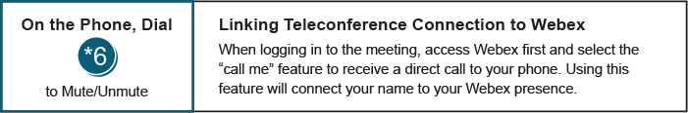

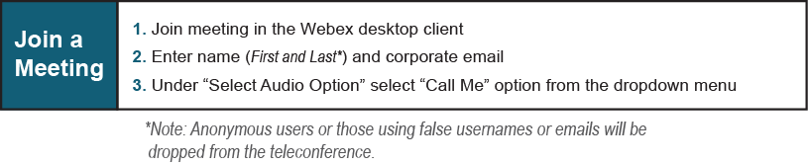
Provide feedback on the progress of this group: Facilitator Feedback Form
Visit learn.pjm.com, an easy-to-understand resource about the power industry and PJM’s role.

