Market Settlements Subcommittee
Conference Call
February 9, 2026
10:00 a.m. – 12:00 p.m.

Administration (10:00 – 10:10)
Welcome, review of Anti-Trust Policy, Code of Conduct, Public Meetings/Media Participation and Participant Identification guidelines, and roll call. A reminder will be given about the new MSS meeting cadence.

Working Issues (10:10 – 10:40)
1. Potential Retirement of Preliminary Reserve and Regulation Data Miner Feeds (10:10 – 10:25)

Sean Flamm, PJM, will review the potential retirement of Data Miner feeds detailing preliminary Reserve market and Regulation market data. Participants are invited to give feedback regarding the use of these feeds.

2. Summary of upcoming Settlement Calculation and Reporting Changes (10:25 – 10:40)

Susan Kenney, PJM, will provide an overview of upcoming PJM items that will require settlement calculation and MSRS reporting changes.

Informational Updates
- Reminder of March Daylight Savings Time switch for PowerMeter and InSchedule Submissions
The March Daylight Savings Time switch will occur on March 8, 2026. PowerMeter and InSchedule have adjusted submissions for the switchover date. Please review March DST PowerMeter and InSchedule for submission guidelines.
- Updates to ARR Target Credits and Cross Monthly Congestion Credit Summary MSRS Reports
New columns will be added to the ARR Target Credits MSRS Report and Cross Monthly Congestion Credit Summary MSRS Report to provide information for ARR deficiencies. Reports are now available for testing in the Train environment. Additional communications will be sent through Pardot to detail Production release schedule.

ARR Deficiencies MSRS Report Updates
- Upcoming MSRS Report Updates
Please review the below document for upcoming MSRS report updates in 2026.
MSRS Report Updates Tracking
- Ongoing MIC Special Session – Operating Reserve Clarification for Resources Operating as Requested by PJM
FERC approved the October 7, 2025 PJM Filing that enhances the rules governing the calculation of Balancing Operating Reserve credits paid to supply resources determined to be operating as requested by PJM. As detailed in the filing, the new Tracking Ramp Limited Desired metric (TRLD) is targeted to be published for informational purposes in MSRS in March 2026. The TRLD metric will not be used in any settlement calculations in 2026, instead acting as informational data in the transitional period to provide Market Participants with the time and necessary information to familiarize themselves with the new TRLD metric. Documentation of the new reports will be shared to the MSS as available.
Issue Details
- Settlement C Updates
No adjustments were processed in the December 2025 billing cycle or January 2026 billing cycle.
Settlement C Adjustment Tracking 2025

Settlement C Adjustment Tracking 2026

Future Agenda Items
Participants will have the opportunity to request the addition of any new item(s) to the agenda of a future meeting.

Future Meeting Dates
Date | Time | Location
May 18, 2026 | 1:00 p.m. – 2:30 p.m. | Teleconference
August 10, 2026 | 10:00 a.m. – 12:00 p.m. | Teleconference
November 17, 2026 | 10:00 a.m. – 12:00 p.m. | Teleconference

Author: Sean Flamm

Antitrust:
You may not discuss any topics that violate, or that might appear to violate, the antitrust laws including but not limited to agreements between or among competitors regarding prices, bid and offer practices, availability of service, product design, terms of sale, division of markets, allocation of customers or any other activity that might unreasonably restrain competition. If any of these items are discussed the chair will re-direct the conversation. If the conversation still persists, parties will be asked to leave the meeting or the meeting will be adjourned.

Code of Conduct:
As a mandatory condition of attendance at today's meeting, attendees agree to adhere to the PJM Code of Conduct as detailed in PJM Manual M-34 section 4.5, including, but not limited to, participants' responsibilities and rules regarding the dissemination of meeting discussion and materials. Expectations for participating in PJM activities are further detailed in the PJM Code of Conduct.

Public Meetings/Media Participation:
Unless otherwise noted, PJM stakeholder meetings are open to the public and to members of the media. Members of the media are asked to announce their attendance at all PJM stakeholder meetings at the beginning of the meeting or at the point they join a meeting already in progress. Members of the Media are reminded that speakers at PJM meetings cannot be quoted without explicit permission from the speaker. PJM Members are reminded that "detailed transcriptional meeting notes" and white board notes from "brainstorming sessions" shall not be disseminated. Stakeholders are also not allowed to create audio, video or online recordings of PJM meetings. PJM may create audio, video or online recordings of stakeholder meetings for internal and training purposes, and your participation at such meetings indicates your consent to the same.
Participant Identification in WebEx:
When logging into the WebEx desktop client, please enter your real first and last name as well as a valid email address. Be sure to select the “call me” option.
PJM support staff continuously monitors WebEx connections during stakeholder meetings. Anonymous users or those using false usernames or emails will be dropped from the teleconference.

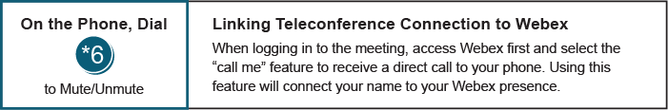

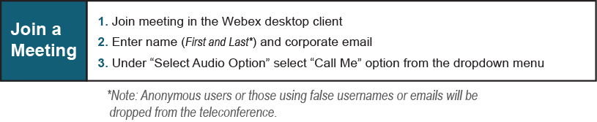
Provide feedback on the progress of this group: Facilitator Feedback Form
Visit learn.pjm.com, an easy-to-understand resource about the power industry and PJM’s role.

