Market Settlements Subcommittee
Conference Call
May 18, 2026
1:00 p.m. – 2:30 p.m.

Administration (1:00 – 1:10)
Welcome, review of Anti-Trust Policy, Code of Conduct, Public Meetings/Media Participation and Participant Identification guidelines, and roll call. Stakeholders will be asked to approve the draft minutes from the February 9, 2026 meeting.

Working Issues (1:10 – 1:50)
1. RPM Settlement Updates (1:10 – 1:25)

Sean Flamm, PJM, will provide an overview of settlement changes that impact RPM billing starting in June 2026.

2. Regulation Market Design Phase 2 (1:25 – 1:40)

Sravani Zangam, PJM, and Nick DiSciullo, PJM, will review Regulation Market Phase 2 design updates including updated settlement calculations and MSRS reports.

3. Tracking Ramp Limited Desired Overview (1:40 – 2:30)

Sravani Zangam, PJM, and Aaron Baizman, PJM, will review the calculation and reporting of the new Tracking Ramp Limit Desired (TRLD) calculation.
The TRLD calculation is the first phase of the larger Energy Market Uplift reforms approved by FERC in December 2025 to be fully implemented in 2027.

Informational Updates
- Reminder of Reactive Power Compensation updates June 1, 2026
FERC approved the October 3, 2025 PJM filing in Docket ER25-1073 in compliance with Order No. 904 to revise Schedule 2 of the Tariff. As detailed in the filing, on June 1, 2026 PJM will remove compensation for the provision of reactive power within the standard power factor range. The associated billing occurred on the Reactive Supply and Voltage Control charges (BLI 1330) and credits (BLI 2330) line items.
- Non-Synchronized Reserve and Secondary Reserve LOC Forfeiture Reports
Please review the below presentation detailing new MSRS reports for detailing Non-Synchronized Reserve LOC Forfeiture and Secondary Reserve LOC Forfeiture.
Non-Synchronized Reserve and Secondary Reserve LOC Forfeiture Reports
- Potential Retirement of Preliminary Reserve and Regulation Data Miner Feeds
At the February 2026 MSS meeting and February 2026 and March 2026 Tech Change Forum meetings PJM detailed the potential retirement of Data Miner feeds covering preliminary reserve market and regulation market data. Based on stakeholder feedback, these feeds will not be retired and will continue to operate as status quo.
- Upcoming MSRS Report Updates
Please review the below document for upcoming MSRS report updates in 2026.
MSRS Report Updates Tracking
- Settlement C Updates
No adjustments were processed in the February 2026 through April 2026 billing cycles.
Settlement C Adjustment Tracking 2026

Future Agenda Items
Participants will have the opportunity to request the addition of any new item(s) to the agenda of a future meeting.

Future Meeting Dates
Date | Time | Location
August 10, 2026 | 10:00 a.m. – 12:00 p.m. | Teleconference
November 17, 2026 | 10:00 a.m. – 12:00 p.m. | Teleconference

Author: Sean Flamm

Antitrust:
It is PJM’s policy to comply with applicable antitrust laws. Participants must not disclose or exchange non-public, competitively sensitive information about their individual business strategies. Prohibited topics include, but are not limited to:
- Non-public individual pricing strategies, bidding strategies, or offer practices  - Non-public forecasts of prices, costs, output, or market behavior | - Non-public information about the availability, output or production costs of specific resources or services  - Confidential terms or conditions of sale, service, or trading strategies | - Planned or potential allocation of specific customers, suppliers, or markets among competitors  - Agreements or understandings between or among competitors to limit supply, coordinate bidding, fix prices, divide markets, or refuse to deal with particular entities | - Any other communication that could unreasonably restrain competition or coordinate competitive behavior among market participants
Discussion of PJM-administered market rules, tariff provisions, system operations, and public market outcomes is appropriate, provided individual confidential business information is not shared. These permitted discussions may include advocacy positions, including those reflecting state regulatory responsibilities or consistent with the obligations and interests of state-regulated entities. These discussions occur in a context where resulting rule changes may be submitted to FERC for approval, or may reflect regulatory mandates established by state authorities.
If prohibited topics are raised, the Chair will redirect the conversation. If the discussion continues, participants may be asked to leave the meeting or the meeting may be adjourned. For more information, please refer to PJM’s Antitrust Guidelines for Stakeholder Meetings, which are posted on PJM’s Committees and Groups page.

Code of Conduct:
As a mandatory condition of attendance at today's meeting, attendees agree to adhere to the PJM Code of Conduct as detailed in PJM Manual M-34 section 4.5, including, but not limited to, participants' responsibilities and rules regarding the dissemination of meeting discussion and materials. Expectations for participating in PJM activities are further detailed in the PJM Code of Conduct.

Public Meetings/Media Participation:
Unless otherwise noted, PJM stakeholder meetings are open to the public and to members of the media. Members of the media are asked to announce their attendance at all PJM stakeholder meetings at the beginning of the meeting or at the point they join a meeting already in progress. Members of the Media are reminded that speakers at PJM meetings cannot be quoted without explicit permission from the speaker. PJM Members are reminded that "detailed transcriptional meeting notes" and white board notes from "brainstorming sessions" shall not be disseminated. Stakeholders are also not allowed to create audio, video or online recordings of PJM meetings. PJM may create audio, video or online recordings of stakeholder meetings for internal and training purposes, and your participation at such meetings indicates your consent to the same.
Participant Identification in WebEx:
When logging into the WebEx desktop client, please enter your real first and last name as well as a valid email address. Be sure to select the “call me” option.
PJM support staff continuously monitors WebEx connections during stakeholder meetings. Anonymous users or those using false usernames or emails will be dropped from the teleconference.
Participant Use of Webex Chat:
The use of the Webex chat feature during meetings shall be primarily reserved for administrative and logistical purposes, such as managing a question or comment queue, noting technical difficulties, and meeting support or management purposes. Utilizing Webex chat for any other commentary should be limited to short phrases. Detailed commentary or substantive dialogue shall be shared orally by entering the speaker queue.

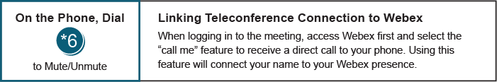

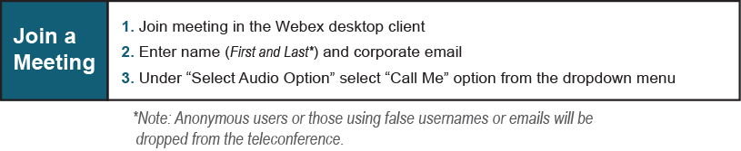
Provide feedback on the progress of this group: Facilitator Feedback Form
Visit learn.pjm.com, an easy-to-understand resource about the power industry and PJM’s role.

