Joint System Operations Subcommittee – Generation and Transmission
WebEx Only
January 6, 2022
9:00 a.m. EPT

Administration (9:00-9:05)
Approve Agenda for this Meeting
- Approve Draft Minutes from the November 29, 2021 SOS Joint Meeting.

Review of Operations (9:05-9:10)
Donnie Bielak will provide an update of System Operations in December and discuss Member Operational Issues.

eDART (9:10-9:15)
- Maria Baptiste will provide an update on the latest and upcoming eDART release.

Dispatcher Training Subcommittee Items (9:15-9:20)
- Bill DePasquale will provide an update on items discussed during the last DTS meeting.

Regional Standards, NAESB, and Compliance Update (9:20-9:25)
- Becky Davis will provide an update on standards and compliance and address any ongoing member issues regarding NERC/RFC.
- Gizella Mali will perform a first read on changes associated with the TO/TOP Matrix Version 16.

Manual Updates (9:25-9:30)
- Liem Hoang will perform a second read and seek endorsement on changes associated with Manual-38 Rev 15.
- Douglas Guignet and Ben Miller will perform a first read on changes associated with Manual 40 Rev 24.

COVID-19 Update (9:50-9:35)
- Paul McGlynn will provide an update on PJM’s operations plan in response to COVID-19.

Future Meeting Dates
February 3, 2022 | 9:00 a.m. | WebEx
March 3, 2022 | 9:00 a.m. | WebEx
April 7, 2022 | 9:00 a.m. | WebEx
May 5, 2022 | 9:00 a.m. | WebEx
June 2, 2022 | 9:00 a.m. | WebEx

Author: Lagy Mathew

Antitrust:
You may not discuss any topics that violate, or that might appear to violate, the antitrust laws including but not limited to agreements between or among competitors regarding prices, bid and offer practices, availability of service, product design, terms of sale, division of markets, allocation of customers or any other activity that might unreasonably restrain competition. If any of these items are discussed the chair will re-direct the conversation. If the conversation still persists, parties will be asked to leave the meeting or the meeting will be adjourned.

Code of Conduct:
As a mandatory condition of attendance at today's meeting, attendees agree to adhere to the PJM Code of Conduct as detailed in PJM Manual M-34 section 4.5, including, but not limited to, participants' responsibilities and rules regarding the dissemination of meeting discussion and materials.

Public Meetings/Media Participation:
Unless otherwise noted, PJM stakeholder meetings are open to the public and to members of the media. Members of the media are asked to announce their attendance at all PJM stakeholder meetings at the beginning of the meeting or at the point they join a meeting already in progress. Members of the Media are reminded that speakers at PJM meetings cannot be quoted without explicit permission from the speaker. PJM Members are reminded that "detailed transcriptional meeting notes" and white board notes from "brainstorming sessions" shall not be disseminated. Stakeholders are also not allowed to create audio, video or online recordings of PJM meetings. PJM may create audio, video or online recordings of stakeholder meetings for internal and training purposes, and your participation at such meetings indicates your consent to the same.
Participant Identification in WebEx:
When logging into the WebEx desktop client, please enter your real first and last name as well as a valid email address. Be sure to select the “call me” option.
PJM support staff continuously monitors WebEx connections during stakeholder meetings. Anonymous users or those using false usernames or emails will be dropped from the teleconference.

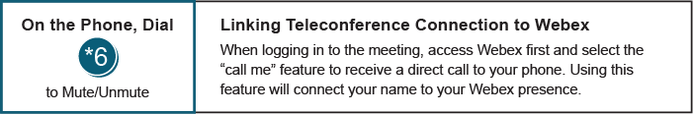

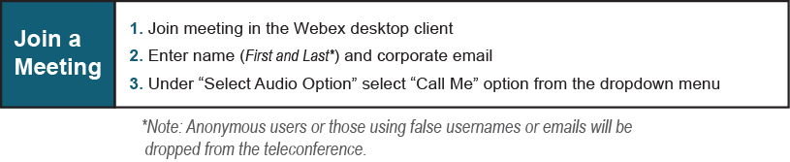
Provide feedback on the progress of this group: Facilitator Feedback Form
Visit learn.pjm.com, an easy-to-understand resource about the power industry and PJM’s role.

