Deactivation Enhancements Senior Task Force (DESTF)
WebEx
June 14, 2024
9:00 a.m. – 12:00 p.m. EPT

Administration (9:00-9:10)
Chantal Hendrzak, PJM, will provide welcome and announcements. Lagy Mathew, will provide announcements, review the Antitrust, Code of Conduct, and Public Meetings/Media Participation Guidelines.
Review and approve draft minutes from the May 17th DESTF meeting.
Chantal Hendrzak, PJM, will review the current work plan.

Consensus Based Issue Resolution Process (9:10-12:00)
- Joe Bowring, IMM, will provide an update on IMM’s Solution Package.
- Asanga Perera, PJM, will provide an update on PJM’s Solution Package.
- Chantal Hendrzak, PJM, will lead a discussion of the Deactivation Enhancements Senior Task Force solution packages. The DESTF may be requested to vote on final solution packages following this meeting.

Future Agenda Items (12:00)
- Review Voting Results

Future Meeting Dates and Materials |  |  | Materials Due  to Secretary | Materials Published
Date | Time | Location |  | Materials Published
Jul 19, 2024 | 9:00 a.m. – 12:00 p.m. | Webex | Jul 11, 2024 | Jul 16, 2024
Aug 19, 2024 | 1:00 p.m. – 4:00 p.m. | Webex | Aug 9, 2024 | Aug 14, 2024

Author: Lagy Mathew

Antitrust:
You may not discuss any topics that violate, or that might appear to violate, the antitrust laws including but not limited to agreements between or among competitors regarding prices, bid and offer practices, availability of service, product design, terms of sale, division of markets, allocation of customers or any other activity that might unreasonably restrain competition. If any of these items are discussed the chair will re-direct the conversation. If the conversation still persists, parties will be asked to leave the meeting or the meeting will be adjourned.
Code of Conduct:
As a mandatory condition of attendance at today's meeting, attendees agree to adhere to the Code of Conduct as detailed in PJM Manual M-34 section 4.5, including, but not limited to, participants' responsibilities and rules regarding the dissemination of meeting discussion and materials. Expectations for participating in PJM activities are further detailed in the PJM Code of Conduct.
Public Meetings/Media Participation:
Unless otherwise noted, PJM stakeholder meetings are open to the public and to members of the media. Members of the media are asked to announce their attendance at all PJM stakeholder meetings at the beginning of the meeting or at the point they join a meeting already in progress. Members of the Media are reminded that speakers at PJM meetings cannot be quoted without explicit permission from the speaker. PJM Members are reminded that "detailed transcriptional meeting notes" and white board notes from "brainstorming sessions" shall not be disseminated. Stakeholders are also not allowed to create audio, video or online recordings of PJM meetings. PJM may create audio, video or online recordings of stakeholder meetings for internal and training purposes, and your participation at such meetings indicates your consent to the same.
Participant Identification in Webex:
When logging into the Webex desktop client, please enter your real first and last name as well as a valid email address. Be sure to select the “call me” option.
PJM support staff continuously monitors Webex connections during stakeholder meetings. Anonymous users or those using false usernames or emails will be dropped from the teleconference.
Participant Use of Webex Chat:
The use of the Webex chat feature during meetings shall be primarily reserved for administrative and logistical purposes, such as managing a question or comment queue, noting technical difficulties, and meeting support or management purposes. Utilizing Webex chat for any other commentary should be limited to short phrases. Detailed commentary or substantive dialog shall be shared orally by entering the speaker queue.

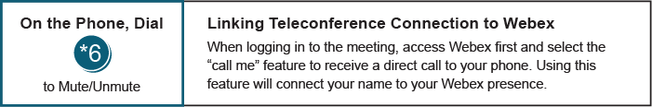

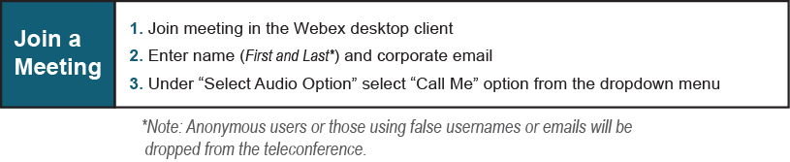
Provide feedback on the progress of this group: Facilitator Feedback Form
Visit learn.pjm.com, an easy-to-understand resource about the power industry and PJM’s role.

