Energy Price Formation Senior Task Force (EPFSTF)
Webex Only
December 10, 2021
9:00 a.m. - 4:00 p.m. EPT

Administration (9:00-9:10)
Susan Kenney, facilitator, will provide a welcome and announcements. Andrea Yeaton, secretary, will review of the Anti-trust, Code of Conduct, and Public Meetings/Media Participation.
Stakeholders will be asked to approve draft minutes from the November 16, 2021 Energy Price Formation Senior Task Force (EPFSTF) meeting.

Charter Updates (9:10-9:55)
Susan Kenney will lead discussion of revised charter wording due to the delayed reserve implementation. The senior task force will be asked to vote on the charter revisions. An acclamation vote will be taken in the meeting. If there is not a clear result from the acclamation vote, the vote will be opened in the Voting Application, and Members will have until Tuesday, December 7, 2021 at 5:00 p.m. EST to cast their votes.

Education (9:55-10:45)
Rebecca Carroll will present education on pricing and dispatch considerations during Emergency Procedures.

CBIR (10:45-2:00)
Keyur Patel will present PJMs Circuit Breaker Design Principles and PJM’s Straw Proposal.

Lunch Break (12:00-12:30)
Catherine Tyler, Monitoring Analytics, will present the IMM’s design principles.
Susan Kenney will lead a review and discussion of the Matrix.

Future Agenda Items
- Participants will have a chance to request future agenda items.

Future Meeting Dates and Materials |  |  | Materials Due  to Secretary | Materials Published
Date | Time | Location |  | Materials Published
1/25/2022 | 9:00 am to 12:00 pm | WebEx | 1/17/2022 | 1/20/2022
2/16/2022 | 9:00 am to 12:00 pm | WebEx | 2/8/2022 | 2/112022
3/22/2022 | 9:00 am to 12:00 pm | WebEx | 3/14/2022 | 3/17/2022
4/26/2022 | 9:00 am to 12:00 pm | WebEx | 4/8/2022 | 4/18/2022
5/24/2022 | 9:00 am to 12:00 pm | WebEx | 5/16/2022 | 5/19/2022
6/28/2022 | 9:00 am to 12:00 pm | WebEx | 6/20/2022 | 6/23/2022

Author: Andrea Yeaton
Antitrust:
You may not discuss any topics that violate, or that might appear to violate, the antitrust laws including but not limited to agreements between or among competitors regarding prices, bid and offer practices, availability of service, product design, terms of sale, division of markets, allocation of customers or any other activity that might unreasonably restrain competition. If any of these items are discussed the chair will re-direct the conversation. If the conversation still persists, parties will be asked to leave the meeting or the meeting will be adjourned.

Code of Conduct:
As a mandatory condition of attendance at today's meeting, attendees agree to adhere to the PJM Code of Conduct as detailed in PJM Manual M-34 section 4.5, including, but not limited to, participants' responsibilities and rules regarding the dissemination of meeting discussion and materials.

Public Meetings/Media Participation:
Unless otherwise noted, PJM stakeholder meetings are open to the public and to members of the media. Members of the media are asked to announce their attendance at all PJM stakeholder meetings at the beginning of the meeting or at the point they join a meeting already in progress. Members of the Media are reminded that speakers at PJM meetings cannot be quoted without explicit permission from the speaker. PJM Members are reminded that "detailed transcriptional meeting notes" and white board notes from "brainstorming sessions" shall not be disseminated. Stakeholders are also not allowed to create audio, video or online recordings of PJM meetings. PJM may create audio, video or online recordings of stakeholder meetings for internal and training purposes, and your participation at such meetings indicates your consent to the same.
Participant Identification in Webex:
When logging into the Webex desktop client, please enter your real first and last name as well as a valid email address. Be sure to select the “call me” option.
PJM support staff continuously monitors Webex connections during stakeholder meetings. Anonymous users or those using false usernames or emails will be dropped from the teleconference.

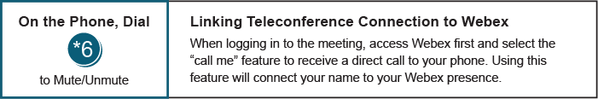

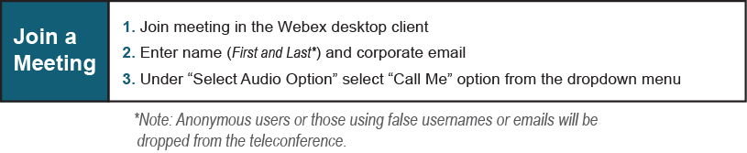

Provide feedback on the progress of this group: Facilitator Feedback Form
Visit learn.pjm.com, an easy-to-understand resource about the power industry and PJM’s role.

