High Voltage DC Task Force (HVDCSTF)
Webex/Teleconference
July 13, 2020
1:00 p.m. – 4:00 p.m. ET

Administration (1:00-1:05)
- Ms. Lisa Krizenoskas will provide welcome, announcements, and review of the Antitrust, Code of Conduct, and Public Meetings/Media Participant Guidelines.

Problem Statement and Issue Charge (1:05-1:25)
- Mr. Vijay Shah will review the Problem Statement and approved Issue Charge for the HVDCSTF.

Education (1:25-3:40)
Mr. Steve Frenkel, SOO Green, will provide initial education on HVDC Converter technology and reliability benefits.
Mr. Paul Scheidecker, PJM, will provide initial education on internal generation capacity resource eligibility for PJM’s Capacity Market.
Ms. Kendra King, PJM, will provide initial education on PJM’s pseudo-tie requirements as they pertain to the external capacity resource eligibility for PJM Markets.

Work Plan (3:40-3:50)
- Mr. Vijay Shah will review the work plan for the HVDCSTF.

Interest Identification (3:50-4:00)
- Mr. Vijay Shah and Ms. Lisa Krizenoskas will open the meeting up for initial interest identification. All participants are encouraged to provide their input.

Future Agenda Items
- Education on eligibility test/pseudo tie test for participation in RPM. – PJM

- Develop Interest identification. - All

- How HVDC Converter stations compare to other capacity resources. SOO Green

- Commercial arrangement for HVDC converter stations in RPM. SOO Green

Future Meeting Dates
August 17, 2020 | 9:00 am – 12:00 pm ET | Webex/Teleconference
September 15, 2020 | 9:00 am – 12:00 pm ET | Webex/Teleconference
October 19, 2020 | 1:00 pm – 4:00 pm ET | Webex/Teleconference
November 9, 2020 | 1:00 pm – 4:00 pm ET | Webex/Teleconference
December 4, 2020 | 9:00 am – 12:00 pm ET | Webex/Teleconference

Author: Lisa Krizenoskas

Antitrust:
You may not discuss any topics that violate, or that might appear to violate, the antitrust laws including but not limited to agreements between or among competitors regarding prices, bid and offer practices, availability of service, product design, terms of sale, division of markets, allocation of customers or any other activity that might unreasonably restrain competition. If any of these items are discussed the chair will re-direct the conversation. If the conversation still persists, parties will be asked to leave the meeting or the meeting will be adjourned.

Code of Conduct:
As a mandatory condition of attendance at today's meeting, attendees agree to adhere to the PJM Code of Conduct as detailed in PJM Manual M-34 section 4.5, including, but not limited to, participants' responsibilities and rules regarding the dissemination of meeting discussion and materials.
Public Meetings/Media Participation:
Unless otherwise noted, PJM stakeholder meetings are open to the public and to members of the media. Members of the media are asked to announce their attendance at all PJM stakeholder meetings at the beginning of the meeting or at the point they join a meeting already in progress. Members of the Media are reminded that speakers at PJM meetings cannot be quoted without explicit permission from the speaker. PJM Members are reminded that "detailed transcriptional meeting notes" and white board notes from "brainstorming sessions" shall not be disseminated. Stakeholders are also not allowed to create audio, video or online recordings of PJM meetings. PJM may create audio, video or online recordings of stakeholder meetings for internal and training purposes, and your participation at such meetings indicates your consent to the same.
Participant Identification in WebEx:
When logging into the WebEx desktop client, please enter your real first and last name as well as a valid email address. Be sure to select the “call me” option.
PJM support staff continuously monitors WebEx connections during stakeholder meetings. Anonymous users or those using false usernames or emails will be dropped from the teleconference.

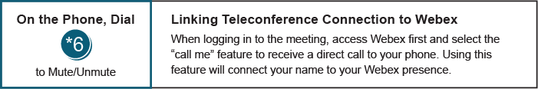

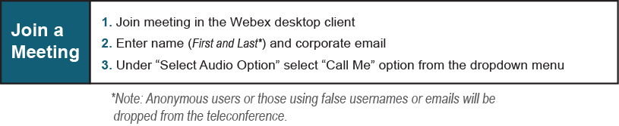
Provide feedback on the progress of this group: Facilitator Feedback Form
Visit learn.pjm.com, an easy-to-understand resource about the power industry and PJM’s role.

