Resource Adequacy Senior Task Force
WebEx Only
April 11, 2022
9:00 a.m. – 4:00 p.m. EPT

Administration (9:00-9:15)
Dave Anders, facilitator, and Alex Scheirer, secretary, will welcome participants, make announcements, and review the Antitrust, Code of Conduct, and Public Meetings/Media Participation Guidelines.
The task force will be asked to approve the Draft Minutes for the March 24, 2022, RASTF meeting.
Dave Anders, facilitator, will provide a brief update on activities of the other reliability services assessment at the OC, the Load Analysis Subcommittee, and the Quadrennial Review MIC Special Sessions.

Education and CBIR (9:15:3:55)
Zach Ming, Energy+Environmental Economics (E3), will present perspectives on Capacity Market reforms. (9:15-9:35)
Supply-Side Market Power Mitigation Rules - Key Work Activity #9 (9:35 – 12:00)
A. Joe Bowring will present the IMM package on Market Seller Offer Cap (MSOC).
B. Pat Bruno will present the PJM package on Market Seller Offer Cap (MSOC).
C. Paul Sotkiewicz will present the E-Cubed Policy Associates package on Market Seller Offer Cap (MSOC).
D. Tom Hoatson will present the LS Power package on Market Seller Offer Cap (MSOC).
E. Matrix Development – Packages – Dave Anders will lead a discussion to continue the Consensus Based Issue Resolution process. The Senior Task Force will be asked to provide packages on Market Seller Offer Cap (MSOC). For more information about the CBIR process, please refer to Manual 34 Section 7.
F. Dave Anders will present a MSOC work plan.
12:00-12:30 Lunch Break
Reliability Risks and Drivers - Key Work Activity #2 (12:30-1:20)
- Tom Hoatson and Mark Spencer, LS Power, will present perspectives on reliability risks and drivers.
- Matrix Development - Interest Identification, Design Components and Options, Dave Anders, facilitator, will lead a discussion to continue the Consensus Based Issue Resolution Process. The Senior Task Force will be asked to provide interests, design components and options on reliability risks and drivers. For more information about the CBIR process, please refer to Manual 34 Section 7.
Procurement Metric and Level - Key Work Activity #3 (1:20-2:00)
A. Matrix Development - Interest Identification and Design Components - Dave Anders, facilitator, will lead a discussion to begin the Consensus Based Issue Resolution Process. The Senior Task Force will be asked to provide interests and design components on the procurement metric and level. For more information about the CBIR process, please refer to Manual 34 Section 7.
PJM Staff will provide education on certain Key Work Activities that relate to the definition of capacity resources. Performance Assessment - Key Work Activity #4, Qualification and Accreditation - Key Work Activity #5, and Obligations of Capacity Resources -Key Work Activity #6. (2.00-3:55)

Next Steps (3:55-4:00)
Dave Anders will discuss next steps

Future Agenda Items (0:00)

Future Meeting Dates and Materials |  |  | Materials Due  to Secretary | Materials Published
Date | Time | Location |  | Materials Published
April 11, 2022 | 9:00 a.m. – 4:00 p.m. | WebEx | April 1, 2022 | April 6, 2022
May 6, 2022 | 9:00 a.m. – 4:00 p.m. | WebEx | April 28, 2022 | May 3, 2022
May 26, 2022 | 9:00 a.m. – 4:00 p.m. | WebEx | May 18, 2022 | May 23, 2022
June 23, 2022 | 9:00 a.m. – 4:00 p.m. | PJM Conference & Training Center / WebEx | June 15, 2022 | June 20, 2022
July 15, 2022 | 9:00 a.m. – 4:00 p.m. | PJM Conference & Training Center / WebEx | July 7, 2022 | July 12, 2022
August 8, 2022 | 9:00 a.m. – 4:00 p.m. | PJM Conference & Training Center / WebEx | July 29, 2022 | August 3. 2022
August 31, 2022 | 9:00 a.m. – 4:00 p.m. | PJM Conference & Training Center / WebEx | August 23, 2022 | August 26, 2022

Author: A. Scheirer

Antitrust:
You may not discuss any topics that violate, or that might appear to violate, the antitrust laws including but not limited to agreements between or among competitors regarding prices, bid and offer practices, availability of service, product design, terms of sale, division of markets, allocation of customers or any other activity that might unreasonably restrain competition. If any of these items are discussed the chair will re-direct the conversation. If the conversation still persists, parties will be asked to leave the meeting or the meeting will be adjourned.

Code of Conduct:
As a mandatory condition of attendance at today's meeting, attendees agree to adhere to the PJM Code of Conduct as detailed in PJM Manual M-34 section 4.5, including, but not limited to, participants' responsibilities and rules regarding the dissemination of meeting discussion and materials.

Public Meetings/Media Participation:
Unless otherwise noted, PJM stakeholder meetings are open to the public and to members of the media. Members of the media are asked to announce their attendance at all PJM stakeholder meetings at the beginning of the meeting or at the point they join a meeting already in progress. Members of the Media are reminded that speakers at PJM meetings cannot be quoted without explicit permission from the speaker. PJM Members are reminded that "detailed transcriptional meeting notes" and white board notes from "brainstorming sessions" shall not be disseminated. Stakeholders are also not allowed to create audio, video or online recordings of PJM meetings. PJM may create audio, video or online recordings of stakeholder meetings for internal and training purposes, and your participation at such meetings indicates your consent to the same.
Participant Identification in Webex:
When logging into the Webex desktop client, please enter your real first and last name as well as a valid email address. Be sure to select the “call me” option.
PJM support staff continuously monitors Webex connections during stakeholder meetings. Anonymous users or those using false usernames or emails will be dropped from the teleconference.

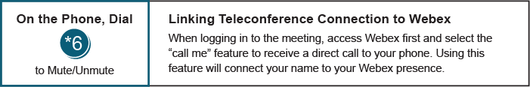

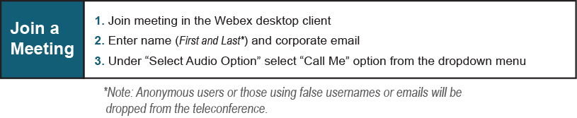

Provide feedback on the progress of this group: Facilitator Feedback Form
Visit learn.pjm.com, an easy-to-understand resource about the power industry and PJM’s role.

